7th Annual Meeting of the Commission
23-27 January, The Hague, The Netherlands
COMM7-Prop14

☒ Create | New CMM on Exploratory Fishing for Toothfish in the SPRFMO Convention Area

Submitted by: EUROPEAN UNION

Summary of the proposal:

The new CMM proposed by the EU seeks to :

- To allow for exploratory bottom longline fishing for Patagonian toothfish (Dissostichus eleginoides) in the area known as the South Tasman Rise, an area outside the Australian EEZ straddling FAO Areas 57 and 81 within the SPRFMO Convention Area, on a precautionary and gradual basis according to the best available science.
- To set out the conditions under which this exploratory fishery will take place, in particular a total allowable catch limit of 45 tonnes and an effort limit consisting of one trip of maximum 21 consecutive days in the period from 1 October to 30 November 2019, setting and hauling no more than 120 sets of 5000 hooks per set with a maximum of 20 sets per research block.
- To specify the fishing vessel authorised to undertake the exploratory fishing (F/V Tronio) and the conditions and procedure for authorising an alternate vessel.
- To set out the management measures applicable to the fishery with particular attention to consistency with relevant measures in force in CCAMLR.
- To set out data collection and reporting obligations applicable to the fishery.
- To specify by-catch rules, move-on rules and other mitigation measures in respect of marine mammals, seabirds, turtles and other species of concern including sharks, skates and rays.
- To set out mitigation measures for encounters with VMEs.
- To set out obligations with regard to monitoring and scientific observers.
- To provide for the review of the CMM.

Objective of the proposal:

To allow for exploratory bottom longline fishing for Patagonian toothfish in the Convention Area on a precautionary and gradual basis according to the best available science in order to, inter alia, assess the long term potential for a toothfish fishery in specific zones of the Convention Area for the purpose of providing regular fishery data to the Scientific Committee.

Ref: COMM7-PROP14 | Received on: 5 December 2018

Background document:
Exploratory fishing for Patagonian toothfish within the SPRFMO Convention area
European Union

Table of Contents
1 Purpose 2
2 Introduction 4
3 Vessel specific details as required under paragraphs 2 and 3 of Annex 1 of CMM 05-2016 (Record of Vessels) 4
4 Fisheries Operation Plan 8
4.1 Description of the exploratory fishery 8
4.2 Fishing gear 9
4.3 Time period of the fisheries operation plan 11
4.4 Biological information on the target species 11
4.5 Risk assessment on non-target by-catch 11
4.5.1 Non-target Fish 12
4.5.2 Sharks 13
4.5.3 Skates and Rays 14
4.5.4 Seabirds 15
4.5.5 Marine Mammals 18
4.5.6 Reptiles 19
4.5.7 VME 20
4.5.8 Additional impact of the longline fishing activity 23
5 Data Collection Plan 24
6 Post-Survey Science Reporting 26
7 References 28
8 Appendix 1: 29

Purpose

The current paper contains the preliminary elements established by CMM 13-2016 on the Management of New and Exploratory Fisheries in the SPRFMO Convention Area for the submission of an application for exploratory fisheries for Patagonian toothfish (Dissostichus eleginoides) by the European Union (EU) to the SPRFMO Commission. Notably, the current paper develops the Fisheries Operation Plan, including area, target species, proposed fishing methods, fishing gear, period and a preliminary data collection plan for the exploratory fishing activities to be undertaken in 2019 in the area known as the South Tasman Rise, an area outside the Australian EEZ straddling FAO areas 57 and 81, and which falls under the SPRFMO jurisdiction. The current paper also identifies the relevant elements of CMM 03-2017 on Bottom Fishing in the SPRFMO Convention Area, notably an assessment of bottom fishing activities outside the established footprint.

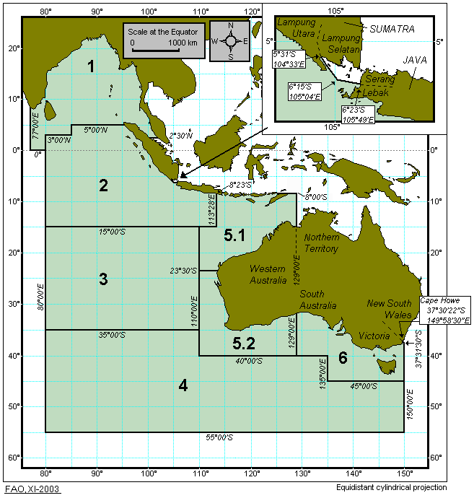 | 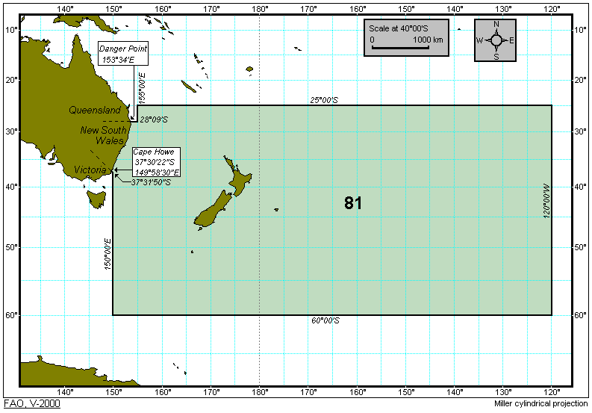
Figure 1: FAO area 57 | Figure 2: FAO Area 81

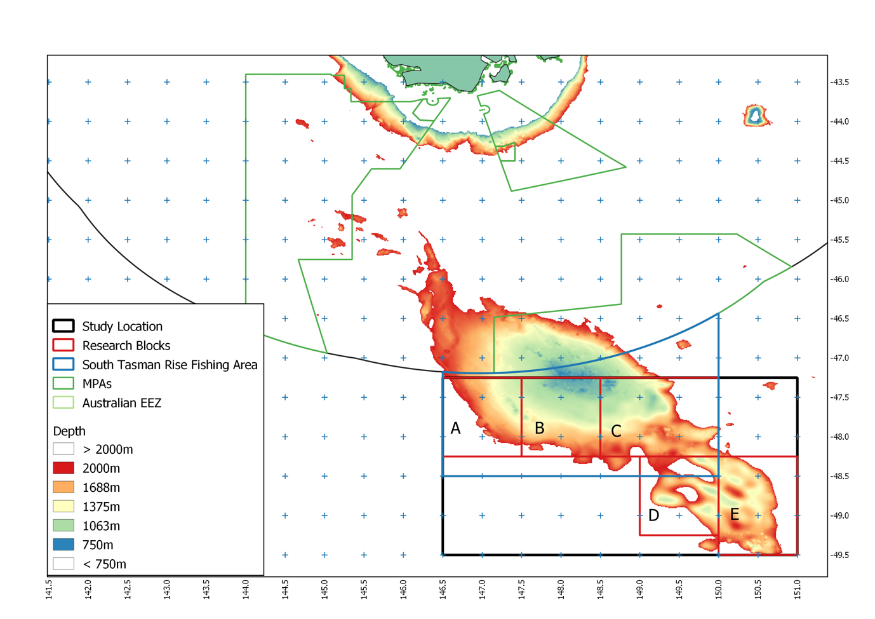
Figure 3: South Tasman Rise – highlighting proposed fishing depths and proposed reearch blocks
Table 1: Proposed study location (corner coordinates) for the South Tasman Rise exploratory fishing total area (around 97,000 km², total depth range 750-2000m = ~33,285km²).
Point | Latitude | Longitude | Distances
NW | 47º 15’ S | 146º 30’ E | 415 km to NE
NE | 47º 15’ S | 151º E | 250 km to SE
SE | 49º 30’ S | 151º E | 360 km to SW
SW | 49º 30’ S | 146º 30’ E | 250 km to NW

Table 2: Proposed research block corner coordinates, total proposed fishable area 750-2000m in brackets.
Research Block | A (4,454 km²) | B (7,651 km²) | C (9,419 km²)
NW | 47º 15’ S, 146º 30’ E | 47º 15’ S, 147º 30’ E | 47º 15’ S, 148º 30’ E
NE | 47º 15’ S, 147º 30’ E | 47º 15’ S, 148º 30’ E | 47º 15’ S, 150º 00’ E
SE | 48º 15’ S, 147º 30’ E | 48º 15’ S, 148º 30’ E | 48º 15’ S, 150º 00’ E
SW | 48º 15’ S, 146º 30’ E | 48º 15’ S, 147º 30’ E | 48º 15’ S, 148º 30’ E
Research Block | D (4,157 km²) | E (6,337 km²) | A-E total 32,018 km²
NW | 48º 15’ S, 149º 00’ E | 48º 15’ S, 150º 00’ E
NE | 48º 15’ S, 150º 00’ E | 48º 15’ S, 151º 00’ E
SE | 49º 15’ S, 150º 00’ E | 49º 30’ S, 151º 00’ E
SW | 49º 15’ S, 149º 00’ E | 49º 30’ S, 150º 00’ E

Introduction

The EU has to date not submitted any paper on Fisheries Operations Plans for exploratory fishing to the SPRFMO Scientific Committee. This paper is a proposal for an exploratory research fishing survey targeting Patagonian toothfish (Dissostichus eleginoides) using the Spanish Bottom Longline System on the South Tasman Rise for a maximum period of 3 weeks on the fishing grounds.

To the best of our knowledge the available scientific literature (Science Direct and Google Scholar), AFMA documentation, and documents from SPRFMO, there has been no bottom longlining fishing in this area for Patagonian toothfish, or any other species. The northern part of the area of interest, and delineated as the ‘South Tasman Rise Fishing Area’ in Figure 3, has had a bottom trawl fishery for Orange Roughy (Hoplostethus atlanticus) for a limited period (1997-2002), jointly managed by New Zealand and Australia, but this ceased in 2001-02 following declining catches (SPRFMO SC5-DW13_rev1, https://www.sprfmo.int/assets/SC5-2017/SC5-DW13-rev1-Roux-Edwards-BDM-method-ORY.pdf and http://docs.niwa.co.nz/library/public/FAR2006-56.pdf), and was eventually closed in 2007.

Because the geographical latitude, oceanography, depth ranges and bathymetry of the area of interest is similar to that of Patagonian toothfish fishing areas elsewhere, there is a likelihood that toothfish may live in this area too. Despite searches through literature and Australian and new Zealand fisheries documents (such as http://www.environment.gov.au/system/files/resources/7a110303-f9c7-44e4-b337-00cb2e4b9fbf/files/south-east-marine-region-profile.pdf and https://data.gov.au/organization/australian-fisheries-management-authority) and the online ‘Atlas of Living Australia’ (ala.org.au), no presence of this species has been recorded on the South Tasman Rise.

Vessel specific details as required under paragraphs 2 and 3 of Annex 1 of CMM 05-2016 (Record of Vessels)

a) Current vessel flag (using the codes indicated in Annex 2); | EUROPEAN UNION (EU) (SPAIN)
b) Name of vessel; | TRONIO
c) Registration number; | 3GC-1-2-05
d) International radio call sign (if any); | ECJF
e) UVI (Unique Vessel Identifier)/IMO number (if issued)²; | 9361603
f) Previous Names (if known); | N/A
g) Port of registry; | CELEIRO (Spain)
h) Previous flag (if any, and using the codes indicated in Annex 2); | UNITED KINGDOM (GBR)
i) Type of vessel (Use appropriate ISSCFV codes, Annex 10 of CMM 02-2018 (Data Standards)); | BOTTOM LONGLINER (LL)
j) Type of fishing method(s) (Use appropriate ISSCFG codes, Annex 9 of CMM 02-2018 (Data Standards)); | LLS 09.3.0
k) Length; l) Length type e.g. “LOA”, “LBP”; | 55 m LOA
m) Gross Tonnage – GT (to be provided as the preferred unit of tonnage); | 1058 GT
n) Gross Register Tonnage – GRT (to be provided if GT not available; may also be provided in addition to GT);
o) Power of main engine(s) (kW); | 1378.70Kw
p) Hold capacity (m3); | 632,3 m³
q) Freezer type (if applicable); | TUNNEL
r) Number of freezers units (if applicable); | 3
s) Freezing capacity (if applicable); | 30Mt
t) Vessel communication types and numbers (INMARSAT A, B and C numbers); | Inmarsat C :422462320  Inmarsat FBB: +870773184117
u) VMS system details (brand, model, features and identification); | Satlink ELB 2014
v) Name of owner(s); | PESQUERÍAS GEORGIAS, S.L
w) Address of owner(s); | Muelle Sur, Almacén 21- Celeiro – Spain
x) Date of inclusion into the SPRFMO Record;
y) Vessel authorisation end date;
z) Flag Authorisation Start Date;
aa) Good quality high resolution photographs of the vessel of appropriate brightness and contrast, no older than 5 years, which shall consist of:
• one photograph not smaller than 12 x 7 cm showing the starboard side of the vessel displaying its full overall length and complete structural features; | See below Figure 4
• one photograph not smaller than 12 x 7 cm showing the port side of the vessel displaying its full overall length and complete structural features; | See below Figure 5
• one photograph not smaller than 12 x 7 cm showing the stern taken directly from astern. | See below Figure 6

The FV Tronio has Ice Class 1C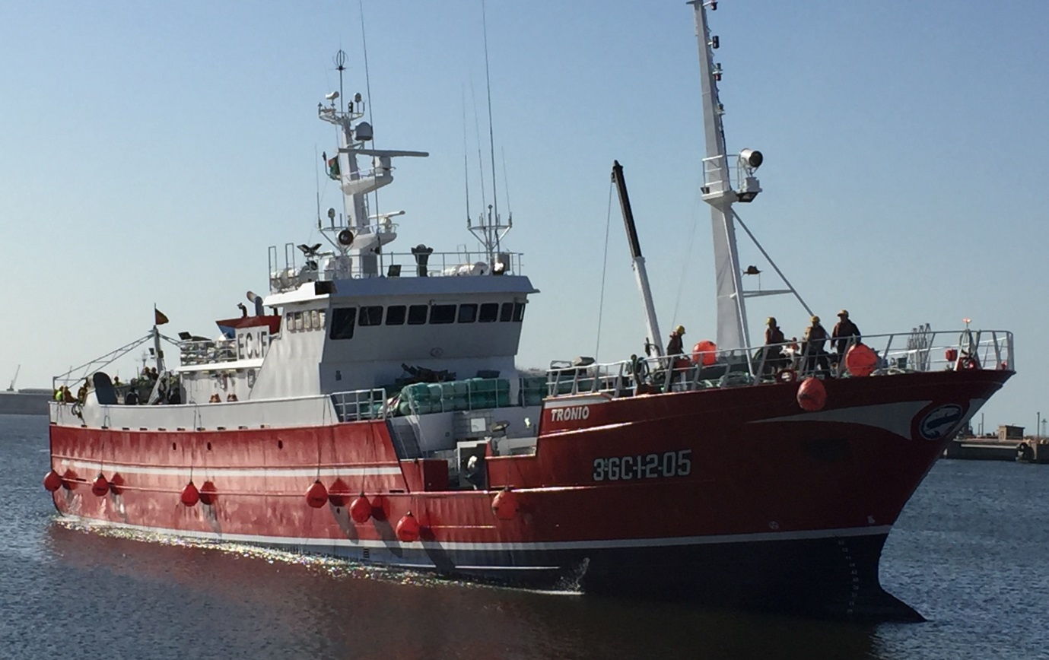
Figure 4: Tronio Starboard
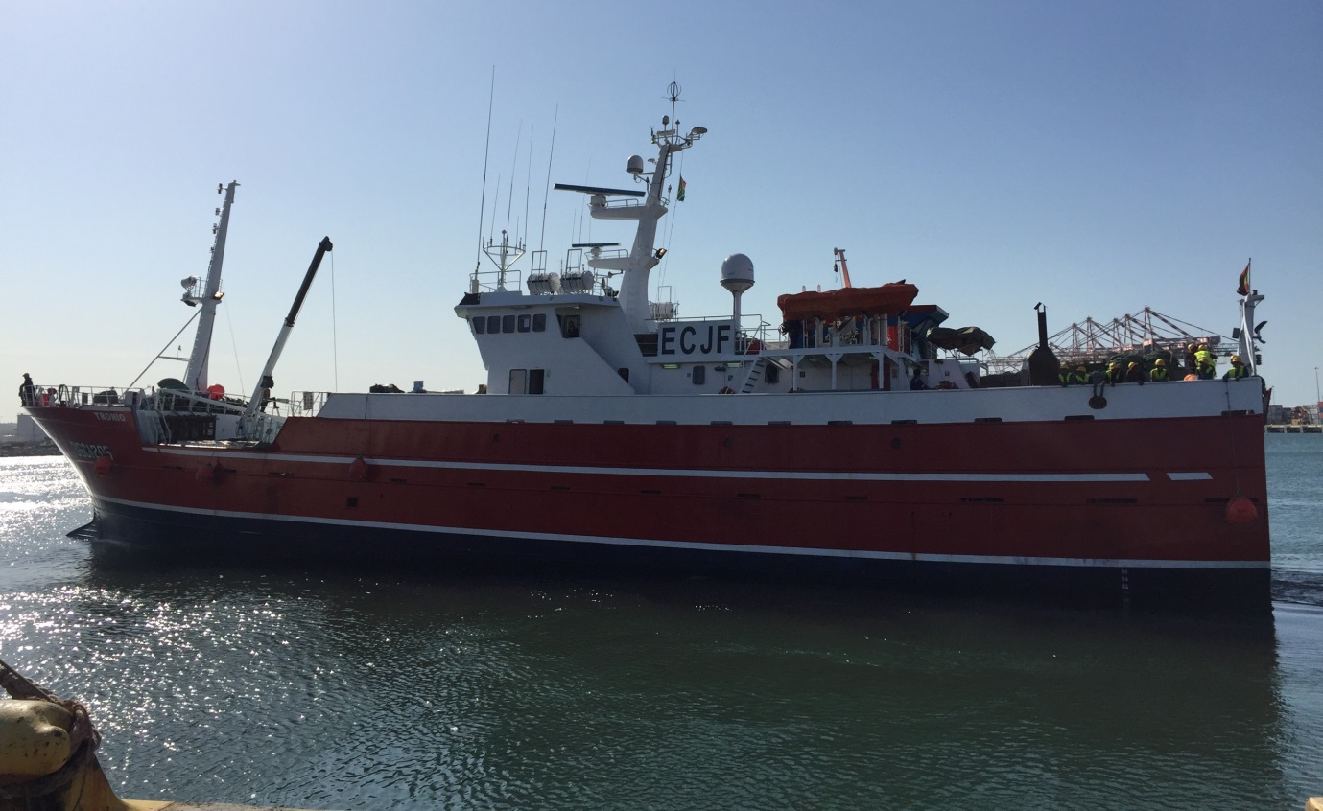
Figure 5: Tronio Port side

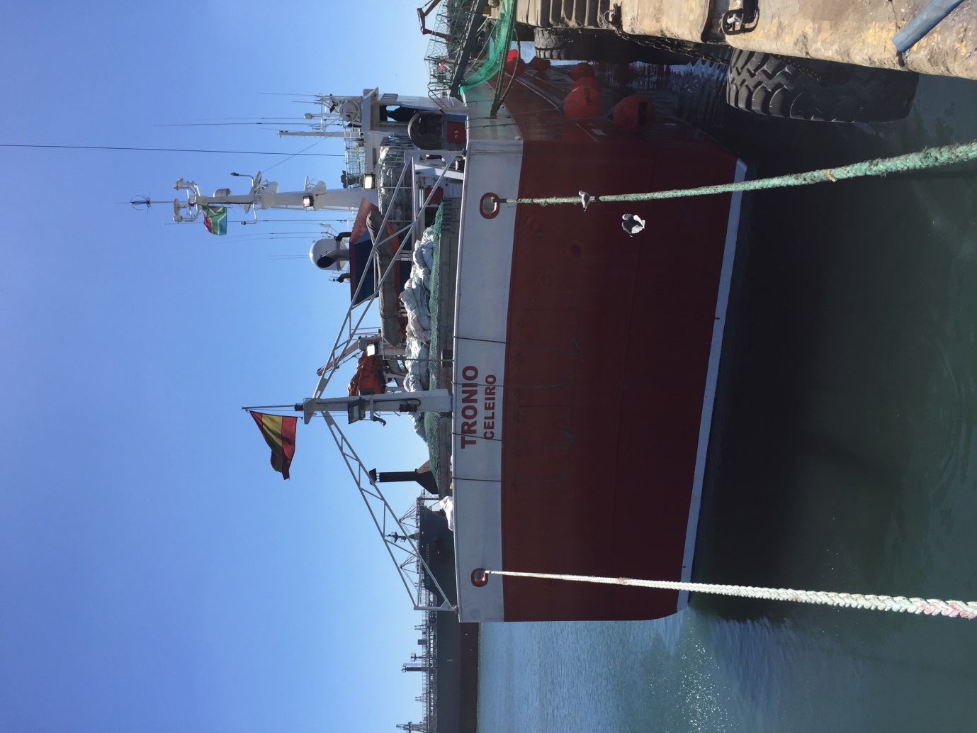
Figure 6: Tronio astern

Fisheries Operation Plan

Description of the exploratory fishery

The main objective of the exploratory fisheries survey will be to establish whether it is possible to develop a long-term sustainable fishery of Patagonian toothfish in the area and to provide the SPRFMO SC with increased information about the area through data collection about the fishing activity, by implementing a survey and sampling design focused on targeted species, by-catch species, accidental catches and Vulnerable Marine Ecosystems (VMEs). Following bathymetric mapping of the area and collecting all relevant catch/by-catch and biological data (including tagging) as detailed below, a Patagonian toothfish stock hypotheses and connectivity analysis with other areas will be drafted.

The proposed exploratory fisheries survey will maintain strict compliance with conservation measures regarding by-catch and the protection of seabirds and marine mammals (CMM 09-2017).

The proposed study area of the South Tasman Rise (with coordinates listed in Table 1), with fishing depths between 750 and 2000m, has been split up into five research blocks A-E (Figure 3) for which the coordinates and fishable area are listed in Table 2., with blocks ranging in size between 8,300-12,500km². This partition has been made to facilitate a systematic approach for this first prospecting phase of the exploratory fishing survey and support subsequent spatial analyses of the fishing results.
It is proposed to conduct a survey limited by both effort and TAC, with a maximum of 20 sets in each block A-E (when possible). For uniformity and to facilitate analyses, all sets will be lines of 5,000 hooks (~8,000m in length). The minimum distance between the centre point of each set is 4nm. It is expected that the maximum total catch of Patagonian toothfish will be lower than 45mt (green weight), and it is requested that this amount will be set as an overall TAC for this study. This amount, given the spatial extent of the proposed area is considered to be a precautionary amount given the spatial extent of the area. Although the research blocks A-E as listed in Table 2 are calculated to cover 47,554 km², the fishable area (750-2000m) is estimated to be 32,018km². Extracting a maximum of 45mt of Patagonian toothfish from a region of this size, would equate to 1.40kg/km².
Results from the NZ exploratory fishery period (SPRFMO SC-04-DW-02) in their research blocks A (59,358km²) and B (14,541km²) suggest an extraction rate of 0.4kg/km², with the first year exploratory period yielding 80kg/100 hooks (28,961kg toothfish) on 35,994 hooks set.
If the Tronio deploys 20,000 hooks per day for three weeks (i.e. 420,000 hooks), while remaining under the 45t threshold, the kg/100 hook rate should not exceed 11kg/100 hooks. For comparison, mean annual catches of 1148t in the Falkland Islands Patagonian Toothfish fishery over a 10 year period 2008-2017 (area between 700-2000m= 148,244.7km²) equated to 7.7kg/km² and 51.2kg/100 hooks
Setting speed is between 7 and 8.5 knots. The average duration of the line setting operation of 5,000 hooks) is ~45 mins, whereas that of line hauling is 4 hours. Usually there are between 3 and 4 lines in the water simultaneously.

Fishing gear

The fishing gear to be used in the exploratory fishery is the Spanish longline system (Figure 7), a well-known gear configuration used in many toothfish longline fisheries (as specified in CCAMLR Gear Catalogue, specifically WG-FSA-11/53). The total length of the line can vary by deploying more or less sections (or baskets) per set line ranging from 60-140 baskets (3,640-10,240 hooks). This translates into a variation of length between 5,824 and 16,384 meters. Typically in exploratory areas, and following acoustic surveying of the area of interest, a shorter line of approximately 5,000 hooks is set to first establish fish density. Normally, and depending on the fishing success of any initial lines, longer lines may be set to optimize efficiency. However, because of the exploratory nature of this proposal, only lines of approximately 5,000 hooks (estimated length 8,000m) will be set.
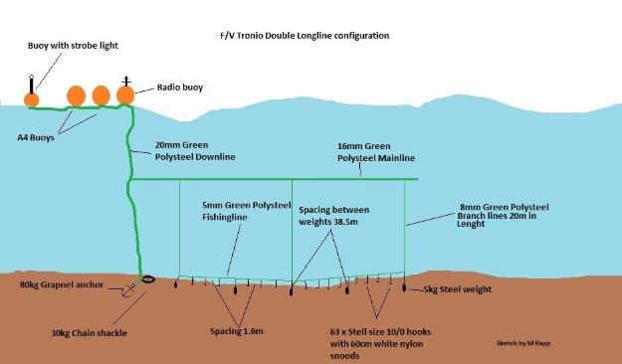
Figure 7: FV Tronio Spanish system in 2017, but note that all steel weights since per November 2017 are now 6kg (not 5kg), and hence achieving a greater sink rate than before. The CCAMLR minimum required sink rate is 0.3m/s. It is expected that the sink rate will be in the region of 0.44m/s.
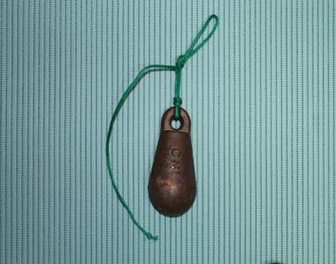
Figure 8 Hydrodynamic shaped steel line weights, 6kg.
Line Sink Rate
Between 2011 and 2017, 63 sink rate tests using the bottle test were conducted by observers. They all exceeded the CCAMLR requirements for sink rate (0.3m/s), as detailed in CM 24-02 (2014).
Figure 9: Sink Rate tests
Table 3: FV Tronio Line SInk Rate Tests 2011-17
 | m/s
mean | 0.44
min | 0.38
max | 0.60
SD | 0.03

IUU Detection and Reporting
Whilst undertaking the exploratory fishing survey on the STR, the FV Tronio will document and report any sighting of fishing vessels suspected of IUU fishing activities to the SPRFMO Secretariat. Furthermore, any abandoned or retrieved fishing gear suspected to be of IUU origin will be photographed, reported with relevant details on position, type of gear, any catches, and retrieved where possible. This is the vessel’s normal operating practice under CCAMLR CM 10-02 Annex 10-02/A while fishing in the CCAMLR Convention Area.

Time period of the fisheries operation plan

The requested time period for the exploratory survey would be up to three weeks. The optimum period of year, bearing in mind operational considerations in which this survey can be conducted is in October-November, prior to the commencement of the Ross sea Fishery (1st December) in CCAMLR. Alternatively, the three-week period may be undertaken in austral winter, following all fishing operations in Antarctica.

Biological information on the target species

Due to the sparsity of information on this region, we have been unable to establish whether Patagonian toothfish has ever been caught on the South Tasman Rise, but one of the purposes of this exploratory trip is to establish exactly that.

The assessment report of longline fishing in the Macquarie Island Toothfish fishery from 2010 (https://www.environment.gov.au/system/files/pages/4f27ef7d-bb8b-41ef-b8bf-ae4449de1d4d/files/afma-assessment.pdf), the closest Patagonian toothfish fishery, reported a mean fish weight of 9.5kg in the area called Macquarie ridge. Tag and recapture data from this fishery suggested limited movement, and high site fidelity.

The life history of Patagonian toothfish is characterised by slow growth, a fecundity ranging between 48,900 and 567,490 (Collins et al., 2010) and late maturity. In CCAMLR Division 58.5.2, the fishery around Heard Island and McDonald Islands, fish up to 175 cm long and older than 50 years of age have been found (Welsford et al., 2011; Welsford et al., 2015). Dissostichus eleginoides are widespread across the entire Kerguelen Plateau (CCAMLR division 58.5) and are known to move long distances across the plateau associated with the different stages of the life cycle. On maturation they migrate to spawning locations, with tagging studies showing occasional migrations of more than 2,500 km to the deeper slopes around 1,400–1,800 m depth (Welsford et al., 2011).
Patagonian toothfish of Heard Island and McDonald Islands as well as Kerguelen, Crozet and Marion/Prince Edward Islands appear to be genetically homogenous (Appleyard et al., 2004) and distinctly different from those at more distant locations such as South Georgia and Macquarie Island (Appleyard et al., 2002).
Patagonian toothfish in CCAMLR Subarea 88.1 are clearly at the southern edge of their range, only extending into the northwest corner of Subarea 88.1 in significant numbers. The fishery catches very few small fish (<50 cm) and the origin of Patagonian toothfish in this area is unclear. It is possible that these fish may be part of the same population as Patagonian toothfish around Macquarie Island as one D. eleginoides tagged at Macquarie Island was caught in SSRU 881B in 2007.

Risk assessment on non-target by-catch

It was recommended by the SPRFMO SC that risk assessments would be conducted on any of the by-catch species.

Methods
Significant adverse impacts (SAI) are assessed according to Figure 10. The aim is to make qualitative assessments that will incorporate key characteristics of the species aiding the evaluation of ‘likeliness’ and ‘consequence’ of by-catch interactions in the case of demersal longline fishing for toothfish on the South Tasman Rise (STR).

Data on spatial overlap and catchability is evaluated and given qualitative assignments of ‘Low’, ‘Low-Med’, ‘Med’, ‘Med-high’, ‘High’ and combined to form overall risk. Mitigation is applied, and residual risk is assessed. Species’ IUCN status is used to inform decisions on triggers and actions to be taken for managing risk. Finally, there is a feed-back process for using new knowledge gained to reduce risk through enhanced mitigation.

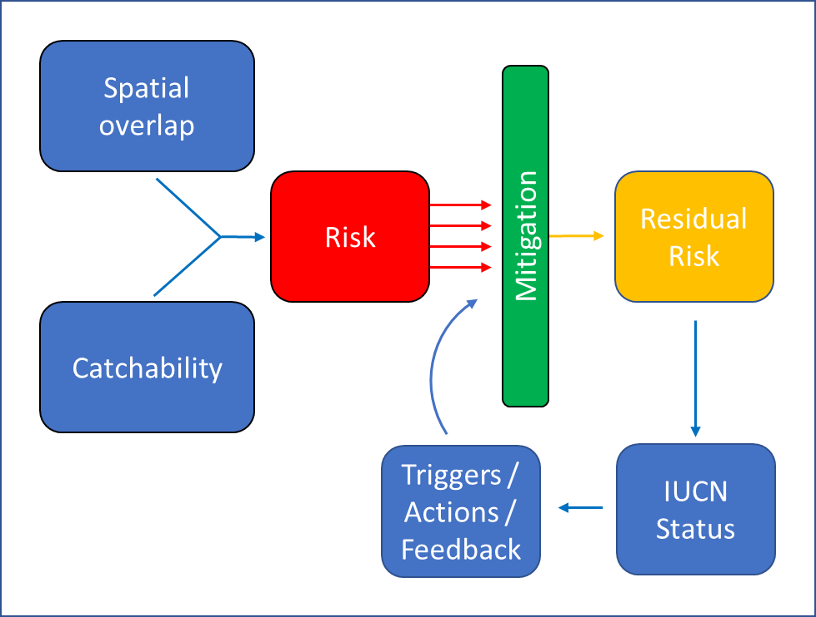
Figure 10: Risk assessment Process
Details on methods, data used, and analyses for providing a risk assessment for reducing significant adverse impact (SAI) is presented in Appendix 1: By-catch risk assessment for experimental Patagonian toothfish demersal longline fishery: South Tasman Rise, South Pacific Regional Fisheries Management Organization (SPRFMO) Convention Area

Non-target Fish

Summary Risk
Spatial overlap | Catchability | Risk
Medium | Grenadiers, Morids, Cusk eels - High | High
 | Others - Low or unknown | Low
Mitigation
Precautionary by-catch limit
Low number of lines proposed
Lines will be set at least 4nm apart from each other, and not set at previous locations.
Residual risk after mitigation
Low

Details on methods, data used, and analyses for providing a risk assessment for reducing significant adverse impact (SAI) is presented in Appendix 1: By-catch risk assessment for experimental Patagonian toothfish demersal longline fishery: South Tasman Rise, South Pacific Regional Fisheries Management Organization (SPRFMO) Convention Area

Given the low numbers of lines sets proposed per research block, it is highly unlikely that removals of by-catch species will have any relevant impact on population integrity. However, there may be a cumulative effect of fishing on by-catch populations if fishing on the STR was to continue in the future.

Mitigation
A 5t total by-catch limit on individual fish species, will be adopted for the survey, with a total amount of all by-catch species combined not exceeding 20t. This would align with what occurs in the Macquarie Island fishery, where, for a 450t toothfish fishery, a combined by-catch limit of 200t is set with a 50t limit on any species. Once this limit has been reached, fishing will cease.

The move-on rule for fish by-catch followed in CCAMLR will be used for this proposal (CCAMLR, CM 41-03, 2018) namely:

- “The by-catch of finfish shall trigger a move-on rule if the catch of skates and rays exceeds 5% of the catch of Dissostichus spp. in any one haul or set, or if the catch of Macrourus spp. reaches 150 kg and exceeds 16% of the catch of Dissostichus spp. in any one haul or set.
- If the move-on rule is triggered, then the fishing vessel shall move to another location at least 5nm distant.”

Consequences to populations
After evaluation of spatial overlap, catchability and mitigation, it is considered that the consequences to the non-target fish populations are low with a high likelihood of recovery over short time frames.

Sharks

Summary Risk
Spatial overlap | Catchability | Risk
Sharks - Medium | Sharks- High | Sharks - Medium-High
Mitigation
Precautionary by-catch limit
Able to release at least some species alive
Caveat - Risk assessments are possibly over-precautionary due to poor data (SC6-DW08)
Residual risk after mitigation
Medium

Details on methods, data used, and analyses for providing a risk assessment for reducing significant adverse impact (SAI) is presented in Appendix 1: By-catch risk assessment for experimental Patagonian toothfish demersal longline fishery: South Tasman Rise, South Pacific Regional Fisheries Management Organization (SPRFMO) Convention Area

A total of 37 shark species and seven species of chimeras, spanning 16 Families, were found to have possible distributions over the proposed fished area of the STR (Appendix 1). A mix of demersal and pelagic species are identified with a few bentho-pelagic species. Catchability of demersal species were considered to be ’high’ whilst pelagic species were considered ‘medium’ catchability given the shorter time the line is suspended in the water column compared to time on the seabed. In terms of over-all risk (before mitigation), 23 species were assessed to be of ’medium-high‘ risk, and 6 species ’high‘ risk, given spatial overlap and catchability. Assessments made here were comparable to assessments made for the same species in SC6-DW08, with assessments made in this study somewhat more precautionary. Similarly, ’high’ risk assessments were made for Deania calcea (Brier shark), Zameus squamulosus (Velvet dogfish), Oxynotus bruniensis (Prickly dogfish), and Dalatias licha (Black shark). ‘High’ risk assessments were made for Centroscymnus coelolepis (Portugese dogfish), and Cetorhinus maximus (Basking Shark), whilst in the SC6-DW08 assessment these were assessed to be at lower risk. The ‘high’ risk assessment for the Genus Centroscymnus is supported by the particularly high catches of Centroscymnus viator (Lantern shark) in the Kerguelen toothfish longline fishery (CCAMLR WG-FSA-18/25).

Mitigation
Sharks may be recovered from the line and released alive, and this will be done in all cases where they are likely to survive release. In the case of larger species, it is not likely that any will be in such condition to be released alive, e.g. Somniosidae, Lamnidae, Cetorhinidae and Alopiidae.

Primary mitigation for reducing risk to sharks is through precautionary by-catch limits. It is also likely that risk assessments here are over-precautionary, given paucity of available data for most chondrichthyans in SPRFMO and, particularly for demersal longline fishing in the STR.

Following paragraph 19c of CMM14b-2018, we will identify and photograph all captured shark species

Move-on rule
Deep-water sharks are not included in the move-on rule as per CCAMLR CM 41-03. However, for the purposes of this exploratory proposal, the vessel will move-on if the following by-catch levels are triggered:

If more than 4 of any of the following families Somniosidae, Lamnidae, Cetrorhinidae, Alopiidae or more than 2 of any one family is by-caught, the vessel shall move on to the next research block.

Consequences to populations
After evaluation of spatial overlap, catchability and mitigation, it is considered that the consequences to the shark populations are low with a high likelihood of recovery over medium time frames.

Skates and Rays
Summary Risk
Spatial overlap | Catchability | Risk
Skates - Medium | Skates - High | Skates - Medium-High
Mitigation
Precautionary by-catch limit
Able to release at least some species alive
Caveat - Risk assessments are possibly over-precautionary due to poor data (SC6-DW08)
Residual risk after mitigation
Medium

Details on methods, data used, and analyses for providing a risk assessment for reducing significant adverse impact (SAI) is presented in Appendix 1: By-catch risk assessment for experimental Patagonian toothfish demersal longline fishery: South Tasman Rise, South Pacific Regional Fisheries Management Organization (SPRFMO) Convention Area

A total of 12 skate species were identified as potentially overlapping with the STR proposed fishing area, with varying degrees of likelihood. Given that skate species are demersal, all skate species are assessed as having a ‘high catchability. However, overall risk is reduced due to total by-catch limits prescribed in the Fishing Operation Plan. The SC6-DW08 assessment (where the species was assessed) also indicates ‘low’ risk for these species.

Mitigation
Skates can often be recovered from the line and released alive, and this will be done in all cases where skates are likely to survive release.

Primary mitigation for reducing risk to skates is through precautionary by-catch limits. It is also likely that risk assessments here are over-precautionary, given paucity of available data for most skates in SPRFMO and, particularly for demersal longline fishing in the STR.

Following paragraph 19c of CMM14b-2018, we will identify and photograph all captured skate and ray species.

Move-on rule
A move on rule for skate and ray by-catch would be triggered. If the skate and ray catch would exceed 5% of the Dissostichus spp. catch or a maximum of 100kg in any one haul or set, then the fishing vessel shall move to another location at least 5nm distant. This is consistent with CCAMLR CM 41-03.

Consequences to populations
After evaluation of spatial overlap, catchability and mitigation, it is considered that the consequences to the skate and ray populations are low with a high likelihood of recovery over short time frames.

Seabirds
Summary Risk
Spatial overlap | Catchability | Risk of mortality
Medium | Albatrosses and Fulmars - High | Albatrosses and Fulmars - High
 | Petrels - Medium | Petrels - High
 | Penguins and Prions - Low | Penguins and Prions - Low
Mitigation
Meets CMM-09-17
Exceed CMM-09-17; 2 x tory lines
Meets paragraphs 18 and 19 of CMM 14b-2018
Vessel light management at night
Residual risk after mitigation
Low

Details on methods, data used, and analyses for providing a risk assessment for reducing significant adverse impact (SAI) is presented in Appendix 1: By-catch risk assessment for experimental Patagonian toothfish demersal longline fishery: South Tasman Rise, South Pacific Regional Fisheries Management Organization (SPRFMO) Convention Area

A total of 51 seabirds were identified as overlapping with the STR to varying degrees (Appendix 1). Seabirds interact with deep-set longline vessels in a number of ways. At the surface, birds are attracted to baited hooks during line setting at the stern of the vessel, where some species may be caught at the surface only (e.g. most albatrosses) or underwater if the species is able to dive and chase baited hooks while descending (e.g. white chinned petrels). During line hauling, birds are attracted to the starboard side of the vessel nearest the hauling bay with the risk again being caught by hooks while attempting to feed on bait. At-risk seabirds are therefore those larger seabirds that are able to feed on large squid and mackerel bait.

Birds striking the vessel itself, so called light-strike, may cause risk particularly at night when vessel lights can attract seabirds from a great distance. This would be a risk primarily to smaller birds or juveniles rather than larger adult albatross species, such as storm petrels and prions. Although this is not necessarily by-catch, it is related to ship fishing operations.

Mitigation
Taking note of CMM 09-2017, and particularly the specifications in Annex 1, the FV Tronio is able to comply fully with all aspects. The bird mitigation devices themselves are detailed below. Officers and crew in collaboration with onboard Compliance officers and Scientific Observers have refined some practical aspects of the devices to best suit the vessel. Figure 11 details the streamer line system deployed during each setting as in place on the vessel in 2017, and which it still uses currently. Figure 12 and Figure 13 show two types of towed devices. The device as shown in Figure 13 shows some of the latest improvements. Note that CCAMLR specifies a single Bird Scaring line, whereas the Tronio deploys a Double BSL.
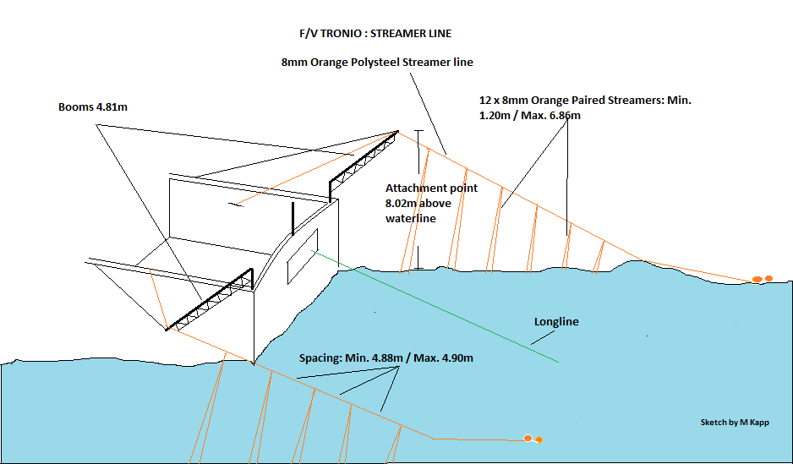
Figure 11 Streamer line alignment during setting.
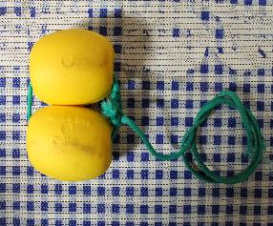 | 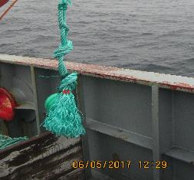
Figure 12 Towed device option 1 | Figure 13 Towed devise option 2, providing additional drag
Seabird interactions during hauling are mitigated against in a number of ways. Firstly, the vessel always deploys a Bird Exclusion Device (BED) around the hauling bay to deter any seabird interaction with the line as shown in Figure 14 and in Figure 15.

Discard management will meet paragraph 18 of CMM 14b-2018, specifically
- no dumping of offal while lines are being set or hauled,
- any offal or discards shall be macerated prior to discarding.
- discarding shall take place only at the end of haul or while steaming; and no biological material shall be discarded for at least 30 minutes before the start of any set or during any set, and
- discarding will only take place from the opposite side to the hauling position

The FV Tronio has the ability to meet CCAMLR CM 26-01, which requires offal/discard storage and prohibits dumping of this south of 60ºS.

Paragraph 6 of CCAMLR CM 25-02 (2015) requires hook removal from by-catch and discard species and this is standard practice on the vessel.
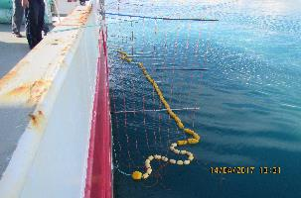 | 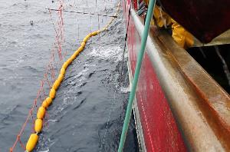
Figure 14 FV Tronio bird exclusion device (BED) around the hauling bay. | Figure 15 FV Tronio bird exclusion device (BED) around the hauling bay.

Vessel Strikes
Management of light emission from vessel at night to avoid vessel-strike. Reducing the use of light to the minimum for safety reasons
Trigger / Action
CMM 09-17 sets a trigger level of 0.01 birds/1000 hooks before additional mitigation measures must be made. In the instance of exceeding this limit, an evaluation of mitigation measures will be made, including ensuring correct deployment of mitigation, and strengthening mitigation where possible (e.g. further reducing night hours of setting).

Consequences to populations
After evaluation of spatial overlap, catchability and mitigation, it is considered that the consequences to the seabird populations are low with a high likelihood of recovery over short time frames.

Marine Mammals

Summary Risk
Spatial overlap | Catchability | Risk
High | Whales/Dolphins - Low | Whales/Dolphins - Low
 | Otariids - Low | Otariids - Low
 | Phocids - Medium | Phocids - Medium
Mitigation
Meets paragraph 19 of CMM 14b-2018
Avoidance of areas of visible mammal activity
Elephant seals may have limited distribution in the STR
Fishing planned for November - likely low Elephant seal encounters
Residual risk after mitigation
Low

Details on methods, data used, and analyses for providing a risk assessment for reducing significant adverse impact (SAI) is presented in Appendix 1: By-catch risk assessment for experimental Patagonian toothfish demersal longline fishery: South Tasman Rise, South Pacific Regional Fisheries Management Organization (SPRFMO) Convention Area

A total of 34 marine mammals were identified as overlapping with the STR to varying degrees

The majority of whale species have a high degree of potential overlap with the STR region. Whales are likely to be at risk at or near the surface during setting or hauling, where entanglement would likely result in injury or drowning. Catchability of whales is thought to be very low and varies with species (Werner et al 2015). Orcas and Sperm whales have a very high degree of association with toothfish longline vessels, where interactions are more damaging economically to the vessel in terms of lost or damaged gear and depredation of catch off the line. Damage to individuals may occur, with mortalities relatively low. Similarly, dolphin mortalities are thought to be very rare among toothfish longline vessels.

Otariiid seals have been associated with toothfish longline vessels and have been observed to depredate on catch. Fur seal and sea lion toothfish fishing related mortalities appear to be very rare.

Specific at-risk species
Southern Elephant (Mirounga leonina) seals may be at risk to incidental mortality, as has been found in other regions. Van den Hoff et al (2017) summarise recent and historic reports of Elephant seal by-catch. These reports include video evidence of interactions with caught toothfish on the seabed as well as reports made by Scientific Observers of Elephant seal mortalities by drowning related to longline fishing.

Elephant seals can dive for up to 2h to depths over 1500m and bottom times of up to 15mins at deep-depths. Males tend to dive deeper (down to ~ 2000m) compared to females (~ 800m) (Prof. Mike Fedak pers com). Elephant seals are known to travel thousands of kilometres on 10-month long foraging trips (Hindell et al 2016). The closest colony to the STR is on Macquarie Island. IUCN distribution data suggest significant overlap with the STR. However, elephant seal tracking data (Fabien et al 2018) suggest that elephant seals may primarily travel south from Macquarie Island and rarely travel north across the STR.

Mitigation
Few mitigation measures have been recommended to avoid marine mammal by-catch. In the case of Orcas and Sperm whales, the vessel will naturally aim to avoid interactions due to depredation behaviour of toothfish, characteristic these species. Seasonal avoidance has been recommended for depredation mitigation and may also be effective for reducing by-catch among other species. Pre-setting and hauling assessments of mammal abundance in the vicinity will be done, and judgement will be made on a case by case basis as to whether vessel avoidance is necessary.

In the case of Elephant seals, there have been no effective mitigation measures recommended for avoiding elephant seal by-catch due in part, to their deep and long-duration diving capabilities. Seasonal avoidance is suggested, where fishing could be conducted in September-November when adult seals are primarily ashore (Van den Hoff et al 2017).

Any seal or whale by-catch will trigger a re-evaluation of fishing strategy.

Consequences to populations
After evaluation of spatial overlap, catchability and mitigation, it is considered that the consequences to the mammal populations are low with a high likelihood of recovery over medium time frames.

Reptiles

Summary Risk
Spatial overlap | Catchability | Risk
Low | Low | Low
Mitigation
Meets paragraph 19 of CMM 14b-2018
Avoidance of areas of visible turtle activity
Avoid periods of motionless line while suspended in the water column
Fishing will take place south of known range. Vessel will move further south if turtles are encountered
Residual risk after mitigation
Low

Details on methods, data used, and analyses for providing a risk assessment for reducing significant adverse impact (SAI) is presented in Appendix 1: By-catch risk assessment for experimental Patagonian toothfish demersal longline fishery: South Tasman Rise, South Pacific Regional Fisheries Management Organization (SPRFMO) Convention Area

There are three species of turtle with possible overlapping distributions in the region of the STR. Hawksbill turtle (Eretmochelys imbricate) and Loggerhead turtle (Caretta caretta) range to the northern flanks of the STR, where the Subtropical Front appears to limit a more southerly distribution. The Leatherback turtle (Dermochelys coriacea) is limited to the southern coast of Tasmania, and is therefore unlikely to reach as far south as the STR.

By-catch of turtles is a particularly prevalent in pelagic longline fisheries such as tunas and swordfishes (Lewison and Crowder 2007). Turtles are attracted to bait as well as the lightsticks used in some fisheries, such that both hooking and entanglement can occur leading to drowning. Whilst Hawksbill and Loggerhead turtles are distributed in shallow waters (down to a few hundred meters), Leatherback turtles feed in much deeper water, diving down to 1000m depth (Lutcavage et al 1992).

Interaction of turtles with demersal toothfish longline fishing would likely occur during setting and hauling while the line is suspended in the water column. During setting and hauling the line will travel through the water column at speeds that would reduce the likelihood of turtle by-catch, the average sink rates on the Tronio are 0.44 ms⁻¹ (~ 1 knot) and hauling speeds are approximately 1 ms⁻¹ (~ 2 knots) (Joost Pompert, pers com).

Specific at-risk species
The Hawksbill turtle has an IUCN listing of ‘Critical’. Loggerhead and Leatherback turtles are rated ‘Vulnerable’.

Mitigation
There are few options for mitigation against turtle by-catch. There is likely to be a natural mitigation given line sink rates during setting, and speed of the line during hauling. During line soak time on the seabed, the line will be out of depth range for Hawksbill and Loggerhead turtles, and will be near the depth limits for Leatherback turtles. Additional mitigation will be the use of avoidance strategies if turtles are seen in a fishing area, such as avoiding long periods of where the line is left motionless in the water column during setting and hauling.

Trigger / Action
If two turtles are caught in any Research Block, then more southern locations on the STR will be chosen in order to move further away from known areas of turtle distribution.

Consequences to populations
After evaluation of spatial overlap, catchability and mitigation, it is considered that the consequences to the reptile populations are low with a high likelihood of recovery over medium time frames.

VME

Summary Risk
Spatial overlap | Catchability | Risk
VME species | VME species | VME species
VME habitats | VME habitats | VME habitats
Mitigation
Limited impact footprint
4nm separation between lines
No spatial overlap of consecutive line setting, eliminating cumulative effects
Residual risk after mitigation
Low
Details on methods, data used, and analyses for providing a risk assessment for reducing significant adverse impact (SAI) is presented in Appendix 1: By-catch risk assessment for experimental Patagonian toothfish demersal longline fishery: South Tasman Rise, South Pacific Regional Fisheries Management Organization (SPRFMO) Convention Area

OBIS data were used to compile an inventory of possible VME species that will be encountered on the STR. 247 species (and putative species) were identified. These were aggregated into VME groupings as recommended in SC6-DW09 for VME species and habitat indicators, where 9 out of the 10 groupings were identified on the STR (Appendix 1). The Porifera (PRF) were further split into the Demospongiae (DMO) and Hexactinellida (HXY) as recommended in CCAMLR (CCAMLR VME taxa Classification Guide 2009). Not found on the STR inventory were the Gorgonacea (GGW).

Mitigation
The potential impact of the longline is considered to be low (BFIAS SWG-10-DW-01A). The Spanish system minimizes contact between main line and seabed due to its positive buoyancy. Contact may be increased by other factors such as longitudinal movement of the main line over the seabed or sidewise (sweeping) movements of the main line and hooks during fishing. Regarding the longitudinal movement of the fishing gear, drifting may occur in the presence of strong currents.

According to Sharp et al. (2009), longitudinal movement happens mainly during hauling. Research carried out by the UK (CCAMLR WG-EMM- 10/33) using video cameras attached to the gear shows that there is longitudinal movement of the line over the seabed during the first phase of hauling, estimated to be of between 7 and 193 m. These surveys have been carried out using an autoline, but in the case of Spanish longlines, both hauling and main line have positive buoyancy: only the anchor and weights (between 6 and 9 kg) joined to the hauling line are in direct contact with the seabed. Thus, there may be longitudinal movement of the gear during hauling, but its impact is expected to be smaller due to the 40-meter distance between weights.

On the other hand, the same survey shows that there is an inverse relationship between gear depth and sidewise movement of the mainline and the hooks. The average depth at which Spanish vessels fish is 1 350 m, which would make this impact very small. Considering the positive buoyancy of the lines, the sweeping effect is estimated to be negligible or non-existent.

The footprint index for the Spanish longline system needs a more nuanced evaluation since, the gear having positive buoyancy, most of the gear does not touch the sea bottom. The parts of the gear that may have a direct impact on the bottom are:

1. The weights used as ballast.
2. The anchors and chains used for anchoring both ends of the gear.

The impact of these two parts on the seabed is due to their weight: the benthic organisms are crushed by them. Lateral movement of the gear, also called sweeping, could, due to water currents, increase their impact area, but not the sidewise mowing effect, which is considered to be non-existent.

3. The probability that the impact would be bigger for hooks closer to the weights, because they are closer to the bottom. The rest of the hooks would tend to hang further away from the bottom.

Under normal fishing conditions, the FV Tronio can deploy and retrieve around 30km of line per 24-hour period (around 20,000 hooks). The footprint and impact of this activity has been reported on in the impact assessment report by the Spanish delegation to CCAMLR (for instance SC-CAMLR-XXXV/BG/05 for 2016-17 seasons).

Consistent with the assumptions described in the Report on Bottom Fisheries and Vulnerable Marine Ecosystems (SC-CCAMLR XXX, Annex 7, Appendix D), an estimated footprint index of 6.67 x 10⁻³ km² of seabed area per km of longline deployed can be applied.

Footprint index | Max Daily Footprint (est.) | Max Weekly Footprint (est.)
6.67 x 10⁻³ km² | 0.2001 km² | 1.4007 km²

Consistent with the assumptions described in the Report on Bottom Fisheries and Vulnerable Marine Ecosystems (SC-CCAMLR XXX, Annex 7, Appendix D) an estimated impact index of 5.07 x 10⁻³ km² of seabed area per km of longline deployed can be applied.

Impact index | Max Daily Impact (est.) | Max Weekly Impact (est.)
5.07 x 10⁻³ km² | 0.1521 km² | 1.0647 km²

If the fishable area is indeed as estimated (32,018km²), the maximum impact in a three-week exploratory period, which would amount to 3.1941 km², would equate 0.00997% of the fishable area.

Due to the short duration of the exploratory phase (3 weeks), and as shown above, it is expected that the impact of the fishing activity (longline method has a relatively low impact/footprint compared to trawling) for the duration of the exploratory survey will be low. This combined with the low number of lines being set across a large spatial extent will ensure low local impact as well as ensure short-term recoverability of impacted habitat. In addition, it is proposed that each line set will be at least 4nm apart (measured from the mid-point of each line), and that no lines will be set on previously fished ground in this campaign. This will ensure that there are no risks of cumulative impacts on VME habitats, satisfying paragraph 12 of CMM 03-18.

In the absence of a predictive study or data, the detail (such as depth, species, weight, benthic imagery) to be collected as part of the data collection program as proposed by the company will facilitate impact analyses of the various aspects that may be considered detrimental, such as the potential impact on any VME.

The F/V Tronio has a broad experience working in the CCAMLR Convention Area where different CMs are in place regarding VME potential encounters (CCAMLR, CMs 22-06 and 22-07).

Trigger / Action
The EU (Spain), as established in paragraph 8 h) of CMM 03-2017, shall require vessels flying their flag to cease bottom fishing activities within five nautical miles of any location where evidence of a VME is encountered in the course of fishing activities, and to report the encounter, so that appropriate conservation measures can be adopted in respect of the relevant site.

The EU (Spain), until the SC has developed advice on SPRFMO threshold limits, shall require their vessel, if 10 or more VME indicator units are recovered in one-line segment, to complete hauling any lines intersecting with the Risk Area without delay and not to set any further lines intersecting with the Risk Area, as described in CCAMLR VME Risk Area assessment method. Under CCAMLR CM 22-07 (2013) paragraph 2(iii), where;

‘VME indicator unit’ is defined as either one litre of those VME indicator organisms that can be placed in a 10-litre container, or one kilogram of those VME indicator organisms that do not fit into a 10-litre container.’

‘Risk areas’ (CCAMLR CM 22-07 paragraph 2(iv)) for VMEs will be delineated where 10 of more VME units are detected in any ‘line segment’ (1000-hook section, CM 22-07 paragraph 2(iv)).

The vessel shall immediately communicate to the Flag State the location of the midpoint of the line segment from which those VME indicator units were recovered along with the number of VME indicator units recovered.

No move-on rule is applicable because all lines will be set at minimum 4nm apart (measured from the mid-point of the line) as part of the Fisheries Operation Plan (Section 4.1).

Consequences to populations
After evaluation of spatial overlap, catchability and mitigation, it is considered that the consequences to the VME populations are low with a high likelihood of recovery over medium time frames, and over small spatial scales.

Additional impact of the longline fishing activity

Gear Loss
Gear loss or of parts of it is very infrequent. We estimate that 1% to 2% of the total number of hooks may be lost, but most are loose hooks without any line, hence they wouldn't have a negative impact on benthic organisms. On the other hand, line breakage doesn't usually involve gear loss because even if breakage occurs on one end, the gear can be hauled back from the other end since both ends are joined to the railings. In general, less than 1% of the gear set is estimated to be lost. Also, in places with a higher risk of line breakage or loss (for instance, near ice floe), the line set is usually shorter and the number of lines in the water is also smaller, therefore limiting gear loss. The rare occasions in which gear is lost are due to loss of the radio buoy, which makes recovery impossible.

The FV Tronio is typically able to deploy/retrieve on average around 22,000 hooks per day. Survey length will of course very much depend on catches, but in any case, should the vessel operate for 3 weeks, it will be able to deploy/retrieve around 450,000 hooks. Lines, or sections thereof, can be lost.

During the last Antarctic fishing season (2017/18) that the Tronio conducted in FAO areas 88.1 and 58.4.1, a hook loss rate of 0.9% was recorded. If the area of the South Tasman Rise can indeed be regarded as comparable, it can be estimated that some 4050 hooks may be lost. This equates to 6,480m of fishing line, and would include some 168 6kg weights.

Information on other relevant fisheries
There is no fishery for Patagonian Toothfish within the EEZ around the Australian continent. However, Australian Patagonian Toothfish fisheries occur in their territories such as the Heard Island and McDonald Islands Fishery and the Macquarie Island fishery of which the latter is the nearest: the Heard and McDonald Island EEZ is some 2800nm to the WSW of the South Tasman Rise, whereas the Macquarie Island EEZ is some 600nm to the SE of the South Tasman Rise. The Macquarie island Patagonian Toothfish fishery dates back to the mid 1990s and has been a certified MSC fishery since 2012 (https://fisheries.msc.org/en/fisheries/macquarie-island-mi-toothfish/@@view). The TAC for this fishery has been 450t (http://www.afma.gov.au/fisheries/macquarie-island-fishery/). Given the distances involved between the South Tasman Rise and the two nearest regulated toothfish fisheries mentioned it is unlikely that there will be any impact on the toothfish stocks in either fisheries. Although tagging studies have shown occasionally larger distances in migration, the majority of migration in other D. eleginoides fisheries suggest this to be an exception to the rule, with migration limited to less than 50km in the Falklands region (Brown et al 2013), and most fish less than 20km in the South Georgia region (Marlow et al 2003). However, the proposed collection of DNA and geochemical samples may help establish whether any and what regional connectivity between populations exists.

Trophic impact
Toothfish are a higher trophic level predator and the only likely natural predators are elephant seals and sperm whales (reviewed in Collins et al., 2010; Hanchet et al., 2015). Evidence shows that Elephant seals and Sperm whales will prey on Toothfish (Slip, 1995; Collins et al., 2010; Hanchet et al., 2015). However, dependence on toothfish in their diet is likely to be low. Given the low potential extraction of toothfish in this proposed survey, there is low likelihood of any impacts on dependent or related species.

Data Collection Plan

For the Fisheries Operation Plan period, the data collection referred to below are proposed for collection in addition to other elements that the Scientific Committee might develop in accordance with paragraph 9 of CMM 13-2016.

The F/V Tronio will fulfil with the data to be collected detailed in CMM 02-2018, and specifically those included in Annex 3 (Standard for Bottom long lining fishing activity data) and a number of sections from Annex 7 (Standard for Observer Data):

Annex 7
Section A: Vessel & Observer Data to be Collected for Each Observer Trip
Section D: Catch & Effort Data to be Collected for Bottom Long Line Fishing Activity
Section E: Length-Frequency Data to Be Collected
Section F: Biological Sampling to be Conducted
Section G: Data to be Collected on Incidental Captures of seabirds, mammals, reptiles (turtles) and other species of concern
Section H: Detection of Fishing in Association with Vulnerable Marine Ecosystems (where relevant for long lining)and
Section I: Data to be collected for all Tag Recoveries.

The F/V Tronio will comply with the data to be collected detailed in paragraphs 8 a-e of CMM 14b-2018, regarding standardized seabird, turtle, and marine mammal observations and other data recordings and opportunistic observations.

Sufficient data will be collected with the aim of establishing baselines to build future monitoring and mitigation, as required under paragraphs 10 and 24 of CMM 13-2016, and to assist the SC in providing recommendations to the Commission under paragraph 5 of CMM 03-2018 and Annex 1 of CMM 03-2018.

All set and hauled lines (for which detailed start/end position, depths, date/time of start/end setting and start/end hauling, duration, bait type, etc. is recorded) the catch will be assessed for the following (responsible parties in brackets):

- Identification of the entire catch (target and by-catch species of fish, skates and rays, mammals, sharks, reptiles, seabirds) by species to the lowest possible taxonomic level. (crew with assistance from CapFish Compliance Officer/Observer).
- Weight and number of all specimens of all species. (crew as directed by the Compliance Officer/Observer)

- Representative random biological sampling of each fish species detailing size, weight (sub-samples), sex, maturity. A suggested representative sampling rate of catches could be 50 toothfish and any by-catch species per line (Compliance officer/Observer and National observer).

- Tagging of toothfish at a rate of 5 fish per 1t. Acknowledging the MoU between SPRFMO and CCAMLR (SC-04-DW-01, “Collaboration between CCAMLR and SPRFMO in respect of Toothfish), CCAMLR tags will be obtained and used during this exploratory period (Compliance officer/Observer and National observer).

- Collection of representative samples for ageing and other requirements of the target species. (Compliance officer/Observer and National observer)

- Checking and confirmation of previously established Conversion Factors (to calculate green weight) already employed for Patagonian Toothfish (1.72 has been a commonly used CF in a number of the vessel’s toothfish fishery operations) and establishing of CFs for other commercially viable fish species. (crew/Compliance Officer/Observer and National observer)

- Identification (to the most detailed taxonomic level possible) and quantification of any potential VME species adopting the same protocols as those in place within CCAMLR waters. Unless provided with alternative material by the SPRFMO SC, the company proposes to use CCAMLR VME identification guides. The total benthos recovered will be registered for each line. VME indicator units for each line segment and the midpoint of each line segment on all lines, including zero catches, should be reported in the fine-scale data. (Compliance Officer/Observer and National Observer)

- Regular (daily) deployment of underwater camera (Figure 16 and Figure 17) with light system for recording of benthic habitat. This is to record data on:
- VME identification and benthic habitat
- Impact of the longline on the seabed
- Any predator/prey interactions
(Compliance Officer/Observer and National Observer)

- Collection of representative samples (frozen or DNA samples or both) of VME species for Museum Victoria. (Compliance Officer/Observer and National Observer).

- Collection of representative samples (frozen or DNA samples or both) of fish, skate and shark species for Museum Victoria. (Compliance Officer/Observer and National Observer).

- Representative collection of tissue samples for DNA analysis from Patagonian Toothfish, to allow for comparison with other Patagonian Toothfish stocks. (Compliance Officer/Observer and National Observer)

- Collection of 30 frozen tissue samples of Toothfish geochemical analyses by Oritain Ltd. for traceability studies. (Compliance Officer/Observer and National Observer)

- Seabird/mammal/reptile observer tasks will be carried out. These include recording at each setting and hauling the species, number present, and interaction levels. If pinnipeds mortalities occur, whisker and DNA samples will be collected. (Compliance Officer/Observer and National Observer)

- Monitoring of light strikes. Daily checking of all deck spaces to monitor and log strikes, detailing species and condition. (Crew, Compliance Officer/Observer and National Observer)

- If a turtle is caught and alive when hauled to the surface, every effort will be made to cut it free and returned alive. The toothfish tagging basket will used to raise the animal from the water to the hauling bay so as not to cause further stress and damage to the animal. The crew will remove the hook cutting through the hook shank, or untangle animal from the line, and lower it back to the surface for release. Animals will be checked for tags and photographed. (Crew, Compliance Officer/Observer and National Observer)

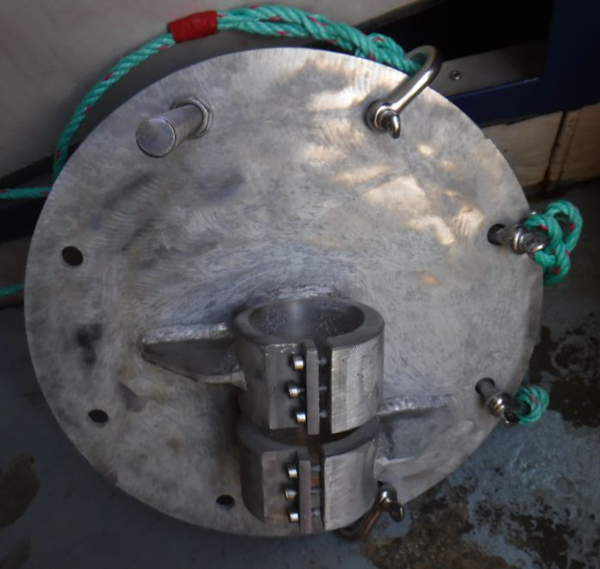  Figure 16: Benthic Camera Plate | 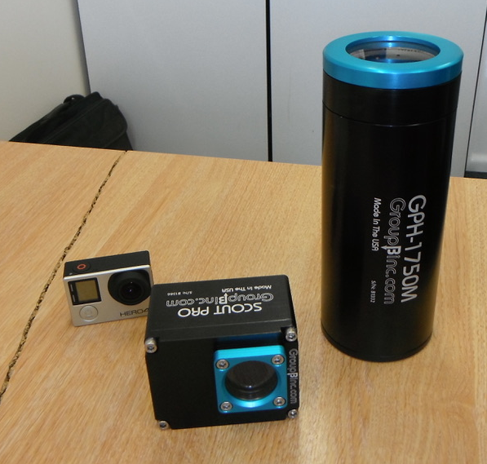  Figure 17: Benthic Camera and Light
Science Team
The science team will be lead by the Company’s general manager, Joost Pompert, who has over 25 years of experience in at sea commercial fisheries science activities. An experienced toothfish/longline observer will be contracted through Capricorn Fisheries Monitoring CC (www.capfish.co.za). A National Observer will also be on board for the duration of the voyage. Factory and hauling crew will be tasked as appropriate.

Post-Survey Science Reporting

The purpose of collecting all the data as outlined above is to meet all the requirements of paragraph 5 of CMM 03-2018, which, inter alia, will advise the SPRFMO Commission on spatial management and sustainable catch levels on the South Tasman Rise.

In the case of shark catches, we will aim to fill two main data gaps as identified in SC6-DW08, namely;

- “Note that the assessment has highlighted that additional work on post capture mortality and gear selectivity of deepwater chondrichthyans would aid future analyses and inform potential future mitigation strategies that would minimise risk associated with susceptibility.”
- “Recommend to the SPRFMO Commission that identification protocols and biological data collection for deepwater chondrichthyans is strengthened for SPRFMO demersal fisheries.”

In the case of VMEs, data will be collected to fill knowledge gaps as identified in Section 6 of SC6-DW09, specifically “Note that insufficient data from bottom longline fisheries exists to develop a data-informed move-on rule for that method”.

- VME data collection will help to develop VME maps for the SPRFMO area as required under paragraph 5(F)(g) of CMM 03-2018.
- Provide data to develop alternative VME threshold methods for demersal longlines such as the incorporation of a biodiversity component, as described in Section 2.6 of SC6-DW09.
- A deep-water video camera will be used to examine species occurrence, density and species / habitat relationships, ), as recommended by the BFIAS. In addition, the real-world impact of demersal longline fishing on VME species and habitats will assessed.
- Environmental data will be collected (Conductivity, Temperature, Depth, Chlorophyll) for predictive modelling purposed (e.g. Maxent), as recommended by the BFIAS.

In addition to the mandatory reporting of data to the SPRFMO Secretariat (CMM 02-2108), analyses of supplementary data and samples collected on this exploratory survey will be treated in the following manner:

Data Analyses | Responsibility | Delivery date
Catch and by-catch data | Georgia Seafoods ltd./SAERI ltd. | 1 month before the next SC meeting
VME mapping/spatial analyses | SAERI ltd. | 1 month before the next SC meeting
Deepwater Camera footage | SAERI ltd. | 1 month before the next SC meeting
DNA samples | Dr. Haseeb Randhawa/Otago University | TBC
Geochemical samples | Oritain Ltd. | TBC
VME and fish samples | Museums Victoria | TBC

The company, in collaboration with their environmental consultants (South Atlantic Environmental Research Institute (SAERI), www.south-atlantic-research.org, based in the Falkland Islands) have been engaged to provide the detail at the next Scientific Committee meeting following the initial survey, providing detail on the presence of the target species, by-catch species, as well as any encounters with VME species. Any fishing impact will be established through the data and imagery collected during this period, and this will be reported on. SAERI employs a benthic ecologist (Dr. Paul Brewin) whom will be leading on the analyses. The toothfish DNA samples will be sequenced at Otago University in Dunedin, New Zealand under contract with Dr. Haseeb Randhawa (https://www.researchgate.net/profile/Haseeb_Randhawa), currently an Honorary Lecturer at Otago University. Otago University has first class facilities for this type of work, and the results will be published in a scientific journal.

Oritain Ltd. have been provided with toothfish samples from other regions in the southern oceans, and will be analysing the geochemical differences between toothfish found on the STR, and those from elsewhere.

Museums Victoria (Melanie Mackenzie, Collection Manager, Marine Invertebrates) has agreed to receive all VME samples for curation and identification.

Museums Victoria (Dr. Martin Gomon, Senior Curator, Ichthyology) has agreed to receive any fish specimens to enhance their coverage of the Australasian region.

References

BFIAS, 2011, SWG-10-DW-01A, Australian report for the South Pacific Regional Fisheries Management Organization (SPRFMO)

Brown J, Brickle P, Scott BE, 2013. Investigating the movements and behaviour of Patagonian toothfish (Dissostichus eleginoides Smitt, 1898) around the Falkland Islands using archival tags satellite linked. Journal of Experimental Marine Biology and Ecology 443 65–74

Marlow TR, Agnew DJ, Purves MG, 2003. Movement and growth of tagged Dissostichus eleginoides around South Georgia and Shag rocks (SUBAREA 48.3) CCAMLR Science, Vol. 10 (2003): 101–111

CCAMLR VME Taxa Classification Guide. 4pp (2009). Commission for the Antarctic Marine Living Resources, Hobart, Tasmania, Australia.

CCAMLR, 2017. https://www.ccamlr.org/en/document/publications/schedule-conservation-measures-force-2017/18.

Collins MA, Brickle P, Brown J & Belchier M, 2010. The Patagonian toothfish: Biology, ecology and fishery. Advances in Marine Biology 58, 227-300.

Fenaughty, J and Cryer, M, 2016. Report on the first year’s fishing under New Zealand’s exploratory fishery for toothfish within the SPRFMO Convention Area. SPRFMO, SC-04-DW-02.

Gerrodette, T. and G. Watters. 2012. The relative impacts of Autolines and Spanish longlines on vulnerable marine ecosystems. CCAMLR, WG-SAM-12/27.

Hanchet S, Dunn A, Parker S, Horn P, Stevens D & Mormede S. 2015. The Antarctic toothfish (Dissostichus mawsoni): biology, ecology, and life history in the Ross Sea region. Hydrobiologia, 361, 374-414.

New Zealand, 2008. Notifications of New Zealand’s intention to conduct exploratory longline fisheries for Dissostichus spp. In the 2008/09 season. CCAMLRXXVII/19. 2008

Sarralde R., L.J López Abellán and S. Barreiro, 2012. Revised research plan for the Spanish exploratory longline fishery for Dissostichus spp. in Divisions 58.4.1 and 58.4.2: Fundamentals and procedures (this is a revision of WG-SAM-12/13). CCAMLR, WG-SAM-12/69.

Sharp Ben R., 2010. Revised impact assessment framework to estimate the cumulative footprint and impact on VME taxa of New Zealand bottom longline fisheries in the Ross Sea region. CCAMLR, WG-SAM-10/20.

Slip, David J., 1995. The diet of southern elephant seals (Mirounga leonina) from Heard Island. Canadian Journal of Zoology, Vol. 73, No. 8, pp. 1519-1528

SPRFMO, 2016. Collaboration between CCAMLR and SPRFMO in respect of Toothfish. SPRFMO SC-04-DW-01.

Welsford, D.C., S.G. Candy, T.D. Lamb, G.B. Nowara, A.J. Constable and R. Williams. 2011. Habitat use by Patagonian toothfish (Dissostichus eleginoides Smitt 1898) on the Kerguelen Plateau around Heard Island and the McDonald Islands. Kerguelen Plateau Symposium. First International Scientific Symposium on the Kerguelen Plateau: Marine Ecosystem and Fisheries: 125–136.

Appendix 1:

By-catch risk assessment for experimental Patagonian toothfish demersal longline fishery: South Tasman Rise, South Pacific Regional Fisheries Management Organization (SPRFMO) Convention Area.

CMM XX
CMM for Exploratory Fishing for Toothfish
in the SPRFMO Convention Area

The Commission of the South Pacific Regional Fisheries Management Organisation;
RECALLING Article 22 of the Convention on the Conservation and Management of High Seas Fishery Resources in the South Pacific Ocean (the Convention) which provides that a fishery that has not been subject to fishing or has not been subject to fishing with a particular gear type or technique for ten years or more shall be opened as a fishery or opened to fishing with such gear type or technique only when the Commission has adopted cautious preliminary Conservation and Management Measures (CMMs) in respect of that fishery and, as appropriate, non-target and associated or dependent species, and appropriate measures to protect the marine ecosystem in which that fishery occurs from adverse impacts of fishing activities;
RECOGNISING Articles 3(1)(a)(i) and (ii) of the Convention, which call on the Commission, in giving effect to the objectives of the Convention, to adopt CMMs that take account of international best practices and protect the marine ecosystem, particularly ecosystems with long recovery times following disturbance;
FURTHER RECOGNISING Articles 3(1)(b) and (2) of the Convention which call on the Commission to apply the precautionary approach and an ecosystem based approach to fishery resources under the mandate of the Convention;
NOTING the conservation value of relevant SPRFMO CMMs which will apply to activities anticipated to be undertaken pursuant to this measure, including, inter alia, CMM 13-2016 (Exploratory Fisheries) on the Management of New and Exploratory Fisheries in the SPRFMO Convention Area, CMM 03-2018 (Bottom Fishing) on the Management of Bottom Fishing in the SPRFMO Convention Area and CMM 09-2017 (Seabirds) on Minimising Bycatch of Seabirds in the SPRFMO Convention Area;
AGREEING that new and exploratory fisheries should not be permitted to expand faster than the acquisition of information necessary to ensure that the fishery can and will be developed in accordance with the principles set out in Article 3 of the Convention;
RECOGNISING Article 22(2) of the Convention, which calls on the Commission to adopt preliminary measures that ensure that any new fishery resource is developed on a precautionary and gradual basis until sufficient information is acquired to enable the Commission to adopt appropriately detailed CMMs;
NOTING the discussions held at the sixth meeting of the Scientific Committee on the proposal from the EU for an exploratory toothfish fishery (SC6-DW02_Rev1);
ADOPTS the following CMM in accordance with Articles 8, 20 and 22 of the Convention:

Objectives
- To allow for exploratory bottom longline fishing for Patagonian toothfish in the Convention Area on a precautionary and gradual basis according to the best available science to meet the following objectives:
- to assess the long term potential for a toothfish fishery in specific zones of the Convention Area for the purpose of providing regular fishery data to the Scientific Committee;
- to evaluate the possible impacts of the fishery on the target stocks, associated or dependent species, and marine ecosystems;
- to evaluate the effectiveness of mitigation measures;
- to provide information on marine mammals, seabirds, turtles, sharks, skates and rays and other species of concern;
- to undertake tagging activities.
Definitions
- For the purposes of this measure:
  - “toothfish” means Patagonian toothfish (Dissostichus eleginoides);
  - “bottom longline” means Spanish long-line system as specified in the CCAMLR Gear Library: WG-FSA-11/53.
Application
- This measure applies to exploratory fishing for toothfish as described in [XX] “European Union Proposal for exploratory bottom longlining for Patagonian toothfish in the SPRFMO Convention Area”.

- None of the obligations in this measure exempt a Member or CNCP from complying with any Convention obligation or any other CMMs adopted by the Commission.

Details and specification of exploratory fishing activities
- Fishing for toothfish, using the bottom longline method, may be conducted in the exploratory fishing research blocks identified in Table 1 below.
Table 1: corner coordinates research blocks A-E, total fishable area 750-2000m in brackets.
Research Block | A (4,454 km²) | B (7,651 km²) | C (9,419 km²)
NW | 47º 15’ S, 146º 30’ E | 47º 15’ S, 147º 30’ E | 47º 15’ S, 148º 30’ E
NE | 47º 15’ S, 147º 30’ E | 47º 15’ S, 148º 30’ E | 47º 15’ S, 150º 00’ E
SE | 48º 15’ S, 147º 30’ E | 48º 15’ S, 148º 30’ E | 48º 15’ S, 150º 00’ E
SW | 48º 15’ S, 146º 30’ E | 48º 15’ S, 147º 30’ E | 48º 15’ S, 148º 30’ E
Research Block | D (4,157 km²) | E (6,337 km²) | A-E total 32,018 km²
NW | 48º 15’ S, 149º 00’ E | 48º 15’ S, 150º 00’ E
NE | 48º 15’ S, 150º 00’ E | 48º 15’ S, 151º 00’ E
SE | 49º 15’ S, 150º 00’ E | 49º 30’ S, 151º 00’ E
SW | 49º 15’ S, 149º 00’ E | 49º 30’ S, 150º 00’ E

- The exploratory fishing shall comprise one exploratory trip of a maximum duration of 21 days which may occur any time between 1 October and 30 November 2019. During this trip, fishing operations shall take place over no more than 21 consecutive days, setting and hauling no more than 120 sets of 5000 hooks per set and with a maximum of 20 sets per research block. Lines shall be set at least 4nm apart from each other, and not set at previous locations. There will be no fishing in depths above 750m and below 2000m.

Total Allowable Catch
- The annual toothfish total allowable catch shall not exceed 45 tonnes (greenweight), unless the Commission revises the TAC at its annual meeting based on advice of the Scientific Committee. This is a precautionary approach, and supports the need to understand other risks like interactions with seabirds, marine mammals or other organisms. Fish that are tagged and returned alive to the sea shall not be counted against this limit. The catch limit of 45 tonnes will allow the collection of a significant amount of scientific information in accordance with the objectives of paragraph 1. Additionally it will also allow for an adequate number of tagged fish to be returned to the sea.

Management Measures
- Fishing pursuant to this measure shall only take place in accordance with [XX] “European Union Proposal for exploratory bottom longlining for Patagonian toothfish in the SPRFMO Convention Area”.

- Catch and effort shall be monitored on a shot-by-shot basis and fishing operations will cease once either the effort or catch limit, whichever occurs first, specified in paragraphs 6 and 7 respectively, has been reached.

- As the catch limit of 45 tonnes is approached, shorter lines shall be set to constrain the retained catch within the limit and the tagging rate will be progressively increased. The company and crew of the proposed vessel shall have experience working to catch limits of 45 tonnes or less and use intensive monitoring of catch retained.

- A minimum overlap statistic of at least 60% once 30 or more Dissostichus of each species shall apply for tag release.

Authorised Vessels
- The FV Tronio shall be authorised to undertake fishing pursuant to this measure. In the event that FV Tronio is unavailable, an alternate vessel of similar capability and capacity shall be authorised by the European Union to undertake fishing pursuant to this measure only after the replacement vessel has been formally notified to the Executive Secretary who will forward that information to all Members and CNCPs.

- In determining the suitability of an alternate vessel the European Union shall consider, inter alia:
  - the vessel’s ability to conduct the exploratory fishing proposed in paper [XX] “European Union Proposal for exploratory bottom longlining for Patagonian toothfish in the SPRFMO Convention Area”;
  - the master and crew’s history and track record in comparable research or exploratory fishing;
  - the ability of the vessel to provide suitable accommodation, facilities, and operating support for observers on-board;
  - the ability of the vessel to comply with the applicable mitigation measures to seabirds and marine mammals;
  - any history of Illegal, Unreported or Unregulated (IUU) fishing by the vessel: consistent with CMM 04-2017 a vessel on the SPRFMO IUU list, or the IUU list of another competent organisation dealing with fisheries management, shall not be accepted as an alternate vessel.

Data Collection
- In undertaking fishing pursuant to this measure the vessel shall collect all the data required by current CMMs including CMM 02-2018 (Data Standards) and CMM 03-2018 (Bottom Fishing) and, to the extent possible, all the data as set out in the paper submitted to the Scientific Committee (SC6-DW02_rev1) and subsequently revised and submitted to the Commission (XX), and any further data requested by the Scientific Committee for its annual evaluation and assessment.

- The vessel shall be fully capable of complying with SPRFMO data standards and reporting and CCAMLR CM 22-07 (2013).

Marine mammals, seabirds, turtles, and other species of concern
- A vessel fishing pursuant to this measure shall use the following mitigation methods:
  - the vessel shall release weights before line tension occurs in line with paragraph 4 of CM 25-01 of CCAMLR;
  - there shall be no dumping of offal while lines are being set or while lines being set or hauled;
  - any offal or discards shall be macerated by machine prior to discarding;
  - discarding shall take place only at the end of a haul or while steaming; and no biological material shall be discarded for at least 30 minutes before the start of any set or during any set;
  - discarding may only take place from the opposite side of the vessel from the hauling position;
  - two bird scaring devises (tori lines) shall be deployed when setting lines and at least one bird exclusion device (BED) shall be used to prevent birds entering the hauling area, to the extent allowed by prevailing weather;
  - in the instance of exceeding trigger level of 0.01 birds/1000 hooks of CMM 09-2017, an evaluation of mitigation measures will be made, including ensuring correct deployment of mitigation, and strengthening mitigation where possible (e.g. further reducing daily hours of setting).
  - as an additional mitigation measure, if turtles are seen in a fishing area, the vessel shall avoid long periods where the line is left motionless in the water column during setting and hauling. If two or more turtles are caught in any Research Block, then the vessel shall move-on towards more southern locations within the research area to avoid known areas of turtle distribution;
  - any seal or cetacean bycatch will trigger a re-evaluation of fishing strategy;
  - the vessel will move-on to the next research block if more than 4 individuals of any of the following families Somniosidae, Lamnidae, Cetorhinidae, Alopiidae are caught or if more than 2 individuals of any one of these families of sharks are caught;
  - the vessel will move-on to another location at least 5nm distant if the skate and ray by-catch exceeds 5% of the Dissostichus spp. catch or a maximum of 100kg in any one haul or set, or if the by-catch of Macrourus spp. reaches 150 kg and exceeds 16% of the catch of Dissostichus spp. in any one haul or set.

- The following information shall be collected for marine mammals, seabirds, turtles, and other species of concern:
  - standardised seabird and marine mammal abundance counts shall be made at the rear of the vessel at the start, middle, end of each event (from set to haul);
  - the observer shall have a target of observing 10% of hooks hauled for marine mammal, seabird and turtle interactions. Where observations take place they will be recorded and stored for analyses and/or reference;
  - all marine mammals, seabirds, turtles, sharks, skates and rays and other species of concern captured shall be identified, and photographs will be taken. Information about birds colliding with the vessel will be recorded and all birds released alive;
  - all dead birds must be retained for formal identification and necropsy;
  - opportunistic observations, photography and identification of marine mammals may be undertaken in collaboration with the crew.
- All information specified in CMM 03-2018 (Bottom Fishing) relating to bottom fisheries and all data necessary to assess encounters with VMEs shall be collected to enable assessment and monitoring of the distribution of marine ecosystem in the areas fished.

VME
- In accordance with paragraph 8 h) of CMM 03-2017, the flag State shall require FV Tronio to cease bottom fishing activities within five nautical miles of any location where evidence of a VME is encountered in the course of fishing activities, and to report the encounter, so that appropriate conservation measures can be adopted in respect of the relevant site.

- Until the SC has developed advice on SPRFMO threshold limits, if 10 or more VME indicator units are recovered in one-line segment, the flag state shall require FV Tronio to complete hauling any lines intersecting with the Risk Area without delay and not to set any further lines intersecting with the Risk Area.

- No move-on rule will be applicable because, under normal fishing operations, all lines will be set at minimum 4nm apart (measured from the mid-point of the line) as part of the Fisheries Operation Plan.

Monitoring
- A vessel undertaking fishing pursuant to this measure shall carry a scientific observer on-board, as well as a dedicated assistant experienced in at-sea scientific data collection to assist the observer with biological measurement and data collection. Observer data shall be collected in accordance with the SPRFMO Observer data standard and shall include gear deployment and retrieval data, catch and effort information, biological data collection, and information on marine mammals, seabirds, reptiles and other species of concern.

- The scientific observer shall examine the existence of the target species in the research area and evaluate the possible impacts of the exploratory fishery on the target stock, associated or dependent species, and marine ecosystems. The scientific observer shall also record encounters with VMEs and evaluate the effectiveness of related mitigation measures and as well as the mitigation measures for marine mammals, seabirds, turtles, sharks, skates and rays and other species of concern.

- The vessel shall also be equipped with several tamperproof Automatic Location Communicators that meet SPRFMO standards for VMS reporting (every hour) and can respond to polling at any rate if required.

Review
- This CMM shall expire following the regular meeting of the Commission in October 2020.

- The exploratory fishery to which this CMM applies may be extended through the development of a new CMM pursuant to CMM 13-2016 (Exploratory Fishing) to be considered by the Commission.

- Fishing activity undertaken pursuant to this measure will not be considered to be a precedent for future allocation decisions.

A 2% variation in number of hooks set may be expected for operational reasons. This detail will be recorded.
Also referred to as demersal longline.

