2013 jack mackerel stock assessment

Introduction
This document and content is based on discussions analyses conducted at the SC-01 meeting. Changes in the data used compared to the 2012 assessment include new age compositions for the acoustic surveys from the northern area of Chile, updates on the main abundance indices as (CPUE of Chile, China, the EU, Peru) and updates on the acoustic survey from Peru. Model modifications relative to the most recent assessment are presented below and mainly involve how selectivity was allowed to vary over time and how different data sets were weighted in model fitting.

Scientific name and general distribution
The Chilean Jack mackerel (Trachurus murphyi, Nichols 1920) is widespread throughout the South Pacific, along the shelf and oceanic waters adjacent to Ecuador, Peru, and Chile, and across the South Pacific along the Subtropical Convergence Zone in what has been described as the “Jack mackerel belt” that goes from the coast of Chile to New Zealand within a 35º to 50º S variable band across the South Pacific.

Main management units
At least five management units of T. murphyi associated to distinct fisheries are identified in the SE Pacific: the Ecuadorian fishery, which is managed as part of a more general pelagic fishery within the Ecuadorian EEZ; the Peruvian fishery, which is managed as part of a Jack mackerel, mackerel and sardine fishery directed exclusively for direct human consumption taking place almost entirely within the Peruvian EEZ; the northern and the central-southern Chilean fisheries which are managed as separate management units, with the northern fishery being mostly within Chilean EEZ and the central-southern Chilean fishery which straddles the Chilean EEZ and the adjacent high sea; and, the purely high sea fishery which is a multinational fishery being managed entirely within the context of the SPRFMO. At present there is no directed fishery for T. murphy in the central and western South Pacific and around New Zealand, where if any, incidental catches are very small.

Stock structure
There are a number of competing stock structure hypotheses, and up to five and more separate stocks have been suggested: i) a Peruvian stock (northern stock) which is a straddling stock with respect to the high seas; ii) a Chilean stock (southern stock) which is also a straddling stock with respect to the high seas; iii) a central Pacific stock which exists solely in the high seas; iv) a southwest Pacific stock which exist solely in the high seas; v) and, a New Zealand-Australian stock which straddles the high seas and both the New Zealand and Australian EEZs. Regarding specifically the eastern and central South Pacific, the SPRFMO has identified the following four alternative stock structure working hypothesis: 1) Jack mackerel caught off the coasts of Peru and Chile each constitute separate stocks which straddle the high seas; 2) Jack mackerel caught off the coasts of Peru and Chile constitute a single shared stock which straddles the high seas; 3) Jack mackerel caught off the Chilean area constitute a single straddling stock extending from the coast out to about 120°W; and, 4) Jack mackerel caught off the Chilean area constitute separate straddling and high seas stocks.
Accordingly, the Jack Mackerel Sub-group (JMSG) of the Science Working Group (SWG) of the SPRFMO at its 11th Session (SWG-11) carried out parallel assessments of the Jack mackerel stock(s) in the Eastern South Pacific under the two main working hypothesis already identified. That is: that Jack mackerel caught off the coasts of Peru and Chile each constitute separate stocks (Peruvian or northern and Chilean or southern stocks - hypothesis 1) which straddle the high seas; and, that Jack mackerel caught off the coasts of Peru and Chile constitute a single shared stock (hypothesis 2) which straddles the high seas. In following up on the SWG-11 recommendations, the SPRFMO Commission at its 1st Commission Meeting requested the newly established Scientific Committee to continue the work on evaluating alternative hypotheses on Jack mackerel stock population and, pending more conclusive findings on the stock population structure of Jack mackerel, the Commission requested the Scientific Committee (SC) to continue and expand the stock assessment work under both the stock hypotheses considered in the 11th SWG Meeting, and this is one of the main tasks for its 1st Session (SC-01) in La Jolla, 21-27 October 2013.

Fishery
The fishery for jack mackerel in the south-eastern Pacific is conducted by fleets from the coastal states (Chile, Peru and Ecuador), and by distant water fleets from various countries, operating beyond the EEZ of the coastal states.
The fishery by the coastal states is done by purse seiners. The largest fishery exists in Chile, where the fish are used mainly for the production of fish meal. In Peru, the fishery is variable from year to year. Here the fish is taken by purse seiners that also fish for anchovy. According to government regulations, the horse mackerel in Peru may only be used for human consumption. Ecuador constitutes the northern fringe of the distribution of jack mackerel. Here the fish only occur in certain years, when the local purse seiners may take substantial quantities (80 000 tons in 2011). Part of the catch is processed into fish meal but recently horse mackerel has been promoted to be used for human consumption.
The distant water fleets operating outside the EEZs are from a number of countries including China, Korea, Taiwan, Japan, Russia, Vanuatu, Netherlands, Germany and Lithuania. These fleets consist exclusively of pelagic trawlers that freeze the catch for human consumption. In the 1980s a large fleet from Russia and other Eastern European countries operated as far west as 130° W. After the economic reforms in the communist countries around 1990, the fishery by these countries in the eastern Pacific was halted. It was not until 2003 that foreign trawlers re-appeared in the waters outside the EEZ of the coastal states.
The fishery for horse mackerel is generally a mono-specific fishery. In the offshore fishery the catch consists for 90 – 98% of jack mackerel, with minor by-catches of chub mackerel (Scomber japonicus) and Pacific bream (Brama australis).
The development of the catches of horse mackerel in the eastern Pacific is shown in Table A5.1.

Management
Jack mackerel were managed by coastal states beginning in the mid-1990s. National catch quota for jack mackerel were introduced by Peru in 1995 and by Chile in 1999. Peru introduced a ban on the use of jack mackerel for fish meal in 2002. For the international waters, the first voluntary agreement on limitation of the number of vessels was introduced in 2010. Starting from 2011, catch quota for jack mackerel were introduced for all countries fishing in eastern Pacific.

Information on the environment in relation to the fisheries
Peru is currently using the Coastal El Niño Index (ICEN, from Indice Costero de El Niño) to describe the short-term variability of the environment. Data to calculate this index on a monthly basis is available from 1950 to date. According to this index, 2013 is a year characterized by the presence of La Niña event.
Large-scale variability has also been observed and analyzed, especially with respect to changes in water masses dynamics and depth of the 15⁰C isotherm between 1961 and 2013. These variables influence the spatial distribution Jack mackerel, and probably in the long run also influence its availability and abundance. The various environmental and biological signals contribute to explain the drastic decline in abundance towards the end of the 1990s implied by the results of the acoustic estimates, which took place in the absence of a significant fishing pressure and very low catches in the 1980s and 1990s. Long-term changes in the distribution pattern of the Sea Surface Temperature in Peruvian waters have by themselves noticeable impacts on the Peruvian Jack mackerel stock, as suggested by the tight parallelism between the decline of the area covered by warm isotherms (22°C-25°C) and the acoustic biomass estimates since mid-1990s.

Reproductive biology
The main spawning season happens from October to December; however spawning has been described to occur from July to March. Gonadosomatic index and eggs surveys are the source of information to describe the time of spawning

Data used in the assessment

Fishery data
The catch data for the model sums values from Table A5.1 and forms four “fleets” which are intended to be consistent with the gear and general areas of fishing (Figure A5.1). These are presented in Table A5.2.
Length data are available from all major fisheries both inside and outside the EEZs. Length distributions from Chile and the international fleet are converted into age distributions using Chilean age-length keys. These data are shown in Tables A5.3, A5.4, and A5.5. For Peruvian and Ecuadorian catches, catch-at length compositions are used (Table A5.6).
Several CPUE data series are used in the model. For the Chilean purse seiner fleet, “General Linear Models” (GLM; McCullagh & Nelder, 1989) were used to standardize the CPUE. Following this approach, CPUE is predicted as a linear combination of explanatory variables, and the ultimate objective is to estimate the annual effect. A normal delta and delta gamma models were assessed (Pennington, 1983; Ortiz y Arocha, 2004), which models separately the positive tows from the number of catch successes, where the index is obtained as the product between the proportion of positive tows and the index estimated for the rates of fishing with catch (Lo et al, 1992). A deviance analysis was conducted to assess the importance of each main effect. Factors in the GLM included year, quarter, zone and the vessel hold capacity. Effort units were computed as the number of days of a trip multiplied by the vessel hold capacity. The rationale being that trip duration can serve as a proxy for search time.
The Chinese CPUE was standardized using a GLM and updated earlier studies. This series was included as an index of exploitable biomass for offshore fleet. As from previous assessments, the Russian time series of CPUE was included but with low weight since it remains unstandardized. Also, for the international trawler fleet, a CPUE series for the EU fleet was used with an updated value for 2013.

Fisheries independent data
China has a system of observers onboard fishing vessels that, among others, collect data on environmental variables (wind direction and speed, SST, etc.) in the fishing grounds. Although this data is not available at the moment, it might be in the future.
In Chile the Jack mackerel research program includes stock assessment surveys using hydroacoustics and the daily egg production method (DEPM). For the northern region (XV-III) data on acoustic biomass and number and weight at age are available from 2006 to 2012 on a yearly basis. For the central-southern regions (V-X), these data are available from 1997 to date. Besides that, for the central-southern regions there are estimates of abundance and numbers at age based on DEPM for the years 2001, 2003, 2004, 2005, 2006, 2008.
In Peru the Jack mackerel research programme includes egg and larvae surveys and hydroacoustic stock assessment surveys. Results of these egg and larvae surveys provide information on the spatial and temporal variability of Jack mackerel larvae along the Peruvian coast from 1966 to-date. Acoustic biomass estimates of Jack mackerel are available from 1983 to-date. Because these surveys have the Peruvian anchoveta as the main target, data only covers the first 80 miles and eventually 100 miles from the coast. Corrections to compensate for this partial coverage of acoustic biomass estimates of Jack mackerel are being made by using an environmental index describing the potential habitat of this species based available data on Sea Surface Temperature (SST), Sea Surface Salinity (SSS), water masses (WM), oxycline depth (OD) and chlorophyll (CHL), since 1983 to the present on monthly basis.
Acoustic surveys, to estimate the biomass and distribution of Jack Mackerel, have been conducted along the Chilean coast, inside and outside of the EEZ and in the Peruvian EEZ, using scientific vessels and well-equipped vessels from the commercial fleet. The available acoustic estimates time series extends from 1984 to 2012. (depending on the area).
Eggs survey (through the Daily Egg Production Method), to estimate the abundance of the spawning stock, were conducted on an annual basis from 1999 to 2008 along the central zone of the Chilean coast. Acoustic estimates and egg survey results are used as relative abundance indices to fine-tune the stock assessment model.
There was a compilation of length compositions (partial results 2013) for countries that don’t have age compositions (China, Vanuatu and Korea). A weighted frequency was done as a representative of offshore fleet. The age conversion for these fleets was done considering age-length keys of central-south area of Chile. A similar procedure was applied considering the information since 2000 for all offshore fleets that have operated off Chile.
In 2012, the conversion of length composition (to age) from Peru and Ecuador was developed. Fishery length compositions (total length since 1980, converted to fork length) were included.
A new series of acoustic biomass was provided by Peru for years 1986-2013. This series represents estimations based on the assumption of shifts in habitat area and its impact over traditional estimations.
All CPUE (and fishery-independent) series used in the model are presented in Table A5.7.

Biological parameters
The maturity-at-age was updated based on a Chilean study (reference). The application of these results reduced the age at first reproduction by about one year, to 2-3 years from the 3-4 years used previously. Maturity at length was consistently observed with L50 at about 23 cm FL. These values, and those for the far-north stock, are shown in A5.8.
To fit the length composition data from the far-north fleet, a growth curve was used to convert age compositions to predicted lengths in the model. The value for the von Bertalanfy growth parameters are given in Table A5.9.
In Chile the mean weight at age is calculated by year taken the mean length at age in the catch and a length-weight relationship of the year. In previous year the same weight at age matrix was used for the Northern Chilean Fleet (Fleet 1) and Southern Chilean Fleet (Fleet 2). This year a weight at age matrix specific for Northern Chile has been applied. The method uses two information sources: the length-age keys and the parameters of weight-at-length relationship from IFOP’s monitoring program of the Chilean fisheries. The information was separated in two zones which correspond to fishing areas (and acoustic surveys) occur in Chile. Annual weight-at-length relationship was fitted to the data by each fleet independently and these relationships were applied to mean length at-age within each zone. The information covers the period 1974-2013; for earlier years the weight at age from 1974 was used. The four weight at-age matrices correspond to: north fleet, central-south fleet, north acoustic survey, and central-south acoustic survey. These are shown in Tables A5.10 - A5.13.
The estimate of natural mortality (0.23) is derived from Pauly´s method using the Gili growth function. This value is assumed to be the same for all ages and all years.

Data sets
A summary list of all data available for the assessment is provided in Table A5.14.

Description of assessment model
A statistical catch-at-age model was used to evaluate the jack mackerel stocks. The JJM (“Joint Jack Mackerel Model”) is implemented on ADMB and considered different types of information, which corresponds to the available data of the jack mackerel fishery in the South Pacific area since 1970 to 2013.
The JJM model is an explicit age-structured model that uses a forward projection approach and maximum likelihood estimation to solve for model parameters. The operational population dynamics model is defined by the standard catch equation with various modifications such as those described by Fournier and Archibald (1982), Hilborn and Walters (1992) and Schnute and Richards (1995). This model was adopted as assessment method in 2010 after several technical meetings (http://www.southpacificrfmo.org/jack-mackerel-sub-group/).

JJM developments
Since its adoption, the JJM model has been improved by participating scientists. The most noted change has been options to include length composition data (and specifying or estimating growth) and the capability to estimate natural mortality by age and time. The model is now more flexible and permits to use catch information either at age or size for any fleet, and incorporate explicitly regime shifts in population productivity.
The model can be considered to consist of several components, (i) the dynamics of the fish population; (ii) the fishery dynamics; (ii) observation models for the data; and (v) parameter estimation procedure.
Population dynamics: the recruitments are considered to occur in January while the spawning season is considered as instantaneous process at mid of November. The population’s age comps considers individual from 1 to 12+ yrs old, and a stochastic relationship (Beverton & Holt) between recruits and spawners is included. The survivors follows the age-specific mortality composed by fishing mortalities at-age by fleet and the natural mortality, the latest one supposed to be constant over time and ages. The model is spatially aggregated except that the fisheries are geographically distinct. The initial population is based on an equilibrium condition and occurs in 1958 (12 years prior to the model start in 1970).
Fishery dynamics: The interaction of the fisheries with the population occurs through fishing mortality. Fishing mortality is assumed to be a composite of several separable processes – selectivity (by fleets), which describes the age-specific pattern of fishing mortality; catchability, which scales fishing effort to fishing mortality; and effort deviations, which are a random effect in the fishing effort − fishing mortality relationship. The selectivity is non-parametric and assumed to be fishery-specific and time-variant. For the northern area, the selectivity follows a dome form, while for the southern fisheries an asymptotic slightly form is considered. The catchability is fix by index and is estimated in nine abundance indexes. However and for some of these, like acoustic biomass from Peru and Chile (south), and the CPUE of southern area of Chile, have been considered some time variations.
Observation models for the data: There are five data components that contribute to the log-likelihood function − the total catch data, the age-frequency data, the length-frequency data and the abundance indexes data. The observed total catch data are assumed to be unbiased and relatively precise, with the CV of residuals being 0.05.
The probability distributions for the age and length-frequency proportions are assumed to be approximated by multinomial distributions. Sample size is specified to be different by gear but constant over years. Total catch data by fishery (4) and abundance indexes (9), a log-normal assumption has been assumed with constant CV but different by fishery.
- Parameter estimation: The model parameters were estimated by maximizing the log-likelihoods of the data plus the log of the probability density functions of the priors and smoothing penalties specified in the model. Estimation was conducted in a series of phases, the first of which used arbitrary starting values for most parameters. The model has been implemented and compiled in ADMB and whose characteristics can be consulted in Fournier et al (2012)

Model details
Parameters estimated conditionally are listed in Table A5.15. The most numerous of these involve estimates of annual and age-specific components of fishing mortality for each year from 1970-2012 and each of the four fisheries identified in the model. Parameters describing population numbers at age 1 in each year (and years prior to 1970 to estimate the initial population numbers at ages 1-12+) were the second most numerous type of parameter.
The table of equations for the assessment model is given in Tables A5.16 and A5.17. Table A5.18 contains the initial variance assumptions for the indices and age and length compositions.
The treatment of selectivities and how they are shared among fisheries and indices are given in Table A5.19, A5.20 and A5.21. Also depending on the model configuration, some growth functions were employed inside the model to convert length compositions to age compositions. Initial variance assumptions and

Models for stock structure hypothesis
During SWG 11, two types of population structure were evaluated and this was continued for SC-01 evaluations. The following table summarizes these hypotheses with cross reference to models presented Table A5.22:
Model reference | Stock/Hypothesis | Fleets | Considerations
2.xN | Northern Stock  (Hypothesis #1, FAO 2008) | Far north | This considers the hypothesis that the Peruvian and Ecuadorian fishery information come from the same population and it’s independent of the southern stock, principally fished by the Chilean fleet.
2.xS | Southern Stock  (Hypothesis #1 and #3, FAO 2008) | Northern  Central-South Offshore fleet | This considers the hypothesis that the fishery information from Chile and those international fleets that operate offshore off EEZ Chile come from the same population, whose it’s independent of the northern stock, principally fished by the Peruvian fleet.
0.x,  1.x  3.x  4.x | A single stock  (Hypothesis #2, FAO 2008) | All fleets | This considers the hypothesis that the northern and southern stock correspond to a single population unit.

Description of exploratory assessments

Description of key changes from base case assessment to exploratory assessment
As a progression of sensitivities of Model 0.4, there were different approaches to consider catchability (q) changes in 2012 and 2013 in the Chilean CPUE (Model 1.1) and the Peruvian acoustic catchability changes from 1994 (Model 1.2). Then, time-varying selectivity changes were introduce for the South Central Chilean fishery (Model 1.3) and because of the improvement in the adjustments, time- varying selectivity changes were considered for the other fleets. There were exercises, increasing variability in the recruitments (Sigma R=1.0 , Model 1.5) and down weighting indices (Models 1.6, 1.7 and 1.9) and also estimating natural mortality (M; Model 1.9). Same model configurations that were used to the single stock hypothesis were implemented as a mirror in Models 2.1 to 2.9 but considering differences in M between areas (M=0.33 and growth function for the Far North model, and M=0.23 for the Southern model). As noted above, these model configurations are summarized in Table A5.22.
Results of exploratory assessments evaluate these, the negative-log likelihood components were presented to evaluate trade-offs between different data components and model assumptions.

Assessment results
During the meeting a series of alternatives were examined. To evaluate these, the negative-log likelihood components were presented to evaluate trade-offs between different data components and model assumptions (Table A5.23). It is important to note that some values in this table for some subsets of models cannot be compared across models because some models introduce new data (i.e., the revised acoustic survey index for Peru). Also, comparison between models with different stock structure hypotheses (i.e., those identified with 2.0-2.9) require consideration of the number of parameters.
For projection purposes, alternative considerations about recruitment regimes and productivity were configured as Models 4.1-4.4. Based on results over all models and sensitivities including ageing error, Model 4.1 (which is identical to 3.1) was selected as the base case for assessment results.
Results comparing the impact of new data (models 0.0-0.4) show that for the starting model configuration, the biomass trend was a bit more gradual and recruitment varied more as all the data were included (Figure A5.2). For the alternative model configurations the range of uncertainty was reasonably broad for the recent trend in spawning biomass but overall the patterns were quite similar (Figure A5.3). The rationale for selecting model 1.4 among these was due to the improved fit to the data and a broader representation of the uncertainty among indices and age compositions. The other alternative configurations (models 1.1-1.9) were largely consistent (except for 1.8 in which an unrealistically high value of M was estimated). Comparing model 1.4 with the alternative stock structure indicated that the “south” model (2.4_S) was very similar to the combined stock-structure model (1.4; Figure A5.4). Comparing the recruitment patterns in this figure, it appears that the far-north model some synchrony in recruitment except for in 1990 and a few other years. This may be due to divergent environmental conditions and may lend some support to the two-stock hypothesis.
Fishery catch fits are shown in Figure A5.5 and mean weight-at-age assumed for this model is shown in Figure A5.6. The model numbers-at-age estimates are given in Table A5.24. The fishery age and length composition fits are shown in Figures A5.7, A5.8, A5.9, and A5.10. The age composition data from the surveys are given in Figures A5.11 and A5.12. This model fit the indices reasonably well (Figure A5.13). Fits to the index and fishery mean age compositions are shown in Figures A5.14, and A5.15.
Selectivity estimates for the fishery and indices is shown over time in Figs. A5.16 and A5.17 respectively. A summary of the time series stock status (spawning biomass, F, recruitment, total biomass) is shown in Fig. A5.18. The immature component of the stock appears to be increasing in since about 2008 and the mature component of the stock has also begun to show signs of stabilization and possibly an increase (Fig. A5.19). As in past years, the biomass can be projected forward based on the estimated recruits (with an adjustment due to the change in spawning biomass through the stock recruitment relationship) to evaluate the impact of fishing. This can be informative to distinguish environmental effects relative to direct fishing impacts. For jack mackerel fishing has appeared to be a major cause of the population trend with the current level at below 20% of what is estimated to have occurred had there been no fishing (Fig. A5.20).
Fishing mortality rates at age (combined fleets) were relatively high starting in about 1992 but has declined in the past few years (Fig. A5.21; Table A5.25.). The stock recruitment relationship appears to be consistent with the fixed value of steepness assumed (0.8; Fig. A5.22). In order to evaluate the potential for alternative “regimes”, stock recruitment curves were estimated over different periods and found that within the current period (2000-2012) the level of expected recruitment was considerably lower than the alternatives (Fig. A5.23).

Management advice

Projections and risk analysis
Considering the actual population status of jack mackerel, the subgroup recommended examining constant fishing mortality scenarios with current levels (F₂₀₁₃) and at 125%, 75%, 50%, and 0% (no catch). The recruitments were projected considering a stock-recruitment relationship adjusted from 2000 to 2011, which represents a low productivity period that has characterized the population condition in the most recent years (Figure A5.23). The uncertainty was measured considering the probability to reduce the spawning biomass in the next 20 yrs (approximated by propagating process—i.e., recruitment variability) and parameter errors forward within the assessment model). As a tentative risk criterion, the SC selected a fishing level considered robust over the alternative models evaluated while ensuring with reasonable probability (>90%) that future spawning biomass would rebuild to the provisional B_{MSY} (5.5 million t) under the long-term average recruitment scenario.
Therefore projections at or below 2013 fishing effort levels are expected to improve the likelihood of spawning biomass increasing from the 2013 2.8 million t. Corresponding catches for 2014 are thus 440,000 t or lower. Fishing effort in the next 20 years at or below 2013 levels are projected to have a high probability of resulting in spawning stock increases under most projections (Figure A5.24).

Assessment issues
Please write this section then delete this comment.
- Describe the difference in predictions from last years assessment with the new fits
- Describe the quality of the data that went into the assessment
- Describe potential points of improvement on the data and methods (for next year)

A5. References
Needs updating
Gavaris, S., Ianelli, J. N., 2001. Statistical issues in fisheries stock assessment. Scand. J. Statistics: Theory and Appl., 29, 245-272.
Gang Li, Xiaorong Zou, Yinqi Zhou & Lin Lei. Update Standardization of CPUE for Chilean Jack Mackerel (Trachurus murphyi) from Chinese Trawl Fleet. SWG-11-JM-08, 2011. 11th Meeting of the Science Working Group, Lima, Perú.
Gili, R., L. Cid, V. Bocic, V. Alegría, H. Miranda & H. Torres. 1995. Determinación de la estructura de edad del recurso jurel. In: Estudio biológico pesquero sobre el recurso jurel en la zona centro-sur, V a IX Regiones. Informes Técnicos FIP/IT-93-18.
Kochkin, P.N., 1994. Age determination and estimate of growth rate for the Peruvian jack mackerels, Trachurus symmetricus murphyi. J. of Ichthyol. 34(3): 39-50.
Leal, E., E. Diaz & J.C. Saavedra, 2011. Reproductive Timing and Maturity at Length and Age of Jack Mackerel Trachurus murphyi, in the Chilean Coast SWG-11-JM-07, 2011. 11th Meeting of the Science Working Group, Lima, Perú.
Saavedra J.C, L. Caballero & C. Canales, 2011. Analysis of the CPUE in the Jack Mackerel Fishery in centre-southern Chile. SWG-11-JM-06. 11th Meeting of the Science Working Group, Lima, Perú.
Serra R. and C. Canales 2009. Short review of some biological aspects of the Chilean jack mackerel, trachurus murphyi. Working Paper SP-07-SWG-JM-SA-05. Jack Mackerel Stock Assessment Methods Workshop. Lima, Peru.

A5. Tables

Table A5.1. Sources and values of catch (t) compiled for the four fleets used for the assessment.
 | Fleet 1 | Fleet 2 | Fleet 3 (Far North) |  |  |  |  |  | Fleet 4 (Offshore Trawl)
Year | N Chile | Chile CS | Cook Islands | Cuba  (2) | Ecuador  (ANJ) | Peru  (ANJ) | USSR | Subtotal | Belize | China | Cuba | European  Union | Faroe  Islands | Japan | Korea | Peru | Russia/  USSR | Ukraine | Vanuatu | Subtotal | Total
1970 | 101685 | 10309 |  |  |  | 4711 |  | 4711 |  |  |  |  |  |  |  |  |  |  |  | 0 | 116705
1971 | 143454 | 14988 |  |  |  | 9189 |  | 9189 |  |  |  |  |  |  |  |  |  |  |  | 0 | 167631
1972 | 64457 | 22546 |  |  |  | 18782 |  | 18782 |  |  |  |  |  |  |  |  | 5500 |  |  | 5500 | 111285
1973 | 83204 | 38391 |  |  |  | 42781 |  | 42781 |  |  |  |  |  |  |  |  |  |  |  | 0 | 164376
1974 | 164762 | 28750 |  |  |  | 129211 |  | 129211 |  |  |  |  |  |  |  |  |  |  |  | 0 | 322723
1975 | 207327 | 53878 |  |  |  | 37899 |  | 37899 |  |  |  |  |  |  |  |  |  |  |  | 0 | 299104
1976 | 257698 | 84571 |  |  |  | 54154 |  | 54154 |  |  |  |  |  | 35 |  |  |  |  |  | 35 | 396458
1977 | 226234 | 114572 |  |  |  | 504992 |  | 504992 |  |  |  |  |  | 2273 |  |  |  |  |  | 2273 | 848071
1978 | 398414 | 188267 |  |  |  | 386793 | 0 | 386793 |  |  |  |  |  | 1667 | 403 |  | 49220 |  |  | 51290 | 1024764
1979 | 344051 | 253460 |  | 6281 |  | 151591 | 175938 | 333810 |  |  | 12719 | 1180 |  | 120 |  |  | 356271 |  |  | 370290 | 1301611
1980 | 288809 | 273453 |  | 38841 |  | 123380 | 252078 | 414299 |  |  | 45130 | 1780 |  |  |  |  | 292892 |  |  | 339802 | 1316363
1981 | 474817 | 586092 |  | 35783 |  | 37875 | 371981 | 445638 |  |  | 38444 |  |  | 29 |  |  | 399649 |  |  | 438123 | 1944670
1982 | 789912 | 704771 |  | 9589 |  | 50013 | 84122 | 143724 |  |  | 74292 | 7136 |  |  |  |  | 651776 |  |  | 733204 | 2371611
1983 | 301934 | 563338 |  | 2096 |  | 76825 | 31769 | 110690 |  |  | 52779 | 39943 |  | 1694 |  |  | 799884 |  |  | 894300 | 1870262
1984 | 727000 | 699301 |  | 560 |  | 184333 | 15781 | 200674 |  |  | 33448 | 80129 |  | 3871 |  |  | 942479 |  |  | 1059927 | 2686902
1985 | 511150 | 945839 |  | 1067 |  | 87466 | 26089 | 114622 |  |  | 31191 |  |  | 5229 |  |  | 762903 |  |  | 799323 | 2370934
1986 | 55210 | 1129107 |  | 66 |  | 49863 | 1100 | 51029 |  |  | 46767 |  |  | 6835 |  |  | 783900 |  |  | 837502 | 2072848
1987 | 313310 | 1456727 |  | 0 |  | 46304 | 0 | 46304 |  |  | 35980 |  |  | 8815 |  |  | 818628 |  |  | 863423 | 2679764
1988 | 325462 | 1812793 |  | 5676 |  | 118076 | 120476 | 244229 |  |  | 38533 |  |  | 6871 |  |  | 817812 |  |  | 863215 | 3245699
1989 | 338600 | 2051517 |  | 3386 | 35108 | 140720 | 137033 | 316247 |  |  | 21100 |  |  | 701 |  |  | 854020 |  |  | 875821 | 3582185
1990 | 323089 | 2148786 |  | 6904 | 4144 | 191139 | 168636 | 370823 |  |  | 34293 |  |  | 157 |  |  | 837609 |  |  | 872059 | 3714757
1991 | 346245 | 2674267 |  | 1703 | 45313 | 136337 | 30094 | 213447 |  |  | 29125 |  |  |  |  |  | 514534 |  |  | 543659 | 3777618
1992 | 304243 | 2907817 |  | 0 | 15022 | 96660 | 0 | 111682 |  |  | 3196 |  |  |  |  |  | 32000 | 2736 |  | 37932 | 3361674
1993 | 379467 | 2856777 |  |  | 2673 | 130681 |  | 133354 |  |  |  |  |  |  |  |  |  |  |  | 0 | 3369598
1994 | 222254 | 3819193 |  |  | 36575 | 196771 |  | 233346 |  |  |  |  |  |  |  |  |  |  |  | 0 | 4274793
1995 | 230177 | 4174016 |  |  | 174393 | 376600 |  | 550993 |  |  |  |  |  |  |  |  |  |  |  | 0 | 4955186
1996 | 278439 | 3604887 |  |  | 56782 | 438736 |  | 495518 |  |  |  |  |  |  |  |  |  |  |  | 0 | 4378844
1997 | 104198 | 2812866 |  |  | 30302 | 649751 |  | 680053 |  |  |  |  |  |  |  |  |  |  |  | 0 | 3597117
1998 | 30273 | 1582639 |  |  | 25900 | 386946 |  | 412846 |  |  |  |  |  |  |  |  |  |  |  | 0 | 2025758
1999 | 55654 | 1164035 |  |  | 19072 | 184679 |  | 203751 |  |  |  |  |  | 7 |  |  |  |  |  | 7 | 1423447
2000 | 118734 | 1115565 |  |  | 7121 | 296579 |  | 303700 |  | 2318 |  |  |  |  |  |  |  |  |  | 2318 | 1540317
2001 | 248097 | 1401836 |  |  | 134011 | 723733 |  | 857744 |  | 20090 |  |  |  |  |  |  |  |  |  | 20090 | 2527767
2002 | 108727 | 1410266 |  |  | 604 | 154219 |  | 154823 |  | 76261 |  |  |  |  |  |  |  |  |  | 76261 | 1750077
2003 | 143277 | 1278019 |  |  | 0 | 217734 |  | 217734 |  | 94690 |  |  |  |  | 2010 |  | 7540 |  | 53959 | 158199 | 1797229
2004 | 158656 | 1292943 |  |  | 0 | 187369 |  | 187369 |  | 131020 |  |  |  |  | 7438 |  | 62300 |  | 94685 | 295443 | 1934411
2005 | 165626 | 1264808 |  |  | 0 | 80663 |  | 80663 | 867 | 143000 |  | 6179 |  |  | 9126 |  | 7040 |  | 77356 | 243568 | 1754665
2006 | 155256 | 1224685 |  |  | 0 | 277568 |  | 277568 | 481 | 160000 |  | 62137 |  |  | 10474 |  | 0 |  | 129535 | 362627 | 2020136
2007 | 172701 | 1130083 | 7 |  | 927 | 254426 |  | 255360 | 12585 | 140582 |  | 123511 | 38700 |  | 10940 |  | 0 |  | 112501 | 438818 | 1996962
2008 | 167258 | 728850 | 0 |  | 0 | 169537 |  | 169537 | 15245 | 143182 |  | 106665 | 22919 |  | 12600 |  | 4800 |  | 100066 | 405477 | 1471122
2009 | 134022 | 700905 | 0 |  | 1935 | 74694 |  | 76629 | 5681 | 117963 |  | 111921 | 20213 | 0 | 13759 | 13326 | 9113 |  | 79942 | 371918 | 1283474
2010 | 169012 | 295796 | 0 |  | 4613 | 17559 |  | 22172 | 2240 | 63606 |  | 67749 | 11643 | 0 | 8183 | 40516 |  |  | 45908 | 239845 | 726825
2011 | 30825 | 216470 | 0 |  | 69153 | 257241 |  | 326394 | 0 | 32862 | 8 | 2248 | 0 | 0 | 9253 | 674 | 8229 |  | 7672 | 60946 | 634635
2012 | 16208 | 211252 | 0 |  | 104 | 168779 |  | 168883 | 0 | 13012 | 0 | 0 | 0 | 0 | 5492 | 5290 | 0 |  | 16068 | 39862 | 436205
2013 | 31000 | 211013 | 0 |  | 2477 | 50000 |  | 52477 |  | 10000 |  | 8992 |  |  | 5054 | 3772 |  |  | 19412 | 47230 | 341720
Underlined figures have been updated; The 2013 figures are the best catch estimates for the entire year.

Table A5.2. Input catch by fleet (combined) for the stock assessment model. Note that 2013 data are preliminary.
 | Fleet 1 | Fleet 2 | Fleet 3 | Fleet 4
1970 | 101,685 | 10,309 | 4,711 | 0
1971 | 143,454 | 14,988 | 9,189 | 0
1972 | 64,457 | 22,546 | 18,782 | 5,500
1973 | 83,204 | 38,391 | 42,781 | 0
1974 | 164,762 | 28,750 | 129,211 | 0
1975 | 207,327 | 53,878 | 37,899 | 0
1976 | 257,698 | 84,571 | 54,154 | 35
1977 | 226,234 | 114,572 | 504,992 | 2,273
1978 | 398,414 | 188,267 | 386,793 | 51,290
1979 | 344,051 | 253,460 | 333,810 | 370,290
1980 | 288,809 | 273,453 | 414,299 | 339,802
1981 | 474,817 | 586,092 | 445,638 | 438,123
1982 | 789,912 | 704,771 | 143,724 | 733,204
1983 | 301,934 | 563,338 | 110,690 | 894,300
1984 | 727,000 | 699,301 | 200,674 | 1,059,927
1985 | 511,150 | 945,839 | 114,622 | 799,323
1986 | 55,210 | 1,129,107 | 51,029 | 837,502
1987 | 313,310 | 1,456,727 | 46,304 | 863,423
1988 | 325,462 | 1,812,793 | 244,229 | 863,215
1989 | 338,600 | 2,051,517 | 316,247 | 875,821
1990 | 323,089 | 2,148,786 | 370,823 | 872,059
1991 | 346,245 | 2,674,267 | 213,447 | 543,659
1992 | 304,243 | 2,907,817 | 111,682 | 37,932
1993 | 379,467 | 2,856,777 | 133,354 | 0
1994 | 222,254 | 3,819,193 | 233,346 | 0
1995 | 230,177 | 4,174,016 | 550,993 | 0
1996 | 278,439 | 3,604,887 | 495,518 | 0
1997 | 104,198 | 2,812,866 | 680,053 | 0
1998 | 30,273 | 1,582,639 | 412,846 | 0
1999 | 55,654 | 1,164,035 | 203,751 | 7
2000 | 118,734 | 1,115,565 | 303,700 | 2,318
2001 | 248,097 | 1,401,836 | 857,744 | 20,090
2002 | 108,727 | 1,410,266 | 154,823 | 76,261
2003 | 143,277 | 1,278,019 | 217,734 | 158,199
2004 | 158,656 | 1,292,943 | 187,369 | 295,443
2005 | 165,626 | 1,264,808 | 80,663 | 243,568
2006 | 155,256 | 1,224,685 | 277,568 | 362,627
2007 | 172,701 | 1,130,083 | 255,360 | 438,818
2008 | 167,258 | 728,850 | 169,537 | 405,477
2009 | 134,022 | 700,905 | 76,629 | 371,918
2010 | 169,012 | 295,796 | 22,172 | 239,845
2011 | 30,825 | 216,470 | 326,394 | 60,946
2012 | 16,208 | 211,252 | 168,883 | 39,862
2013 | 31,000 | 211,013 | 52,477 | 47,230

Table A5.3. Input catch at age for fleet 1. Units are relative value (they are normalized to sum to one for each year in the model).
 | 1 | 2 | 3 | 4 | 5 | 6 | 7 | 8 | 9 | 10 | 11 | 12+
1975 | 0 | 1 | 2 | 8 | 10 | 28 | 29 | 14 | 5 | 1 | 1 | 0
1976 | 0 | 0 | 0 | 2 | 10 | 30 | 37 | 17 | 3 | 1 | 0 | 0
1977 | 0 | 2 | 3 | 7 | 20 | 33 | 25 | 9 | 1 | 0 | 0 | 0
1978 | 0 | 1 | 8 | 15 | 14 | 9 | 25 | 20 | 7 | 1 | 0 | 0
1979 | 0 | 0 | 4 | 9 | 18 | 22 | 23 | 18 | 6 | 1 | 0 | 0
1980 | 0 | 1 | 3 | 6 | 17 | 23 | 27 | 19 | 4 | 0 | 0 | 0
1981 | 0 | 0 | 2 | 9 | 20 | 24 | 29 | 14 | 3 | 0 | 0 | 0
1982 | 0 | 0 | 1 | 14 | 15 | 20 | 27 | 16 | 5 | 1 | 0 | 0
1983 | 0 | 0 | 0 | 7 | 20 | 29 | 27 | 14 | 3 | 0 | 0 | 0
1984 | 0 | 0 | 11 | 28 | 13 | 13 | 17 | 15 | 3 | 0 | 0 | 0
1985 | 0 | 0 | 4 | 17 | 27 | 29 | 17 | 5 | 1 | 0 | 0 | 0
1986 | 4 | 13 | 12 | 7 | 8 | 15 | 22 | 13 | 5 | 1 | 0 | 0
1987 | 0 | 5 | 40 | 41 | 10 | 2 | 2 | 1 | 0 | 0 | 0 | 0
1988 | 0 | 0 | 11 | 41 | 38 | 9 | 0 | 0 | 0 | 0 | 0 | 0
1989 | 0 | 1 | 1 | 6 | 45 | 38 | 8 | 1 | 0 | 0 | 0 | 0
1990 | 1 | 9 | 1 | 3 | 28 | 48 | 10 | 1 | 0 | 0 | 0 | 0
1991 | 0 | 2 | 20 | 20 | 11 | 17 | 24 | 6 | 0 | 1 | 0 | 0
1992 | 0 | 3 | 21 | 12 | 23 | 23 | 13 | 5 | 1 | 0 | 0 | 0
1993 | 0 | 3 | 62 | 25 | 5 | 4 | 1 | 0 | 0 | 0 | 0 | 0
1994 | 0 | 14 | 34 | 10 | 26 | 13 | 2 | 0 | 0 | 0 | 0 | 0
1995 | 0 | 16 | 32 | 28 | 14 | 8 | 2 | 0 | 0 | 0 | 0 | 0
1996 | 8 | 16 | 31 | 34 | 9 | 2 | 0 | 0 | 0 | 0 | 0 | 0
1997 | 0 | 5 | 55 | 36 | 4 | 0 | 0 | 0 | 0 | 0 | 0 | 0
1998 | 0 | 2 | 57 | 24 | 12 | 4 | 0 | 0 | 0 | 0 | 0 | 0
1999 | 0 | 6 | 72 | 17 | 4 | 1 | 0 | 0 | 0 | 0 | 0 | 0
2000 | 7 | 30 | 17 | 30 | 14 | 2 | 0 | 0 | 0 | 0 | 0 | 0
2001 | 0 | 12 | 63 | 23 | 1 | 0 | 0 | 0 | 0 | 0 | 0 | 0
2002 | 6 | 12 | 47 | 21 | 11 | 2 | 1 | 0 | 0 | 0 | 0 | 0
2003 | 1 | 14 | 55 | 22 | 5 | 2 | 1 | 0 | 0 | 0 | 0 | 0
2004 | 0 | 2 | 13 | 59 | 24 | 1 | 0 | 0 | 0 | 0 | 0 | 0
2005 | 4 | 26 | 38 | 16 | 12 | 4 | 0 | 0 | 0 | 0 | 0 | 0
2006 | 2 | 3 | 33 | 52 | 6 | 2 | 1 | 0 | 0 | 0 | 0 | 0
2007 | 0 | 9 | 32 | 44 | 10 | 3 | 2 | 1 | 0 | 0 | 0 | 0
2008 | 1 | 49 | 24 | 8 | 9 | 8 | 1 | 0 | 0 | 0 | 0 | 0
2009 | 0 | 7 | 29 | 51 | 4 | 8 | 0 | 0 | 0 | 0 | 0 | 0
2010 | 0 | 46 | 5 | 32 | 12 | 3 | 1 | 0 | 0 | 0 | 0 | 0
2011 | 6 | 59 | 28 | 3 | 1 | 2 | 0 | 0 | 0 | 0 | 0 | 0
2012 | 4 | 12 | 15 | 61 | 8 | 0 | 0 | 0 | 0 | 0 | 0 | 0

Table A5.4. Input catch at age for fleet 2. Units are relative value (they are normalized to sum to one in the model)
 | 1 | 2 | 3 | 4 | 5 | 6 | 7 | 8 | 9 | 10 | 11 | 12+
1975 | 0 | 0 | 1 | 2 | 6 | 18 | 28 | 25 | 14 | 5 | 2 | 0
1976 | 0 | 1 | 0 | 0 | 1 | 14 | 36 | 31 | 14 | 2 | 0 | 0
1977 | 0 | 0 | 0 | 3 | 11 | 19 | 35 | 27 | 4 | 0 | 0 | 0
1978 | 0 | 0 | 1 | 6 | 19 | 31 | 26 | 12 | 3 | 0 | 0 | 0
1979 | 0 | 0 | 1 | 13 | 18 | 18 | 18 | 16 | 11 | 4 | 0 | 0
1980 | 0 | 0 | 1 | 9 | 23 | 25 | 22 | 12 | 6 | 1 | 0 | 0
1981 | 0 | 0 | 0 | 4 | 17 | 31 | 28 | 14 | 4 | 1 | 0 | 0
1982 | 0 | 0 | 0 | 3 | 18 | 24 | 26 | 18 | 7 | 2 | 0 | 0
1983 | 0 | 2 | 4 | 7 | 17 | 25 | 26 | 13 | 5 | 1 | 0 | 0
1984 | 0 | 0 | 4 | 8 | 10 | 23 | 27 | 20 | 7 | 1 | 0 | 0
1985 | 0 | 0 | 1 | 8 | 14 | 25 | 31 | 16 | 4 | 0 | 0 | 0
1986 | 0 | 1 | 1 | 5 | 15 | 24 | 33 | 18 | 3 | 0 | 0 | 0
1987 | 0 | 4 | 9 | 8 | 5 | 15 | 32 | 22 | 4 | 1 | 0 | 0
1988 | 0 | 0 | 3 | 21 | 24 | 10 | 17 | 18 | 6 | 1 | 0 | 0
1989 | 0 | 0 | 0 | 4 | 23 | 32 | 19 | 15 | 6 | 1 | 0 | 0
1990 | 0 | 0 | 0 | 1 | 8 | 26 | 33 | 19 | 11 | 2 | 0 | 0
1991 | 0 | 1 | 2 | 2 | 1 | 7 | 28 | 31 | 16 | 8 | 3 | 1
1992 | 0 | 0 | 1 | 4 | 6 | 7 | 8 | 24 | 21 | 18 | 8 | 3
1993 | 0 | 0 | 4 | 12 | 15 | 14 | 13 | 12 | 14 | 12 | 4 | 1
1994 | 0 | 0 | 1 | 11 | 17 | 18 | 11 | 10 | 15 | 12 | 4 | 0
1995 | 0 | 0 | 4 | 18 | 14 | 25 | 18 | 9 | 6 | 4 | 2 | 0
1996 | 0 | 1 | 11 | 14 | 20 | 18 | 16 | 11 | 5 | 2 | 1 | 0
1997 | 0 | 2 | 17 | 31 | 22 | 11 | 6 | 4 | 4 | 2 | 1 | 0
1998 | 0 | 4 | 28 | 35 | 14 | 6 | 3 | 3 | 3 | 1 | 1 | 0
1999 | 0 | 4 | 37 | 34 | 14 | 5 | 2 | 1 | 1 | 1 | 1 | 1
2000 | 0 | 1 | 15 | 40 | 25 | 10 | 3 | 1 | 1 | 1 | 1 | 1
2001 | 0 | 1 | 10 | 26 | 34 | 16 | 5 | 2 | 2 | 2 | 1 | 2
2002 | 0 | 1 | 12 | 26 | 26 | 16 | 6 | 3 | 2 | 2 | 2 | 3
2003 | 0 | 0 | 6 | 25 | 30 | 20 | 8 | 3 | 2 | 2 | 1 | 1
2004 | 0 | 0 | 4 | 14 | 29 | 29 | 13 | 5 | 3 | 2 | 1 | 1
2005 | 1 | 1 | 1 | 5 | 17 | 39 | 19 | 8 | 5 | 2 | 1 | 1
2006 | 0 | 0 | 1 | 4 | 8 | 21 | 27 | 14 | 10 | 7 | 4 | 3
2007 | 0 | 0 | 1 | 13 | 15 | 11 | 15 | 15 | 13 | 9 | 5 | 4
2008 | 1 | 2 | 0 | 1 | 7 | 21 | 19 | 15 | 11 | 9 | 5 | 9
2009 | 0 | 0 | 4 | 9 | 2 | 19 | 22 | 17 | 11 | 7 | 5 | 4
2010 | 0 | 0 | 4 | 29 | 20 | 10 | 10 | 6 | 9 | 7 | 2 | 2
2011 | 0 | 0 | 1 | 16 | 13 | 35 | 10 | 6 | 13 | 5 | 1 | 1
2012 | 0 | 0 | 0 | 6 | 30 | 36 | 16 | 6 | 4 | 1 | 0 | 0

Table A5.5. Input catch at length for fleet 3. Units are relative value (they are normalized to sum to one for each year in the model).

Table A5.6. Input catch at age for fleet 4. Units are relative value (they are normalized to sum to one for each year in the model).
 | 1 | 2 | 3 | 4 | 5 | 6 | 7 | 8 | 9 | 10 | 11 | 12+
1979 | 0 | 0 | 0 | 0 | 4 | 13 | 25 | 30 | 19 | 8 | 1 | 0
1980 | 0 | 1 | 1 | 5 | 16 | 24 | 26 | 17 | 9 | 2 | 0 | 0
1981 | 0 | 0 | 0 | 2 | 10 | 24 | 31 | 22 | 8 | 2 | 0 | 0
1982 | 0 | 0 | 0 | 1 | 7 | 20 | 31 | 26 | 11 | 3 | 1 | 1
1983 | 0 | 2 | 4 | 3 | 10 | 23 | 30 | 18 | 7 | 1 | 0 | 0
1984 | 0 | 0 | 2 | 7 | 11 | 19 | 26 | 23 | 9 | 1 | 0 | 0
1985 | 0 | 0 | 1 | 10 | 17 | 25 | 28 | 14 | 5 | 1 | 0 | 0
1986 | 0 | 1 | 2 | 7 | 20 | 25 | 26 | 15 | 3 | 0 | 0 | 0
1987 | 0 | 4 | 5 | 3 | 8 | 24 | 33 | 18 | 4 | 1 | 0 | 0
1988 | 0 | 1 | 4 | 15 | 16 | 16 | 24 | 17 | 6 | 1 | 0 | 0
1989 | 0 | 0 | 1 | 5 | 22 | 27 | 21 | 15 | 8 | 2 | 0 | 0
1990 | 0 | 0 | 0 | 1 | 10 | 33 | 28 | 15 | 10 | 3 | 0 | 0
1991 | 0 | 0 | 0 | 1 | 2 | 16 | 40 | 23 | 10 | 5 | 2 | 1
2000 | 0 | 3 | 18 | 27 | 17 | 11 | 7 | 6 | 5 | 4 | 2 | 0
2001 | 0 | 2 | 15 | 30 | 30 | 14 | 4 | 2 | 2 | 1 | 0 | 0
2002 | 1 | 2 | 20 | 42 | 21 | 9 | 3 | 1 | 1 | 0 | 0 | 0
2003 | 0 | 1 | 18 | 48 | 25 | 7 | 1 | 0 | 0 | 0 | 0 | 0
2006 | 0 | 0 | 0 | 1 | 13 | 37 | 29 | 10 | 5 | 3 | 1 | 0
2007 | 0 | 0 | 0 | 1 | 7 | 22 | 23 | 16 | 15 | 10 | 6 | 0
2008 | 0 | 0 | 0 | 0 | 1 | 11 | 30 | 26 | 16 | 10 | 6 | 0
2009 | 0 | 0 | 1 | 1 | 0 | 2 | 15 | 35 | 25 | 14 | 9 | 0
2010 | 0 | 1 | 29 | 14 | 0 | 0 | 5 | 10 | 19 | 15 | 5 | 0
2011 | 0 | 0 | 1 | 9 | 8 | 17 | 11 | 10 | 24 | 14 | 6 | 0
2012 | 0 | 0 | 0 | 0 | 0 | 0 | 2 | 4 | 50 | 27 | 8 | 8

Table A5.7. Index values used as input to the assessment model. ACS=Acoustics for southern –central zone in Chile, ACN=Acoustics for northern zone in Chile, C-U = Chilean fleet 1 CPUE, DEPM= Daily Egg Production Method, ACP = Acoustics in Fleet 3, Ch-U = Chinese CPUE for fleet 4, EU-U – CPUE for EU and Vanuatu (combined) in fleet 4, USSR-U = Catch per day (nominal CPUE for Fleet 4).
 | ACS | ACN | C-U | DEPM | ACP | P-U | Ch_U | EU_U | USSR_U
1970
1971
1972
1973
1974
1975
1976
1977
1978
1979
1980
1981
1982 |  |  | 0.6458
1983 |  |  | 0.569
1984 |  | 99 | 0.4661
1985 |  | 324 | 0.4023
1986 |  | 123 | 0.4813 |  | 17,811
1987 |  | 213 | 0.4097 |  | 22,955 |  |  |  | 55.02
1988 |  | 134 | 0.4187 |  | 9,459 |  |  |  | 58.24
1989 |  |  | 0.3326 |  | 15,034 |  |  |  | 51.06
1990 |  |  | 0.4093 |  | 14,139 |  |  |  | 52.57
1991 |  | 242 | 0.3486 |  | 16,486 |  |  |  | 60.99
1992 |  |  | 0.3018 |  | 6,266
1993 |  |  | 0.3592 |  | 19,659
1994 |  |  | 0.3223 |  | 10,768
1995 |  |  | 0.3335 |  | 6,429
1996 |  |  | 0.293 |  | 7,271
1997 | 3,530 |  | 0.2769 |  | 2,561
1998 | 3,200 |  | 0.3287 |  | 190
1999 | 4,100 |  | 0.3087 | 5,724 | 342
2000 | 5,600 |  | 0.3967 | 4,688 | 2,373
2001 | 5,950 |  | 0.3314 | 5,627 | 2,052 |  | 1.143664
2002 | 3,700 |  | 0.2893 | 1,388 | 248 | 214.4154 | 2.022303
2003 | 2,640 |  | 0.3157 | 3,287 | 1,118 | 244.8605 | 1.606788
2004 | 2,640 |  | 0.287 | 1,043 | 864 | 277.6053 | 1.190338
2005 | 4,110 |  | 0.3159 | 3,283 | 1,025 | 194.763 | 1.190338
2006 | 3,192 | 112 | 0.2402 | 626 | 1,678 | 247.4908 | 0.782108 | 310
2007 | 3,140 | 275 | 0.1607 | 1,935 | 522 | 231.5738 | 0.87305 | 308
2008 | 487 | 259 | 0.1338 |  | 223 | 220.9557 | 0.666468 | 256 | 77.42
2009 | 328 | 18 | 0.0985 |  | 849 | 184.0818 | 0.633964 | 209 | 59.56
2010 |  | 440 | 0.0573 |  | 678 |  | 0.498694 | 124
2011 |  | 432 | 0.1725 |  | 94 | 267.9173 | 0.392286 | 57 | 45.21
2012 |  | 230 | 0.1479 |  | 890 | 267.0885 | 0.408296
 |  |  |  |  |  |  |  | 81

Table A5.8. Jack mackerel sexual maturity by age used in the JMM models.
Age (yr) | 1 | 2 | 3 | 4 | 5 | 6 | 7 | 8 | 9 | 10 | 11 | 12
Southern Stock | 0.07 | 0.31 | 0.72 | 0.93 | 0.98 | 0.99 | 1.00 | 1.00 | 1.00 | 1.00 | 1.00 | 1.00
Far North Stock | 0.00 | 0.37 | 0.98 | 1.00 | 1.00 | 1.00 | 1.00 | 1.00 | 1.00 | 1.00 | 1.00 | 1.00

Table A5.9. Growth parameters and natural mortality.
Parameter | Far North stock | South Stock | Single stock
L∞ (cm) (Total length) | 80.77 | - | 80.77
k | 0.16 | - | 0.16
to (year) | -0.356 | - | -0.356
M (year⁻¹) | 0.33 | 0.23 | 0.23

Table A5.10. Input mean body mass (kg) at age over time assumed for fleet 1.
Fleet 1 | 1 | 2 | 3 | 4 | 5 | 6 | 7 | 8 | 9 | 10 | 11 | 12+
1975 | 0.050 | 0.089 | 0.129 | 0.189 | 0.248 | 0.313 | 0.396 | 0.488 | 0.584 | 0.728 | 0.880 | 1.115
1976 | 0.050 | 0.089 | 0.129 | 0.189 | 0.248 | 0.313 | 0.396 | 0.488 | 0.584 | 0.728 | 0.880 | 1.115
1977 | 0.050 | 0.089 | 0.129 | 0.189 | 0.248 | 0.313 | 0.396 | 0.488 | 0.584 | 0.728 | 0.880 | 1.115
1978 | 0.050 | 0.105 | 0.124 | 0.163 | 0.204 | 0.314 | 0.369 | 0.405 | 0.434 | 0.453 | 0.590 | 1.115
1979 | 0.050 | 0.108 | 0.163 | 0.179 | 0.217 | 0.274 | 0.370 | 0.420 | 0.474 | 0.629 | 0.633 | 1.115
1980 | 0.050 | 0.069 | 0.118 | 0.210 | 0.256 | 0.324 | 0.410 | 0.451 | 0.511 | 0.998 | 0.880 | 1.115
1981 | 0.050 | 0.094 | 0.139 | 0.214 | 0.269 | 0.331 | 0.412 | 0.481 | 0.580 | 0.661 | 1.112 | 1.115
1982 | 0.071 | 0.093 | 0.168 | 0.202 | 0.248 | 0.305 | 0.356 | 0.411 | 0.446 | 0.471 | 0.719 | 1.115
1983 | 0.084 | 0.099 | 0.119 | 0.221 | 0.264 | 0.314 | 0.377 | 0.429 | 0.475 | 0.528 | 0.540 | 1.115
1984 | 0.050 | 0.164 | 0.186 | 0.217 | 0.273 | 0.345 | 0.394 | 0.437 | 0.497 | 0.568 | 0.786 | 1.115
1985 | 0.050 | 0.167 | 0.173 | 0.224 | 0.271 | 0.340 | 0.401 | 0.465 | 0.536 | 0.582 | 0.726 | 1.115
1986 | 0.096 | 0.099 | 0.143 | 0.222 | 0.289 | 0.332 | 0.418 | 0.497 | 0.550 | 0.869 | 0.880 | 1.115
1987 | 0.092 | 0.121 | 0.146 | 0.189 | 0.233 | 0.336 | 0.427 | 0.477 | 0.513 | 0.650 | 0.803 | 1.115
1988 | 0.050 | 0.110 | 0.167 | 0.197 | 0.230 | 0.298 | 0.472 | 0.545 | 0.586 | 0.610 | 0.880 | 1.115
1989 | 0.050 | 0.123 | 0.167 | 0.230 | 0.270 | 0.310 | 0.379 | 0.491 | 0.541 | 0.569 | 0.713 | 1.115
1990 | 0.069 | 0.099 | 0.160 | 0.248 | 0.290 | 0.338 | 0.409 | 0.533 | 0.651 | 0.677 | 0.756 | 1.115
1991 | 0.049 | 0.121 | 0.143 | 0.201 | 0.277 | 0.366 | 0.408 | 0.478 | 0.637 | 0.720 | 0.794 | 0.883
1992 | 0.069 | 0.092 | 0.127 | 0.201 | 0.268 | 0.300 | 0.373 | 0.444 | 0.512 | 0.595 | 0.681 | 0.786
1993 | 0.021 | 0.116 | 0.152 | 0.205 | 0.298 | 0.364 | 0.422 | 0.489 | 0.528 | 0.596 | 0.774 | 0.889
1994 | 0.059 | 0.097 | 0.107 | 0.235 | 0.291 | 0.330 | 0.387 | 0.459 | 0.565 | 0.748 | 0.798 | 0.898
1995 | 0.069 | 0.101 | 0.137 | 0.186 | 0.263 | 0.321 | 0.357 | 0.434 | 0.561 | 0.668 | 0.880 | 1.115
1996 | 0.067 | 0.000 | 0.140 | 0.170 | 0.229 | 0.295 | 0.367 | 0.507 | 0.657 | 0.639 | 0.880 | 1.115
1997 | 0.029 | 0.063 | 0.125 | 0.177 | 0.246 | 0.357 | 0.503 | 0.615 | 0.584 | 0.728 | 0.880 | 1.115
1998 | 0.000 | 0.082 | 0.104 | 0.195 | 0.249 | 0.290 | 0.390 | 0.475 | 0.634 | 0.728 | 0.880 | 1.115
1999 | 0.071 | 0.074 | 0.089 | 0.147 | 0.270 | 0.315 | 0.446 | 0.722 | 0.584 | 0.728 | 0.880 | 1.115
2000 | 0.043 | 0.054 | 0.138 | 0.191 | 0.225 | 0.251 | 0.372 | 0.488 | 0.584 | 0.728 | 0.880 | 1.115
2001 | 0.066 | 0.093 | 0.112 | 0.133 | 0.204 | 0.286 | 0.421 | 0.488 | 0.584 | 0.728 | 0.880 | 1.115
2002 | 0.029 | 0.059 | 0.092 | 0.172 | 0.238 | 0.327 | 0.398 | 0.416 | 0.628 | 0.728 | 0.880 | 1.115
2003 | 0.036 | 0.082 | 0.102 | 0.141 | 0.227 | 0.309 | 0.416 | 0.464 | 0.534 | 0.728 | 0.880 | 1.115
2004 | 0.037 | 0.078 | 0.164 | 0.186 | 0.203 | 0.257 | 0.342 | 0.488 | 0.584 | 0.728 | 0.880 | 1.115
2005 | 0.029 | 0.076 | 0.111 | 0.175 | 0.222 | 0.268 | 0.281 | 0.488 | 0.584 | 0.728 | 0.880 | 1.115
2006 | 0.032 | 0.074 | 0.114 | 0.132 | 0.204 | 0.374 | 0.442 | 0.506 | 0.606 | 0.728 | 0.880 | 1.115
2007 | 0.087 | 0.075 | 0.122 | 0.158 | 0.222 | 0.296 | 0.404 | 0.514 | 0.614 | 0.723 | 0.723 | 1.115
2008 | 0.042 | 0.047 | 0.066 | 0.187 | 0.243 | 0.291 | 0.388 | 0.563 | 0.616 | 0.748 | 0.880 | 1.115
2009 | 0.015 | 0.047 | 0.106 | 0.138 | 0.239 | 0.285 | 0.335 | 0.526 | 0.584 | 0.728 | 0.880 | 1.115
2010 | 0.013 | 0.048 | 0.101 | 0.172 | 0.233 | 0.301 | 0.397 | 0.493 | 0.639 | 0.772 | 0.880 | 1.115
2011 | 0.019 | 0.065 | 0.095 | 0.167 | 0.276 | 0.314 | 0.398 | 0.488 | 0.584 | 0.728 | 0.880 | 1.115
2012 | 0.016 | 0.048 | 0.088 | 0.202 | 0.235 | 0.269 | 0.396 | 0.488 | 0.584 | 0.728 | 0.880 | 1.115
2013 | 0.050 | 0.090 | 0.129 | 0.188 | 0.248 | 0.312 | 0.395 | 0.488 | 0.565 | 0.687 | 0.821 | 1.086

Table A5.11. Input mean body mass (kg) at age over time assumed for fleet 2.
Fleet 2 | 1 | 2 | 3 | 4 | 5 | 6 | 7 | 8 | 9 | 10 | 11 | 12+
1975 | 0.052 | 0.093 | 0.131 | 0.178 | 0.262 | 0.294 | 0.340 | 0.396 | 0.549 | 0.738 | 0.984 | 1.093
1976 | 0.052 | 0.078 | 0.155 | 0.214 | 0.275 | 0.336 | 0.394 | 0.472 | 0.632 | 0.714 | 0.898 | 1.538
1977 | 0.055 | 0.092 | 0.109 | 0.236 | 0.275 | 0.314 | 0.375 | 0.456 | 0.521 | 0.732 | 0.651 | 1.137
1978 | 0.052 | 0.084 | 0.104 | 0.147 | 0.211 | 0.327 | 0.394 | 0.449 | 0.514 | 0.583 | 0.631 | 1.538
1979 | 0.052 | 0.108 | 0.160 | 0.199 | 0.241 | 0.301 | 0.388 | 0.466 | 0.588 | 0.871 | 1.265 | 1.972
1980 | 0.026 | 0.060 | 0.132 | 0.231 | 0.272 | 0.350 | 0.447 | 0.519 | 0.716 | 0.820 | 1.073 | 1.854
1981 | 0.052 | 0.095 | 0.149 | 0.242 | 0.294 | 0.340 | 0.407 | 0.503 | 0.637 | 0.765 | 1.184 | 1.900
1982 | 0.055 | 0.085 | 0.166 | 0.207 | 0.269 | 0.323 | 0.378 | 0.472 | 0.536 | 0.644 | 0.987 | 1.185
1983 | 0.070 | 0.099 | 0.122 | 0.230 | 0.273 | 0.320 | 0.374 | 0.461 | 0.596 | 0.709 | 1.196 | 1.769
1984 | 0.035 | 0.135 | 0.154 | 0.185 | 0.266 | 0.330 | 0.383 | 0.449 | 0.577 | 0.685 | 1.012 | 1.846
1985 | 0.058 | 0.148 | 0.181 | 0.223 | 0.270 | 0.339 | 0.398 | 0.473 | 0.573 | 0.796 | 1.376 | 1.647
1986 | 0.073 | 0.075 | 0.172 | 0.247 | 0.286 | 0.346 | 0.427 | 0.518 | 0.640 | 0.844 | 1.351 | 2.110
1987 | 0.076 | 0.117 | 0.140 | 0.191 | 0.270 | 0.357 | 0.434 | 0.503 | 0.577 | 0.689 | 1.089 | 1.979
1988 | 0.100 | 0.124 | 0.159 | 0.197 | 0.233 | 0.342 | 0.444 | 0.512 | 0.588 | 0.750 | 1.012 | 1.372
1989 | 0.052 | 0.103 | 0.220 | 0.241 | 0.278 | 0.339 | 0.467 | 0.585 | 0.702 | 0.779 | 0.880 | 1.538
1990 | 0.064 | 0.091 | 0.153 | 0.264 | 0.309 | 0.373 | 0.461 | 0.582 | 0.694 | 0.835 | 0.970 | 1.598
1991 | 0.037 | 0.106 | 0.132 | 0.186 | 0.271 | 0.381 | 0.451 | 0.542 | 0.667 | 0.787 | 0.901 | 1.053
1992 | 0.063 | 0.083 | 0.118 | 0.177 | 0.239 | 0.275 | 0.409 | 0.524 | 0.594 | 0.709 | 0.851 | 1.046
1993 | 0.011 | 0.089 | 0.121 | 0.181 | 0.246 | 0.320 | 0.408 | 0.579 | 0.719 | 0.853 | 0.965 | 1.174
1994 | 0.041 | 0.084 | 0.112 | 0.224 | 0.270 | 0.336 | 0.462 | 0.643 | 0.808 | 0.868 | 1.058 | 1.421
1995 | 0.070 | 0.098 | 0.145 | 0.192 | 0.270 | 0.340 | 0.429 | 0.577 | 0.807 | 0.965 | 1.115 | 1.367
1996 | 0.061 | 0.092 | 0.151 | 0.191 | 0.280 | 0.352 | 0.524 | 0.683 | 0.945 | 1.216 | 1.426 | 1.477
1997 | 0.104 | 0.106 | 0.146 | 0.201 | 0.260 | 0.355 | 0.495 | 0.683 | 0.884 | 1.088 | 1.467 | 1.647
1998 | 0.084 | 0.128 | 0.138 | 0.178 | 0.248 | 0.340 | 0.545 | 0.806 | 1.035 | 1.246 | 1.412 | 1.655
1999 | 0.090 | 0.109 | 0.134 | 0.174 | 0.250 | 0.331 | 0.465 | 0.742 | 1.021 | 1.258 | 1.376 | 1.776
2000 | 0.043 | 0.064 | 0.163 | 0.196 | 0.255 | 0.346 | 0.466 | 0.756 | 0.999 | 1.141 | 1.228 | 1.563
2001 | 0.066 | 0.098 | 0.122 | 0.179 | 0.258 | 0.325 | 0.461 | 0.614 | 0.828 | 1.074 | 1.360 | 1.671
2002 | 0.031 | 0.074 | 0.130 | 0.200 | 0.257 | 0.329 | 0.445 | 0.645 | 0.883 | 1.102 | 1.321 | 1.649
2003 | 0.036 | 0.086 | 0.117 | 0.186 | 0.245 | 0.307 | 0.400 | 0.564 | 0.768 | 1.005 | 1.209 | 1.537
2004 | 0.034 | 0.080 | 0.158 | 0.193 | 0.247 | 0.307 | 0.387 | 0.528 | 0.700 | 0.897 | 1.087 | 1.541
2005 | 0.029 | 0.075 | 0.113 | 0.196 | 0.259 | 0.318 | 0.399 | 0.517 | 0.641 | 0.767 | 0.918 | 1.296
2006 | 0.033 | 0.076 | 0.116 | 0.141 | 0.261 | 0.350 | 0.419 | 0.516 | 0.631 | 0.752 | 0.924 | 1.263
2007 | 0.086 | 0.074 | 0.121 | 0.172 | 0.226 | 0.331 | 0.431 | 0.510 | 0.621 | 0.756 | 0.903 | 1.177
2008 | 0.036 | 0.048 | 0.069 | 0.186 | 0.254 | 0.312 | 0.416 | 0.515 | 0.605 | 0.719 | 0.861 | 1.148
2009 | 0.014 | 0.045 | 0.109 | 0.142 | 0.253 | 0.330 | 0.411 | 0.532 | 0.625 | 0.764 | 0.886 | 1.144
2010 | 0.014 | 0.052 | 0.101 | 0.175 | 0.237 | 0.313 | 0.415 | 0.539 | 0.649 | 0.787 | 0.964 | 1.473
2011 | 0.019 | 0.067 | 0.101 | 0.190 | 0.287 | 0.353 | 0.466 | 0.613 | 0.774 | 0.923 | 1.173 | 1.514
2012 | 0.007 | 0.014 | 0.082 | 0.202 | 0.264 | 0.353 | 0.476 | 0.558 | 0.711 | 0.912 | 1.146 | 1.600
2013 | 0.052 | 0.125 | 0.268 | 0.263 | 0.310 | 0.362 | 0.431 | 0.507 | 0.678 | 0.726 | 0.936 | 1.143

Table A5.12. Input mean body mass (kg) at age over time assumed for fleet 3.
Fleet 3 | 1 | 2 | 3 | 4 | 5 | 6 | 7 | 8 | 9 | 10 | 11 | 12+
1975 | 0.034 | 0.136 | 0.310 | 0.540 | 0.808 | 1.095 | 1.387 | 1.674 | 1.946 | 2.201 | 2.434 | 2.645
1976 | 0.044 | 0.160 | 0.340 | 0.567 | 0.822 | 1.087 | 1.351 | 1.606 | 1.845 | 2.065 | 2.266 | 2.446
1977 | 0.032 | 0.130 | 0.294 | 0.510 | 0.760 | 1.028 | 1.300 | 1.566 | 1.818 | 2.054 | 2.270 | 2.465
1978 | 0.032 | 0.129 | 0.295 | 0.516 | 0.774 | 1.050 | 1.332 | 1.608 | 1.872 | 2.117 | 2.343 | 2.547
1979 | 0.036 | 0.138 | 0.304 | 0.518 | 0.762 | 1.020 | 1.280 | 1.532 | 1.770 | 1.991 | 2.193 | 2.375
1980 | 0.036 | 0.136 | 0.298 | 0.506 | 0.743 | 0.994 | 1.245 | 1.490 | 1.721 | 1.934 | 2.130 | 2.306
1981 | 0.041 | 0.148 | 0.314 | 0.524 | 0.758 | 1.003 | 1.247 | 1.481 | 1.702 | 1.905 | 2.089 | 2.255
1982 | 0.039 | 0.144 | 0.309 | 0.519 | 0.755 | 1.002 | 1.249 | 1.488 | 1.712 | 1.920 | 2.108 | 2.278
1983 | 0.042 | 0.138 | 0.280 | 0.451 | 0.638 | 0.828 | 1.014 | 1.191 | 1.356 | 1.507 | 1.643 | 1.764
1984 | 0.044 | 0.156 | 0.328 | 0.541 | 0.778 | 1.024 | 1.267 | 1.501 | 1.719 | 1.921 | 2.103 | 2.267
1985 | 0.040 | 0.149 | 0.322 | 0.541 | 0.789 | 1.048 | 1.308 | 1.558 | 1.794 | 2.012 | 2.211 | 2.389
1986 | 0.042 | 0.151 | 0.323 | 0.539 | 0.781 | 1.033 | 1.285 | 1.527 | 1.755 | 1.965 | 2.156 | 2.327
1987 | 0.034 | 0.132 | 0.294 | 0.504 | 0.745 | 1.001 | 1.260 | 1.512 | 1.751 | 1.973 | 2.176 | 2.359
1988 | 0.038 | 0.145 | 0.315 | 0.533 | 0.780 | 1.041 | 1.302 | 1.554 | 1.793 | 2.013 | 2.215 | 2.396
1989 | 0.044 | 0.158 | 0.337 | 0.561 | 0.812 | 1.074 | 1.334 | 1.585 | 1.821 | 2.038 | 2.236 | 2.413
1990 | 0.042 | 0.150 | 0.320 | 0.532 | 0.769 | 1.017 | 1.263 | 1.499 | 1.722 | 1.927 | 2.113 | 2.280
1991 | 0.039 | 0.142 | 0.305 | 0.511 | 0.743 | 0.985 | 1.227 | 1.461 | 1.680 | 1.883 | 2.068 | 2.234
1992 | 0.040 | 0.148 | 0.318 | 0.534 | 0.776 | 1.031 | 1.286 | 1.531 | 1.763 | 1.976 | 2.171 | 2.346
1993 | 0.039 | 0.147 | 0.323 | 0.549 | 0.807 | 1.080 | 1.354 | 1.620 | 1.871 | 2.104 | 2.317 | 2.508
1994 | 0.036 | 0.147 | 0.335 | 0.584 | 0.874 | 1.186 | 1.503 | 1.813 | 2.109 | 2.385 | 2.638 | 2.867
1995 | 0.038 | 0.146 | 0.318 | 0.540 | 0.792 | 1.058 | 1.325 | 1.583 | 1.827 | 2.053 | 2.260 | 2.446
1996 | 0.038 | 0.145 | 0.317 | 0.537 | 0.788 | 1.053 | 1.318 | 1.576 | 1.820 | 2.045 | 2.251 | 2.436
1997 | 0.045 | 0.152 | 0.312 | 0.506 | 0.720 | 0.940 | 1.155 | 1.361 | 1.553 | 1.729 | 1.889 | 2.031
1998 | 0.040 | 0.140 | 0.294 | 0.483 | 0.693 | 0.911 | 1.126 | 1.333 | 1.526 | 1.703 | 1.864 | 2.008
1999 | 0.037 | 0.146 | 0.324 | 0.557 | 0.824 | 1.107 | 1.394 | 1.673 | 1.938 | 2.183 | 2.408 | 2.611
2000 | 0.035 | 0.145 | 0.336 | 0.592 | 0.893 | 1.218 | 1.550 | 1.877 | 2.189 | 2.481 | 2.750 | 2.994
2001 | 0.033 | 0.139 | 0.324 | 0.572 | 0.864 | 1.180 | 1.504 | 1.822 | 2.127 | 2.412 | 2.674 | 2.912
2002 | 0.036 | 0.145 | 0.330 | 0.576 | 0.861 | 1.167 | 1.478 | 1.783 | 2.074 | 2.344 | 2.593 | 2.817
2003 | 0.040 | 0.154 | 0.341 | 0.584 | 0.862 | 1.157 | 1.454 | 1.743 | 2.017 | 2.272 | 2.504 | 2.714
2004 | 0.038 | 0.149 | 0.333 | 0.574 | 0.852 | 1.148 | 1.447 | 1.740 | 2.017 | 2.275 | 2.511 | 2.724
2005 | 0.037 | 0.150 | 0.341 | 0.595 | 0.890 | 1.206 | 1.527 | 1.842 | 2.142 | 2.422 | 2.678 | 2.911
2006 | 0.038 | 0.152 | 0.347 | 0.606 | 0.907 | 1.230 | 1.558 | 1.880 | 2.187 | 2.473 | 2.735 | 2.973
2007 | 0.038 | 0.149 | 0.335 | 0.579 | 0.861 | 1.161 | 1.465 | 1.762 | 2.044 | 2.306 | 2.546 | 2.763
2008 | 0.036 | 0.146 | 0.334 | 0.585 | 0.876 | 1.190 | 1.510 | 1.823 | 2.122 | 2.400 | 2.656 | 2.888
2009 | 0.038 | 0.150 | 0.337 | 0.582 | 0.865 | 1.167 | 1.474 | 1.773 | 2.057 | 2.321 | 2.563 | 2.782
2010 | 0.039 | 0.150 | 0.332 | 0.567 | 0.837 | 1.123 | 1.411 | 1.691 | 1.956 | 2.203 | 2.428 | 2.631
2011 | 0.031 | 0.143 | 0.351 | 0.644 | 1.000 | 1.395 | 1.806 | 2.217 | 2.614 | 2.990 | 3.337 | 3.655
2012 | 0.032 | 0.145 | 0.349 | 0.632 | 0.971 | 1.344 | 1.731 | 2.115 | 2.485 | 2.834 | 3.156 | 3.449
2013 | 0.032 | 0.145 | 0.349 | 0.632 | 0.971 | 1.344 | 1.731 | 2.115 | 2.485 | 2.834 | 3.156 | 3.449

Table A5.13. Input mean body mass (kg) at age over time assumed for fleet 4.
Fleet 4 | 1 | 2 | 3 | 4 | 5 | 6 | 7 | 8 | 9 | 10 | 11 | 12+
1975 | 0.052 | 0.093 | 0.131 | 0.178 | 0.262 | 0.294 | 0.340 | 0.396 | 0.549 | 0.738 | 0.984 | 1.093
1976 | 0.052 | 0.078 | 0.155 | 0.214 | 0.275 | 0.336 | 0.394 | 0.472 | 0.632 | 0.714 | 0.898 | 1.538
1977 | 0.055 | 0.092 | 0.109 | 0.236 | 0.275 | 0.314 | 0.375 | 0.456 | 0.521 | 0.732 | 0.651 | 1.137
1978 | 0.052 | 0.084 | 0.104 | 0.147 | 0.211 | 0.327 | 0.394 | 0.449 | 0.514 | 0.583 | 0.631 | 1.538
1979 | 0.052 | 0.108 | 0.160 | 0.199 | 0.241 | 0.301 | 0.388 | 0.466 | 0.588 | 0.871 | 1.265 | 1.972
1980 | 0.026 | 0.060 | 0.132 | 0.231 | 0.272 | 0.350 | 0.447 | 0.519 | 0.716 | 0.820 | 1.073 | 1.854
1981 | 0.052 | 0.095 | 0.149 | 0.242 | 0.294 | 0.340 | 0.407 | 0.503 | 0.637 | 0.765 | 1.184 | 1.900
1982 | 0.055 | 0.085 | 0.166 | 0.207 | 0.269 | 0.323 | 0.378 | 0.472 | 0.536 | 0.644 | 0.987 | 1.185
1983 | 0.070 | 0.099 | 0.122 | 0.230 | 0.273 | 0.320 | 0.374 | 0.461 | 0.596 | 0.709 | 1.196 | 1.769
1984 | 0.035 | 0.135 | 0.154 | 0.185 | 0.266 | 0.330 | 0.383 | 0.449 | 0.577 | 0.685 | 1.012 | 1.846
1985 | 0.058 | 0.148 | 0.181 | 0.223 | 0.270 | 0.339 | 0.398 | 0.473 | 0.573 | 0.796 | 1.376 | 1.647
1986 | 0.073 | 0.075 | 0.172 | 0.247 | 0.286 | 0.346 | 0.427 | 0.518 | 0.640 | 0.844 | 1.351 | 2.110
1987 | 0.076 | 0.117 | 0.140 | 0.191 | 0.270 | 0.357 | 0.434 | 0.503 | 0.577 | 0.689 | 1.089 | 1.979
1988 | 0.100 | 0.124 | 0.159 | 0.197 | 0.233 | 0.342 | 0.444 | 0.512 | 0.588 | 0.750 | 1.012 | 1.372
1989 | 0.052 | 0.103 | 0.220 | 0.241 | 0.278 | 0.339 | 0.467 | 0.585 | 0.702 | 0.779 | 0.880 | 1.538
1990 | 0.064 | 0.091 | 0.153 | 0.264 | 0.309 | 0.373 | 0.461 | 0.582 | 0.694 | 0.835 | 0.970 | 1.598
1991 | 0.037 | 0.106 | 0.132 | 0.186 | 0.271 | 0.381 | 0.451 | 0.542 | 0.667 | 0.787 | 0.901 | 1.053
1992 | 0.063 | 0.083 | 0.118 | 0.177 | 0.239 | 0.275 | 0.409 | 0.524 | 0.594 | 0.709 | 0.851 | 1.046
1993 | 0.011 | 0.089 | 0.121 | 0.181 | 0.246 | 0.320 | 0.408 | 0.579 | 0.719 | 0.853 | 0.965 | 1.174
1994 | 0.041 | 0.084 | 0.112 | 0.224 | 0.270 | 0.336 | 0.462 | 0.643 | 0.808 | 0.868 | 1.058 | 1.421
1995 | 0.070 | 0.098 | 0.145 | 0.192 | 0.270 | 0.340 | 0.429 | 0.577 | 0.807 | 0.965 | 1.115 | 1.367
1996 | 0.061 | 0.092 | 0.151 | 0.191 | 0.280 | 0.352 | 0.524 | 0.683 | 0.945 | 1.216 | 1.426 | 1.477
1997 | 0.104 | 0.106 | 0.146 | 0.201 | 0.260 | 0.355 | 0.495 | 0.683 | 0.884 | 1.088 | 1.467 | 1.647
1998 | 0.084 | 0.128 | 0.138 | 0.178 | 0.248 | 0.340 | 0.545 | 0.806 | 1.035 | 1.246 | 1.412 | 1.655
1999 | 0.090 | 0.109 | 0.134 | 0.174 | 0.250 | 0.331 | 0.465 | 0.742 | 1.021 | 1.258 | 1.376 | 1.776
2000 | 0.043 | 0.064 | 0.163 | 0.196 | 0.255 | 0.346 | 0.466 | 0.756 | 0.999 | 1.141 | 1.228 | 1.563
2001 | 0.066 | 0.098 | 0.122 | 0.179 | 0.258 | 0.325 | 0.461 | 0.614 | 0.828 | 1.074 | 1.360 | 1.671
2002 | 0.031 | 0.074 | 0.130 | 0.200 | 0.257 | 0.329 | 0.445 | 0.645 | 0.883 | 1.102 | 1.321 | 1.649
2003 | 0.036 | 0.086 | 0.117 | 0.186 | 0.245 | 0.307 | 0.400 | 0.564 | 0.768 | 1.005 | 1.209 | 1.537
2004 | 0.034 | 0.080 | 0.158 | 0.193 | 0.247 | 0.307 | 0.387 | 0.528 | 0.700 | 0.897 | 1.087 | 1.541
2005 | 0.029 | 0.075 | 0.113 | 0.196 | 0.259 | 0.318 | 0.399 | 0.517 | 0.641 | 0.767 | 0.918 | 1.296
2006 | 0.033 | 0.076 | 0.116 | 0.141 | 0.261 | 0.350 | 0.419 | 0.516 | 0.631 | 0.752 | 0.924 | 1.263
2007 | 0.086 | 0.074 | 0.121 | 0.172 | 0.226 | 0.331 | 0.431 | 0.510 | 0.621 | 0.756 | 0.903 | 1.177
2008 | 0.036 | 0.048 | 0.069 | 0.186 | 0.254 | 0.312 | 0.416 | 0.515 | 0.605 | 0.719 | 0.861 | 1.148
2009 | 0.014 | 0.045 | 0.109 | 0.142 | 0.253 | 0.330 | 0.411 | 0.532 | 0.625 | 0.764 | 0.886 | 1.144
2010 | 0.014 | 0.052 | 0.101 | 0.175 | 0.237 | 0.313 | 0.415 | 0.539 | 0.649 | 0.787 | 0.964 | 1.473
2011 | 0.019 | 0.067 | 0.101 | 0.190 | 0.287 | 0.353 | 0.466 | 0.613 | 0.774 | 0.923 | 1.173 | 1.514
2012 | 0.007 | 0.014 | 0.082 | 0.202 | 0.264 | 0.353 | 0.476 | 0.558 | 0.711 | 0.912 | 1.146 | 1.600
2013 | 0.052 | 0.125 | 0.268 | 0.263 | 0.310 | 0.362 | 0.431 | 0.507 | 0.678 | 0.726 | 0.936 | 1.143

Table A5.14. Years and types of information used in the JJM assessment models.
Fleet | Catch-at-age | Catch-at-length | Landings | CPUE | Acoustic | DEPM
North Chile purse seine | 1975-2012 | - | 1970-2013 | - | Index: 1984-1988; 1991; 2006-2012  Age comps: 2006-2012 | Index: 1999-2008  Age comps: 2001-2008
South-central  Chile purse seine | 1975-2013 | - | 1970-2013 | 1983-2013 | 1997-2009  Age comps: 1997-2009 | -
FarNorth | - | 1980-2012 | 1970-2013 | 2002-2009, 2011-2012 | 1983-2013 | -
International trawl off Chile | 1979-1991 | 2007-2013* | 1978-2013 | China (2001-2012); EU & Vanuatu (2006-2013); Russian (1987-1991, 2008-09, 2011) | - | -
(*)Are converted to age using age-length keys of central-southern area off Chile

Table A5.15. Symbols and definitions used for model equations.
General Definitions | Symbol/Value | Use in Catch at Age Model
Year index: i = {1970, …., 2013} | i
Age index: j = { 1,2,…, 12⁺} | j
length index: l = { 10,11,…, 50}  Mean length at age  Variation coefficient the length at age  Mean weight in year t by age j | l  L_{j}  cv  W_{t,j}
Maximum age beyond which selectivity is constant | Maxage | Selectivity parameterization
Instantaneous Natural Mortality | M | Fixed M=0.23, constant over all ages
Proportion females mature at age j | p_{j} | Definition of spawning biomass
Proportion of length at some age  Sample size for proportion in year i |  | Transform from age to length  Scales multinomial assumption about estimates of proportion at age
Survey catchability coefficient |  | Prior distribution = lognormal(, )
Stock-recruitment parameters |  | Unfished equilibrium recruitment
 |  | Stock-recruitment steepness
 |  | Recruitment variance
Unfished biomass |  | Spawning biomass per recruit when there is not fishing
Estimated parameters
Note that the number of selectivity parameters estimated depends on the model configuration.

Table A5.16. Variables and equations describing implementation of the joint jack mackerel assessment model (JJM).
Eq | Description | Symbol/Constraints | Key Equation(s)
1) | Survey abundance index (s) by year (represents the fraction of the year when the survey occurs)
2) | Catch biomass by year and age/length | $${\hat{C}}_{il},{\hat{C}}_{ij}$$ | $${\hat{C}}_{il}=Γ_{l,j}{\hat{C}}_{ij}$$
3) | Proportion at age j, in year i  Proportion at length l, in year i | $$P_{il},\sum_{l=10}^{50}{P_{il}}=1.0$$ | $$P_{il}=\frac{C_{il}}{\sum_{l=10}^{50}{C_{il}}}$$
4) | Initial numbers at age | j = 1
5) |  | 1 < j < 11
6) |  | j = 12+
7) | Subsequent years (i >1970) | j = 1
8) |  | 1 < j < 11
9) |  | j = 12+
10) | Year effect and individuals at age 1 and  i = 1958, …, 2013 | $$ε_{i},\sum_{i=1958}^{2013}{ε_{i}}=0$$
11) | Index catchability  Mean effect  Age effect | $${η^{s}}_{j},\sum_{j=1958}^{2013}{{η^{s}}_{j}}=0$$

12) | Instantaneous fishing mortality
13) | Mean fishing effect
14) | Annual effect of fishing mortality in year i | $$φ_{i},\sum_{i=1970}^{2013}{φ_{i}}=0$$
15) | age effect of fishing (regularized) In year time variation allowed  In years where selectivity is constant over time | $${η^{f}}_{j},\sum_{j=1958}^{2013}{{η^{f}}_{j}}=0$$
16) | Natural Mortality | M | fixed
17) | Total mortality
17) | Spawning biomass (note spawning taken to occur at mid of November)
18) | Recruitments (Beverton-Holt form) at age 1. |  | h=0.8

Table A5.17. Specification of objective function that is minimized (i.e., the penalized negative of the log-likelihood).
 | Likelihood /penalty component |  | Description / notes
19) | Abundance indices | $$L_{1}=0.5\sum_{s}{\frac{1}{{cv}_{s}^{2}}}\sum_{j}{log}{\left(\frac{I_{j}}{{\hat{I}}_{j}}\right)}^{2}$$ | Surveys / CPUE indexes
20) | Prior on smoothness for selectivities |  | Smoothness (second differencing),  Note: l={s, or f} for survey and fishery selectivity
21) | Prior on recruitment regularity | $$L_{3}=λ_{3}\sum_{j=1958}^{2013}{{ε^{2}}_{j}}$$ | Influences estimates where data are lacking (e.g., if no signal of recruitment strength is available, then the recruitment estimate will converge to median value).
22) | Catch biomass likelihood | $$L_{4}=0.5\sum_{f}{\frac{1}{{cv}_{f}^{2}}}\sum_{j=1970}^{2013}{log}{\left(\frac{{C^{f}}_{j}}{{{\hat{C}}^{f}}_{j}}\right)}^{2}$$ | Fit to catch biomass in each year
23) | Proportion at age/length likelihood |  | v={s, f} for survey and fishery age composition observations  are the catch-at-age/length proportions  n effective sample size
24) | Fishing mortality regularity | F values constrained between 0 and 5 | (relaxed in final phases of estimation)
25) | Recruitment curve fit | $$L_{6}=\frac{0.5}{{cv}_{r}^{2}}\sum_{j=1970}^{2013}{log}{\left(\frac{N_{i,1}}{{\tilde{R}}_{i}}\right)}^{2}$$ | Conditioning on stock-recruitment curve over period 1977-2012.
26) | Priors or assumptions | non-informative | (Explored alternative values of )
27) | Overall objective function to be minimized

Table A5.18. Coefficients of variation and sample sizes used in likelihood functions.
Abundance index | cv | Catch biomass likelihood | cv
Acoustic CS- Chile | 0.20 | N-Chile | 0.05
Acoustic N-Chile | 0.50 | CS- Chile | 0.05
CPUE – Chile | 0.15 | Farnorth | 0.05
DEPM – Chile | 0.50 | Offshore | 0.05
Acoustic-Peru | 0.20
CPUE – Peru | 0.20
CPUE- China | 0.20
CPUE-EU | 0.20
CPUE- ex USSR | 0.40
Smoothness for selectivities (indexes) | λ | Proportion at age likelihood (indexes) | n
Acoustic CS- Chile | 100 | Acoustic CS- Chile | 30
Acoustic N-Chile | 100 | Acoustic N- Chile | 30
CPUE – Chile | 100 | DEPM – Chile | 20
CPUE- China | 100
CPUE-EU | 100
CPUE ex-USSR | 100
Smoothness for selectivities  (fleets) | λ | Proportion at age likelihood | n
N-Chile | 1 | N-Chile | 20
CS- Chile | 25 | CS- Chile | 50
Farnorth | 12.5 | Farnorth | 30
Offshore | 12.5 | Offshore | 30
Recruitment regularity | λ | S-Recruitment curve fit | cv
 | 1.4 |  | 0.7

Table A5.19. Description of JJM model components and how selectivity was treated (Far North Stock).
Item | Description | Selectivity assumption
Fisheries
1) | Peruvian and Ecuadorian area fishery | Estimated from length composition data (converted to age inside the model). Two time-blocks were considered, before and after 2002.
Index series
2) | Acoustic survey in Peru | Completely available since 3 yrs old.
3) | Peruvian fishery CPUE | Assumed to be the same as 1)

Table A5.20. Description of JJM model components and how selectivity was treated (South stock).
Item | Description | Selectivity assumption
Fisheries
1) | Chilean northern area fishery | Estimated from age composition data. Annual variations were considered since 1984
2) | Chilean central and southern area fishery | Estimated from age composition data. Annual variations were considered since 1984.
3) | Offshore trawl fishery | Estimated from age composition data. Annual variations were considered since 1984.
Index series
4) | Acoustic survey in central and southern Chile | Estimated from age composition data. Two time-blocks were considered 1970-2004; 2005-2013.
5) | Acoustic survey in northern Chile | Estimated from age composition data. Annual variations were considered since 1984.
6) | Central and southern fishery CPUE | Assumed to be the same as 2)
7) | Egg production survey | Estimated from age composition data. Two time-blocks were considered 1970-2002; 2003-2012.
8) | Chinese fleet CPUE (from FAO workshop) | Assumed to be the same as 3)
9) | Vanuatu & EU fleets CPUE | Assumed to be the same as 3)
10) | ex-USSR CPUE | Assumed to be the same as 3) but for earlier period

Table A5.21. Description of JJM model components and how selectivity was treated for the single stock cases.
Item | Description | Selectivity assumption
Fisheries
1) | Chilean northern area fishery | Estimated from age composition data. Annual variations were considered since 1984
2) | Chilean central and southern area fishery | Estimated from age composition data. Annual variations were considered since 1984.
3) | Peruvian and Ecuadorian area fishery | Estimated from length composition data (converted to age inside the model). Two time-blocks were considered, before and after 2002.
4) | Offshore trawl fishery | Estimated from age composition data. Annual variations were considered since 1984.
Index series
5) | Acoustic survey in central and southern Chile | Estimated from age composition data. Two time-blocks were considered 1970-2004; 2005-2013.
6) | Acoustic survey in northern Chile | Estimated from age composition data. Annual variations were considered since 1984.
7) | Central and southern fishery CPUE | Assumed to be the same as 2)
8) | Egg production survey | Estimated from age composition data. Two time-blocks were considered 1970-2002; 2003-2012.
9) | Acoustic survey in Peru | Completely available since 3 yrs old.
10) | Peruvian fishery CPUE | Assumed to be the same as 3)
11) | Chinese fleet CPUE (from FAO workshop) | Assumed to be the same as 4)
12) | Vanuatu & EU fleets CPUE | Assumed to be the same as 4)
13) | ex-USSR CPUE | Assumed to be the same as 4) but for earlier period

Table A5.22. Systematic model progression from the 2012 assessment data to the agreed revised datasets for 2013. Note that the data file names corresponding to each model follow the convention e.g., “Mod0.1.dat” and “Mod0.1.ctl”.
Model | Description
0.0 | 2012 configuration and data (Model 7c from the 2012 assessment)
0.1 | As in Model 0.0 but with the updated catch time series (through 2012 only)
0.2 | As in Model 0.1 but with the revised mean weights-at-age provided by Chile
0.3 | As in Model 0.2 but extended to 2013 (estimated end-year catches) and with the updated Chilean indices and age compositions
0.4 | As in Model 0.3 but with the all other updated indices and age compositions
1.1 | As in 0.4 Chilean SC CPUE q change in 2012 and SC Acoustic q step 2002+
1.2 | As in 1.1 Peruvian acoustic q change from 1994, and again in 1997
1.3 | As in 1.2 but with time-varying selectivity for the SC Chilean fleet
1.4 | As 1.3 add time-varying for other fleets
1.5 | As 1.4 but SigmaR = 1.0
1.6 | As 1.2 but down weight offshore trawl composition data by a factor of 10
1.7 | As 1.2 but down weight all indices (and their age or length comps) except Chinese CPUE, SC Chilean CPUE, and SC Acoustics, and downweight offshore age compositions
1.8 | As 1.2 w/ M estimated (but constant w/ age and time)
1.9 | As 1.2 with all age composition data downweighted by 10
2.1-2.9 | Mirrors all of 1.1-1.9 but with split area assessments into north and south components
3.1 | As 1.4 but with age-error option turned on
3.2 | As 3.1, age-error on, sigmaR=1.0, with downweight all indices (and their age or length comps) except Chinese CPUE, SC Chilean CPUE, and SC Acoustics, and downweight offshore age compositions
3.3 | As 3.2 but downweight SC Chile Acoustic Age compositions
4.1 | As 3.1; uses recruits from 1970-2011 to scale stock recruitment relationship
4.2 | As 3.1 but for projections, use recruits from 2000-2011
4.3 | As 3.1 but for projections, fix steepness at 0.65, recent period (2000-2011)
4.4 | As 3.1 but for projections, fix steepness at 0.65, using recruits from 1970-2011

Table A5.23. Comparison of jack mackerel models by contributions from negative log-likelihood components based on data and model conditioned priors for one stock hypothesis model (0.0-1.9) and the two-stock hypothesis (2.1-2.9). Some rows are not comparable across all models due to different input data and model assumptions.
Model | Number of parameters | Fishery age | Fishery length | Indices | Index ages | Data sub-total | Fishery selectivity | Index selectivity | Recruit | Prior | Prior sub-total | Total
0.0 | 378 | 614 | 467 | 522 | 133 | 1,737 | 75 | 25 | 25 | 0 | 125 | 1,863
0.1 | 378 | 614 | 467 | 518 | 132 | 1,732 | 75 | 25 | 26 | 0 | 125 | 1,859
0.2 | 378 | 616 | 466 | 534 | 132 | 1,750 | 74 | 26 | 25 | 0 | 125 | 1,877
0.3 | 383 | 634 | 471 | 571 | 229 | 1,907 | 76 | 27 | 21 | 0 | 124 | 2,032
0.4 | 383 | 645 | 534 | 702 | 236 | 2,119 | 74 | 28 | 30 | 0 | 131 | 2,251
1.1 | 385 | 630 | 534 | 678 | 233 | 2,078 | 74 | 24 | 32 | 0 | 130 | 2,208
1.2 | 387 | 611 | 528 | 405 | 224 | 1,772 | 71 | 23 | 17 | 0 | 112 | 1,885
1.3 | 657 | 521 | 525 | 374 | 219 | 1,640 | 100 | 22 | 18 | 0 | 140 | 1,781
1.4 | 1,333 | 384 | 422 | 296 | 184 | 1,286 | 271 | 21 | 27 | 0 | 320 | 1,607
1.5 | 1,333 | 365 | 421 | 294 | 183 | 1,264 | 268 | 21 | 52 | 0 | 341 | 1,606
1.6 | 387 | 430 | 522 | 385 | 227 | 1,568 | 65 | 25 | 2 | 0 | 93 | 1,662
1.7 | 387 | 410 | 508 | 133 | 112 | 1,165 | 67 | 20 | 4 | 0 | 90 | 1,257
1.8 | 388 | 574 | 532 | 398 | 227 | 1,734 | 68 | 25 | 3 | 15 | 110 | 1,845
1.9 | 387 | 119 | 61 | 229 | 43 | 454 | 34 | 4 | -2 | 0 | 36 | 491
2.1 |  | 583 | 417 | 359 | 221 | 1,587 | 84 | 22 | 53 | 0 | 159 | 1,745
2.2 |  | 583 | 400 | 362 | 221 | 1,571 | 84 | 22 | 41 | 0 | 147 | 1,732
2.3 |  | 496 | 400 | 328 | 215 | 1,441 | 111 | 21 | 42 | 0 | 174 | 1,629
2.4 |  | 368 | 424 | 270 | 188 | 1,253 | 255 | 21 | 48 | 0 | 324 | 1,597
2.5 |  | 349 | 417 | 261 | 187 | 1,217 | 251 | 21 | 94 | 0 | 366 | 1,602
2.6 |  | 408 | 400 | 342 | 225 | 1,379 | 78 | 23 | 22 | 0 | 123 | 1,516
2.7 |  | 391 | 400 | 290 | 113 | 1,198 | 79 | 19 | 19 | 0 | 117 | 1,328
2.8 |  | 542 | 405 | 321 | 225 | 1,497 | 79 | 24 | 31 | 28 | 162 | 1,679
2.9 |  | 583 | 59 | 324 | 221 | 1,193 | 73 | 22 | 24 | 0 | 119 | 1,327

Table A5.24. Estimated begin-year numbers at age (Model 4.1), 1970-2013.
 | 1 | 2 | 3 | 4 | 5 | 6 | 7 | 8 | 9 | 10 | 11 | 12+
1970 | 8,168 | 5,357 | 3,437 | 1,941 | 1,467 | 1,237 | 1,046 | 915 | 801 | 699 | 607 | 5,516
1971 | 5,538 | 6,488 | 4,254 | 2,725 | 1,537 | 1,156 | 957 | 784 | 700 | 629 | 550 | 4,819
1972 | 10,264 | 4,398 | 5,150 | 3,368 | 2,153 | 1,204 | 880 | 692 | 587 | 547 | 493 | 4,203
1973 | 9,007 | 8,150 | 3,488 | 4,068 | 2,663 | 1,695 | 930 | 656 | 523 | 460 | 430 | 3,697
1974 | 9,176 | 7,145 | 6,451 | 2,737 | 3,202 | 2,086 | 1,295 | 678 | 487 | 408 | 361 | 3,241
1975 | 20,605 | 7,260 | 5,621 | 4,957 | 2,128 | 2,487 | 1,565 | 909 | 496 | 377 | 318 | 2,806
1976 | 22,311 | 16,350 | 5,750 | 4,418 | 3,894 | 1,651 | 1,840 | 1,063 | 648 | 382 | 293 | 2,425
1977 | 19,023 | 17,698 | 12,940 | 4,507 | 3,461 | 3,003 | 1,200 | 1,201 | 736 | 495 | 295 | 2,098
1978 | 25,202 | 14,953 | 13,708 | 9,439 | 3,407 | 2,636 | 2,162 | 773 | 812 | 558 | 381 | 1,841
1979 | 18,760 | 19,885 | 11,684 | 10,294 | 7,196 | 2,550 | 1,767 | 1,170 | 456 | 595 | 419 | 1,666
1980 | 23,647 | 14,819 | 15,579 | 8,852 | 7,880 | 5,364 | 1,650 | 821 | 567 | 320 | 431 | 1,511
1981 | 29,275 | 18,665 | 11,590 | 11,737 | 6,781 | 5,943 | 3,606 | 858 | 453 | 408 | 237 | 1,435
1982 | 32,636 | 23,134 | 14,596 | 8,664 | 8,940 | 5,017 | 3,747 | 1,612 | 409 | 312 | 295 | 1,210
1983 | 21,399 | 25,842 | 18,266 | 11,330 | 6,631 | 6,363 | 2,723 | 1,120 | 533 | 251 | 204 | 984
1984 | 59,365 | 16,983 | 20,452 | 14,261 | 8,782 | 4,872 | 3,798 | 1,013 | 413 | 327 | 163 | 770
1985 | 65,161 | 47,103 | 13,404 | 15,811 | 10,796 | 6,147 | 2,626 | 1,082 | 294 | 210 | 179 | 512
1986 | 18,032 | 51,720 | 37,273 | 10,465 | 12,035 | 7,622 | 3,387 | 823 | 327 | 141 | 114 | 374
1987 | 21,390 | 14,321 | 41,016 | 29,399 | 8,135 | 8,933 | 4,800 | 1,343 | 270 | 152 | 76 | 263
1988 | 28,051 | 16,979 | 11,327 | 32,082 | 22,441 | 5,940 | 5,699 | 1,938 | 398 | 100 | 66 | 148
1989 | 15,902 | 22,234 | 13,266 | 8,718 | 24,153 | 15,925 | 3,742 | 2,636 | 568 | 112 | 32 | 69
1990 | 29,905 | 12,601 | 17,387 | 10,150 | 6,581 | 17,291 | 10,110 | 1,934 | 1,008 | 171 | 32 | 29
1991 | 19,766 | 23,699 | 9,893 | 13,269 | 7,589 | 4,767 | 11,514 | 5,751 | 846 | 333 | 45 | 16
1992 | 26,053 | 15,671 | 18,647 | 7,593 | 9,878 | 5,484 | 3,232 | 6,746 | 2,529 | 268 | 85 | 16
1993 | 16,993 | 20,659 | 12,331 | 14,311 | 5,613 | 7,000 | 3,691 | 1,979 | 3,245 | 687 | 55 | 21
1994 | 19,189 | 13,467 | 16,145 | 9,252 | 10,184 | 3,775 | 4,465 | 2,204 | 1,017 | 1,227 | 128 | 14
1995 | 31,913 | 15,202 | 10,512 | 11,978 | 6,349 | 6,152 | 2,068 | 2,252 | 896 | 271 | 196 | 23
1996 | 19,726 | 25,199 | 11,607 | 7,129 | 6,897 | 2,748 | 2,334 | 740 | 685 | 188 | 39 | 32
1997 | 30,763 | 15,532 | 18,925 | 7,492 | 3,312 | 1,992 | 782 | 718 | 224 | 175 | 43 | 16
1998 | 24,150 | 24,223 | 11,592 | 11,721 | 2,147 | 563 | 492 | 263 | 247 | 69 | 49 | 17
1999 | 33,815 | 18,938 | 18,079 | 8,056 | 4,931 | 752 | 249 | 251 | 137 | 122 | 32 | 31
2000 | 40,793 | 26,694 | 14,491 | 13,066 | 4,279 | 2,415 | 420 | 151 | 155 | 81 | 69 | 35
2001 | 11,633 | 32,129 | 20,234 | 10,680 | 8,204 | 2,290 | 1,408 | 263 | 96 | 94 | 47 | 59
2002 | 20,966 | 9,021 | 22,789 | 14,080 | 6,717 | 4,121 | 1,228 | 831 | 158 | 54 | 48 | 54
2003 | 5,005 | 16,534 | 6,953 | 17,137 | 9,545 | 3,788 | 2,352 | 739 | 494 | 84 | 25 | 47
2004 | 7,813 | 3,931 | 12,606 | 5,127 | 11,972 | 5,823 | 2,200 | 1,438 | 444 | 259 | 36 | 30
2005 | 4,962 | 6,146 | 3,022 | 9,272 | 3,566 | 7,700 | 3,359 | 1,288 | 835 | 221 | 106 | 27
2006 | 10,241 | 3,903 | 4,705 | 2,186 | 6,469 | 2,387 | 4,627 | 1,937 | 730 | 421 | 92 | 56
2007 | 6,070 | 8,020 | 2,868 | 3,158 | 1,436 | 4,317 | 1,455 | 2,505 | 994 | 322 | 164 | 58
2008 | 3,970 | 4,767 | 6,018 | 1,885 | 1,890 | 875 | 2,568 | 773 | 1,128 | 359 | 102 | 71
2009 | 10,609 | 3,128 | 3,627 | 3,986 | 1,129 | 1,155 | 500 | 1,368 | 351 | 436 | 114 | 55
2010 | 10,823 | 8,388 | 2,420 | 2,608 | 2,495 | 630 | 565 | 229 | 482 | 110 | 111 | 43
2011 | 5,493 | 8,564 | 6,482 | 1,790 | 1,730 | 1,379 | 357 | 316 | 107 | 168 | 34 | 48
2012 | 7,750 | 4,328 | 6,380 | 4,635 | 1,310 | 1,211 | 915 | 231 | 198 | 58 | 84 | 41
2013 | 8,619 | 6,138 | 3,371 | 4,818 | 3,526 | 937 | 780 | 611 | 157 | 126 | 36 | 76
Mean | 19,771 | 15,599 | 12,053 | 8,981 | 6,260 | 4,122 | 2,525 | 1,309 | 628 | 313 | 175 | 921

Table A5.25. Estimated total fishing mortality at age, 1970-2013.
 | 1 | 2 | 3 | 4 | 5 | 6 | 7 | 8 | 9 | 10 | 11 | 12+
1970 | 0.000 | 0.001 | 0.002 | 0.003 | 0.009 | 0.027 | 0.059 | 0.037 | 0.011 | 0.009 | 0.009 | 0.009
1971 | 0.000 | 0.001 | 0.004 | 0.006 | 0.014 | 0.043 | 0.095 | 0.059 | 0.018 | 0.015 | 0.015 | 0.015
1972 | 0.001 | 0.002 | 0.006 | 0.005 | 0.009 | 0.028 | 0.063 | 0.049 | 0.013 | 0.009 | 0.009 | 0.009
1973 | 0.002 | 0.004 | 0.013 | 0.009 | 0.014 | 0.039 | 0.086 | 0.068 | 0.019 | 0.012 | 0.012 | 0.012
1974 | 0.004 | 0.010 | 0.033 | 0.021 | 0.023 | 0.057 | 0.123 | 0.082 | 0.025 | 0.020 | 0.020 | 0.020
1975 | 0.001 | 0.003 | 0.011 | 0.011 | 0.024 | 0.071 | 0.157 | 0.109 | 0.031 | 0.023 | 0.023 | 0.023
1976 | 0.002 | 0.004 | 0.013 | 0.014 | 0.030 | 0.089 | 0.196 | 0.137 | 0.039 | 0.029 | 0.029 | 0.029
1977 | 0.011 | 0.025 | 0.085 | 0.050 | 0.042 | 0.098 | 0.210 | 0.161 | 0.047 | 0.032 | 0.032 | 0.032
1978 | 0.007 | 0.017 | 0.056 | 0.041 | 0.060 | 0.170 | 0.385 | 0.298 | 0.082 | 0.058 | 0.058 | 0.058
1979 | 0.006 | 0.014 | 0.047 | 0.037 | 0.064 | 0.205 | 0.536 | 0.494 | 0.123 | 0.092 | 0.092 | 0.092
1980 | 0.007 | 0.016 | 0.053 | 0.037 | 0.052 | 0.167 | 0.424 | 0.366 | 0.099 | 0.072 | 0.072 | 0.072
1981 | 0.005 | 0.016 | 0.061 | 0.042 | 0.071 | 0.231 | 0.575 | 0.510 | 0.141 | 0.094 | 0.094 | 0.094
1982 | 0.003 | 0.006 | 0.023 | 0.037 | 0.110 | 0.381 | 0.978 | 0.877 | 0.258 | 0.195 | 0.195 | 0.195
1983 | 0.001 | 0.004 | 0.017 | 0.025 | 0.078 | 0.286 | 0.759 | 0.768 | 0.259 | 0.204 | 0.204 | 0.204
1984 | 0.001 | 0.007 | 0.027 | 0.048 | 0.127 | 0.388 | 1.026 | 1.006 | 0.445 | 0.371 | 0.371 | 0.371
1985 | 0.001 | 0.004 | 0.017 | 0.043 | 0.118 | 0.366 | 0.931 | 0.965 | 0.505 | 0.385 | 0.385 | 0.385
1986 | 0.000 | 0.002 | 0.007 | 0.022 | 0.068 | 0.232 | 0.695 | 0.885 | 0.540 | 0.389 | 0.389 | 0.389
1987 | 0.001 | 0.005 | 0.016 | 0.040 | 0.084 | 0.219 | 0.677 | 0.986 | 0.759 | 0.596 | 0.596 | 0.596
1988 | 0.002 | 0.017 | 0.032 | 0.054 | 0.113 | 0.232 | 0.541 | 0.997 | 1.036 | 0.901 | 0.901 | 0.901
1989 | 0.003 | 0.016 | 0.038 | 0.051 | 0.104 | 0.224 | 0.430 | 0.731 | 0.969 | 1.011 | 1.011 | 1.011
1990 | 0.003 | 0.012 | 0.040 | 0.061 | 0.092 | 0.177 | 0.334 | 0.597 | 0.878 | 1.100 | 1.100 | 1.100
1991 | 0.002 | 0.010 | 0.035 | 0.065 | 0.095 | 0.159 | 0.305 | 0.592 | 0.918 | 1.136 | 1.136 | 1.136
1992 | 0.002 | 0.010 | 0.035 | 0.072 | 0.114 | 0.166 | 0.261 | 0.502 | 1.074 | 1.359 | 1.359 | 1.359
1993 | 0.003 | 0.017 | 0.057 | 0.110 | 0.167 | 0.220 | 0.285 | 0.436 | 0.742 | 1.452 | 1.452 | 1.452
1994 | 0.003 | 0.018 | 0.069 | 0.147 | 0.274 | 0.372 | 0.454 | 0.671 | 1.094 | 1.603 | 1.603 | 1.603
1995 | 0.006 | 0.040 | 0.158 | 0.322 | 0.607 | 0.739 | 0.797 | 0.961 | 1.333 | 1.699 | 1.699 | 1.699
1996 | 0.009 | 0.056 | 0.208 | 0.537 | 1.012 | 1.027 | 0.949 | 0.967 | 1.136 | 1.247 | 1.247 | 1.247
1997 | 0.009 | 0.063 | 0.249 | 1.020 | 1.542 | 1.168 | 0.859 | 0.836 | 0.949 | 1.035 | 1.035 | 1.035
1998 | 0.013 | 0.063 | 0.134 | 0.636 | 0.819 | 0.586 | 0.445 | 0.423 | 0.475 | 0.534 | 0.534 | 0.534
1999 | 0.006 | 0.038 | 0.095 | 0.403 | 0.484 | 0.353 | 0.269 | 0.252 | 0.290 | 0.345 | 0.345 | 0.345
2000 | 0.009 | 0.047 | 0.075 | 0.235 | 0.395 | 0.310 | 0.237 | 0.224 | 0.265 | 0.330 | 0.330 | 0.330
2001 | 0.024 | 0.113 | 0.133 | 0.234 | 0.458 | 0.393 | 0.297 | 0.280 | 0.342 | 0.436 | 0.436 | 0.436
2002 | 0.007 | 0.030 | 0.055 | 0.159 | 0.343 | 0.331 | 0.278 | 0.290 | 0.399 | 0.559 | 0.559 | 0.559
2003 | 0.012 | 0.041 | 0.075 | 0.129 | 0.264 | 0.313 | 0.262 | 0.280 | 0.414 | 0.621 | 0.621 | 0.621
2004 | 0.010 | 0.033 | 0.077 | 0.133 | 0.211 | 0.320 | 0.305 | 0.314 | 0.468 | 0.664 | 0.664 | 0.664
2005 | 0.010 | 0.037 | 0.094 | 0.130 | 0.171 | 0.279 | 0.321 | 0.337 | 0.456 | 0.643 | 0.643 | 0.643
2006 | 0.014 | 0.078 | 0.169 | 0.190 | 0.174 | 0.266 | 0.383 | 0.437 | 0.589 | 0.710 | 0.710 | 0.710
2007 | 0.012 | 0.057 | 0.190 | 0.284 | 0.266 | 0.289 | 0.402 | 0.568 | 0.787 | 0.915 | 0.915 | 0.915
2008 | 0.008 | 0.043 | 0.182 | 0.282 | 0.263 | 0.329 | 0.400 | 0.560 | 0.722 | 0.918 | 0.918 | 0.918
2009 | 0.005 | 0.027 | 0.100 | 0.239 | 0.353 | 0.485 | 0.553 | 0.813 | 0.928 | 1.135 | 1.135 | 1.135
2010 | 0.004 | 0.028 | 0.072 | 0.180 | 0.363 | 0.339 | 0.351 | 0.525 | 0.826 | 0.949 | 0.949 | 0.949
2011 | 0.008 | 0.064 | 0.105 | 0.082 | 0.127 | 0.180 | 0.206 | 0.238 | 0.379 | 0.464 | 0.464 | 0.464
2012 | 0.003 | 0.020 | 0.051 | 0.044 | 0.105 | 0.210 | 0.173 | 0.154 | 0.223 | 0.263 | 0.263 | 0.263
2013 | 0.002 | 0.009 | 0.024 | 0.035 | 0.094 | 0.175 | 0.134 | 0.121 | 0.197 | 0.242 | 0.242 | 0.242

Figures
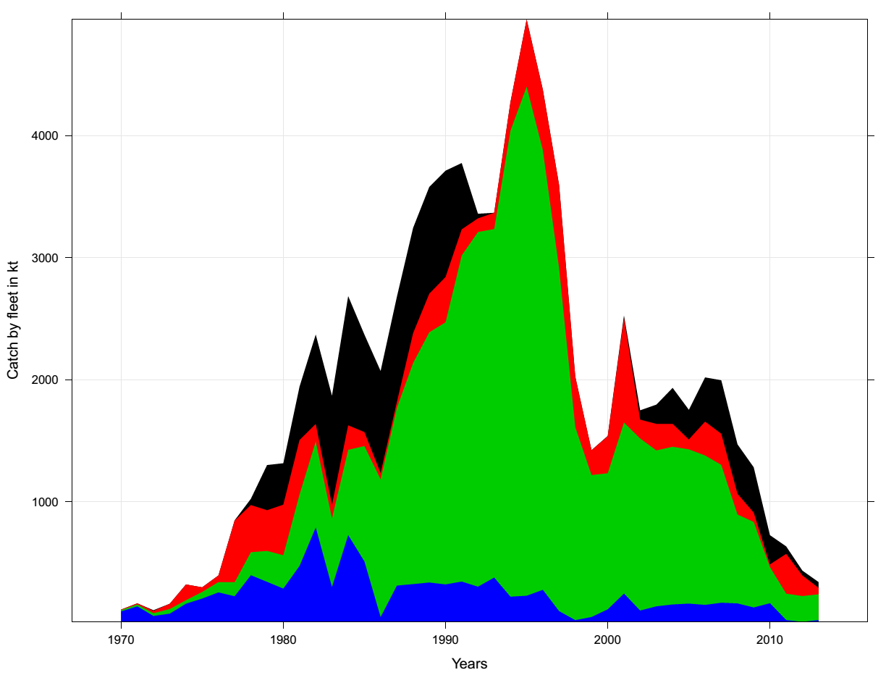

Figure A5.1. Catch of jack mackerel by fleet. Green is the SC Chilean fleet, black is the offshore trawl fleet, red is the far-north fleet, and blue in the northern Chilean fleet.

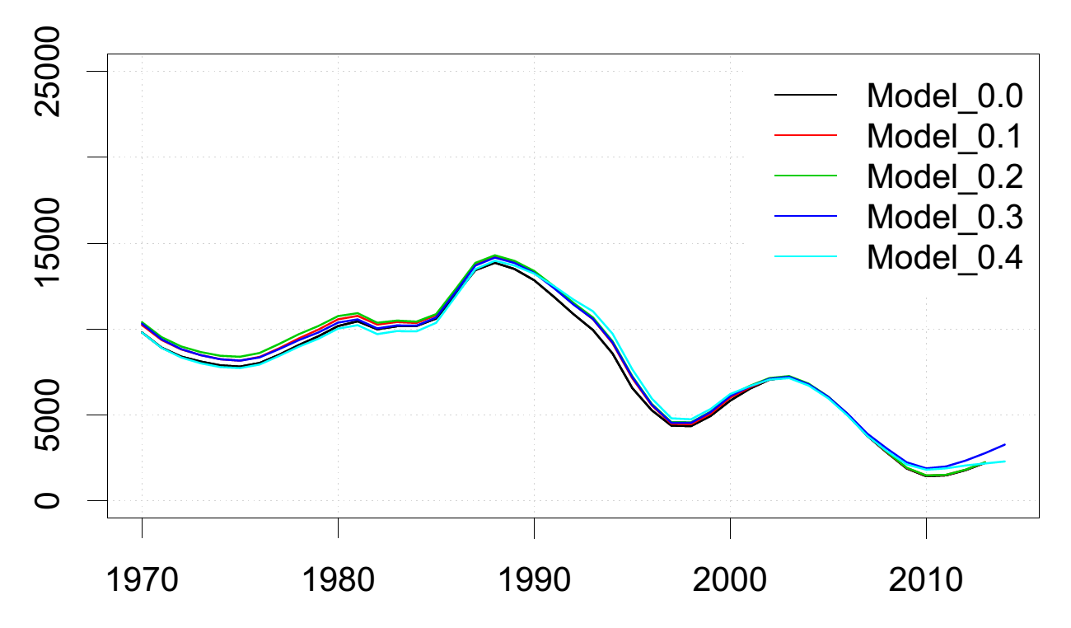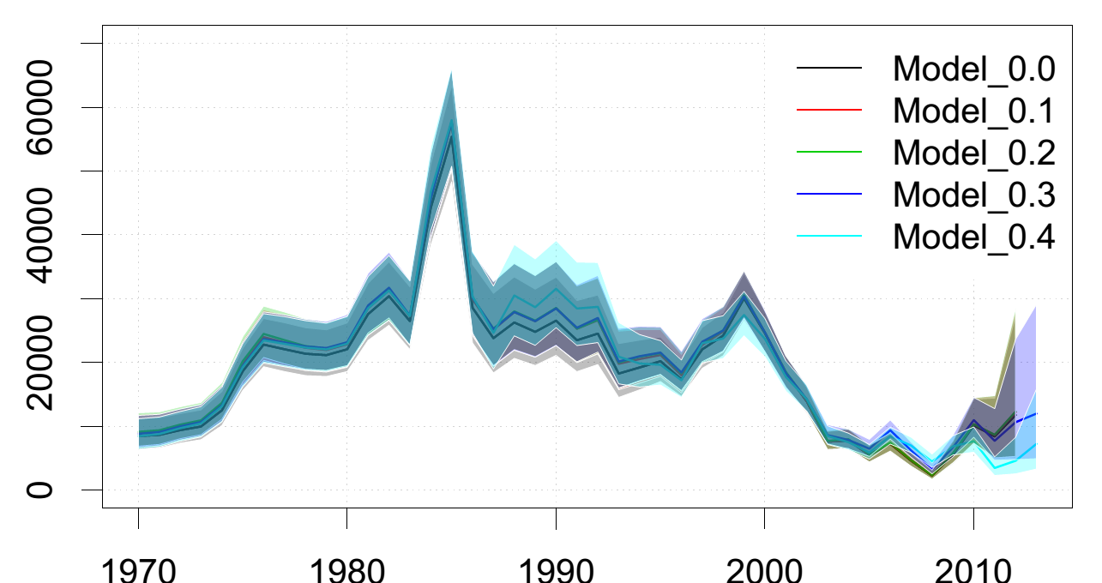
Year

Figure A5.2. Spawning biomass (top; in kt) and age one recruitment estimates (in millions) comparing model configurations 0.0 - 0.4.
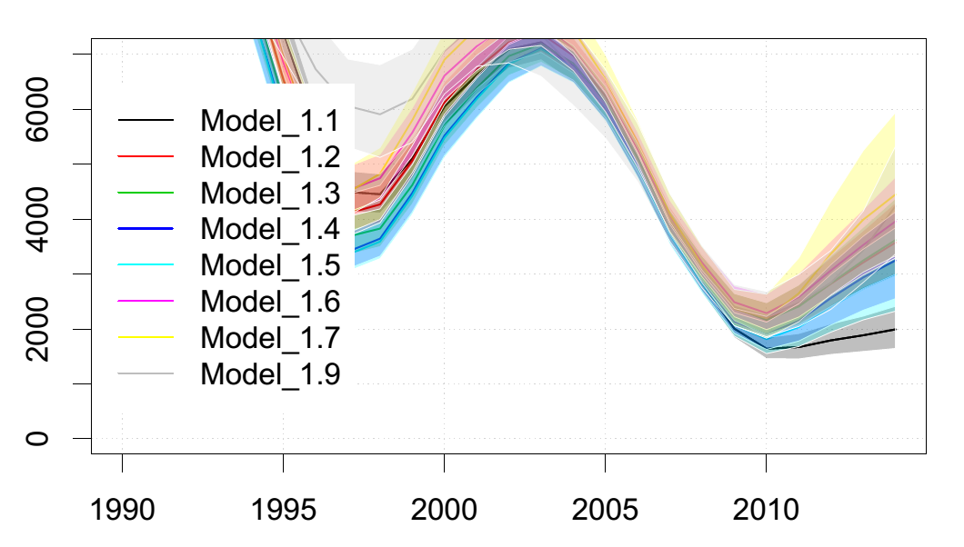
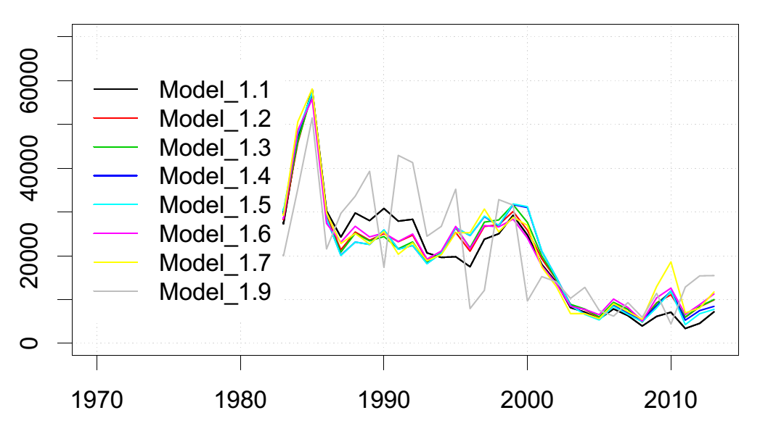

Figure A5.3. Spawning biomass (top; in kt) and age one recruitment estimates (in millions) comparing model configurations 1.1 - 1.9 (model 1.8 is omitted since it was off the scale).

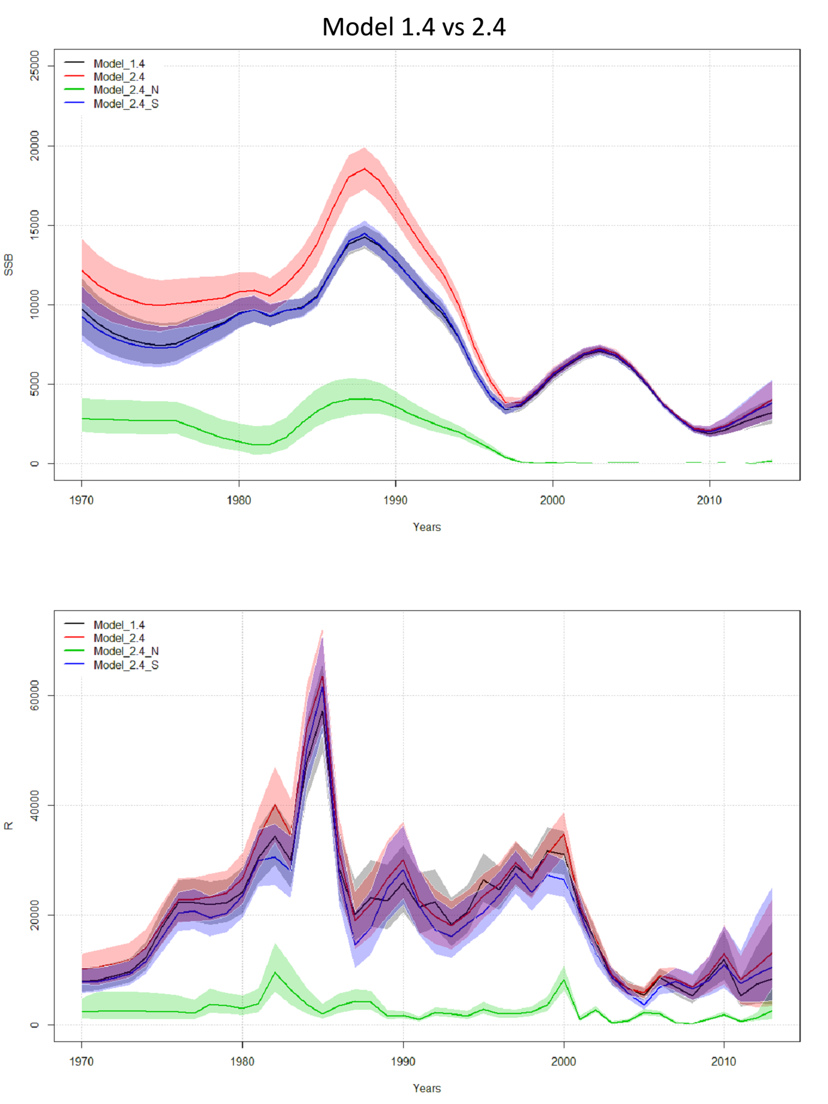

Figure A5.4. Spawning biomass (top; in kt) and age one recruitment estimates (in millions) comparing model configurations 1.4 and 2.4 (and the component models of 2.4).

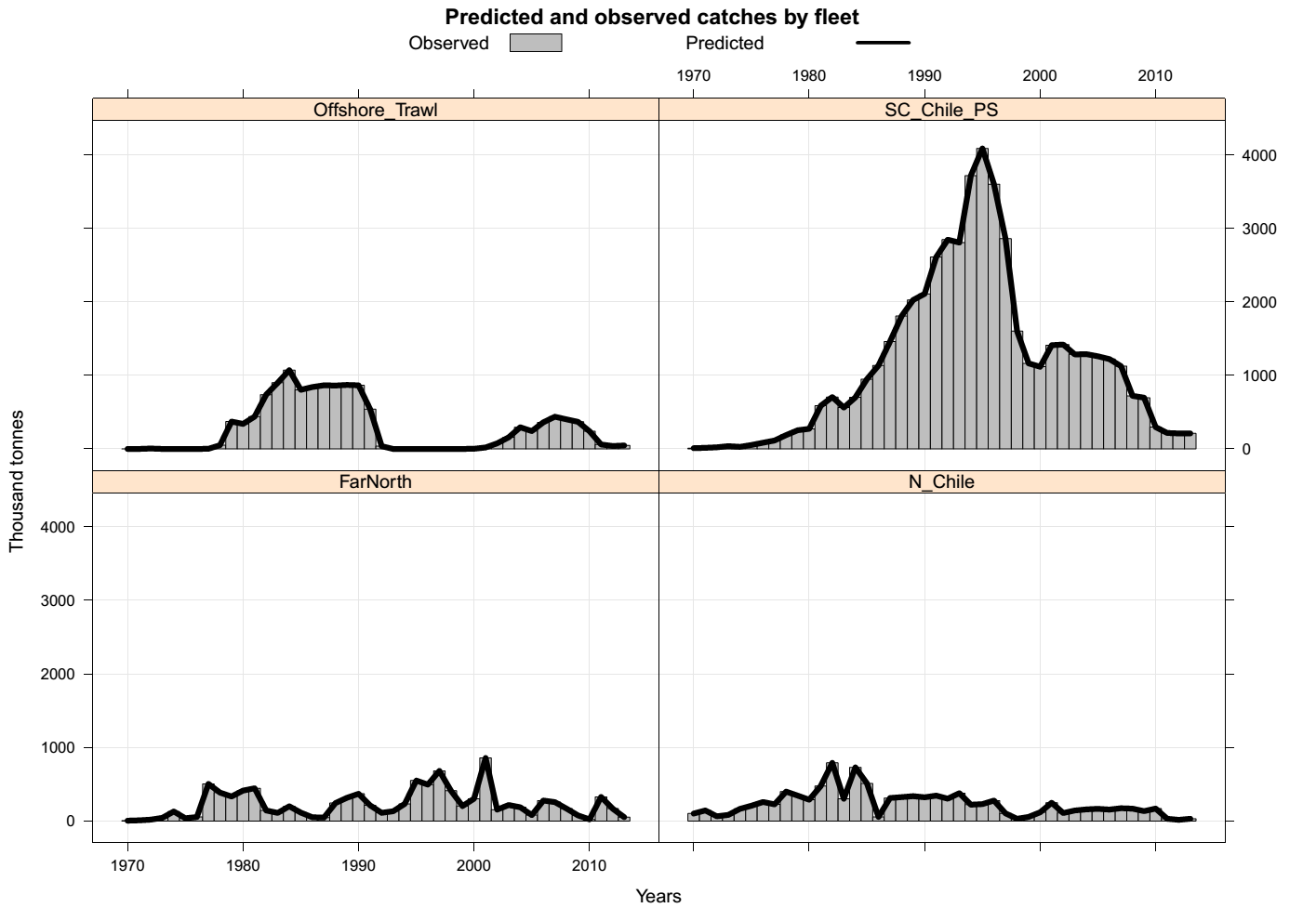

Figure A5.5. JJM Model fit to the total catches (‘000 tonnes) by fleet for Fleet 1 (N_Chile_PS), Fleet 2 (SC_Chile_PS ), Fleet 3 (Far_North) and Fleet 4 (Offshore_Trawl). The bars represent the observations and the line represents the predicted values.
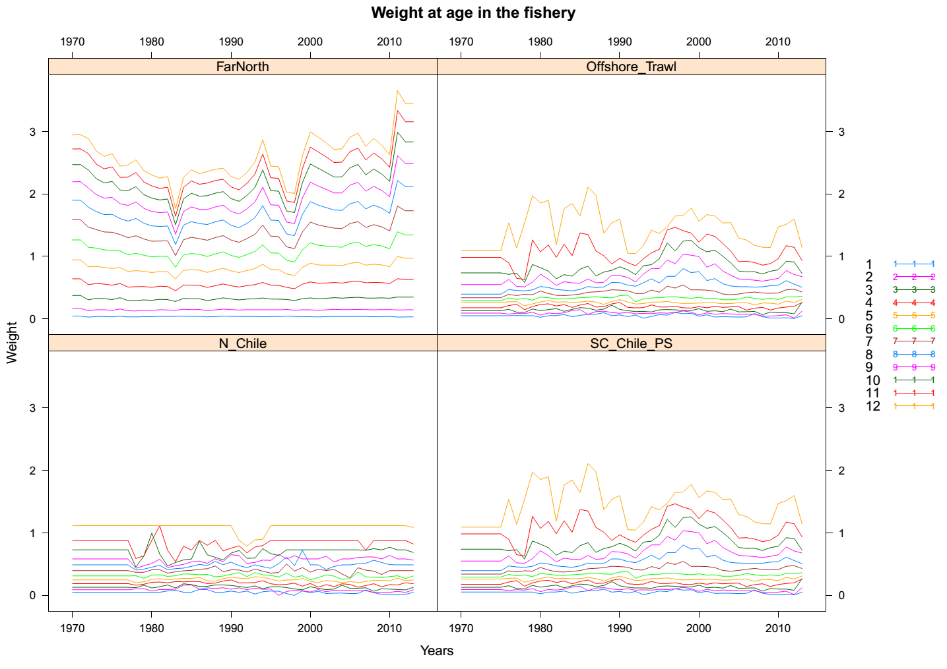

Figure A5.6. Mean weights-at-age (kg) over time used for all data types in the JJM models. Different lines represent ages 1 to 12.

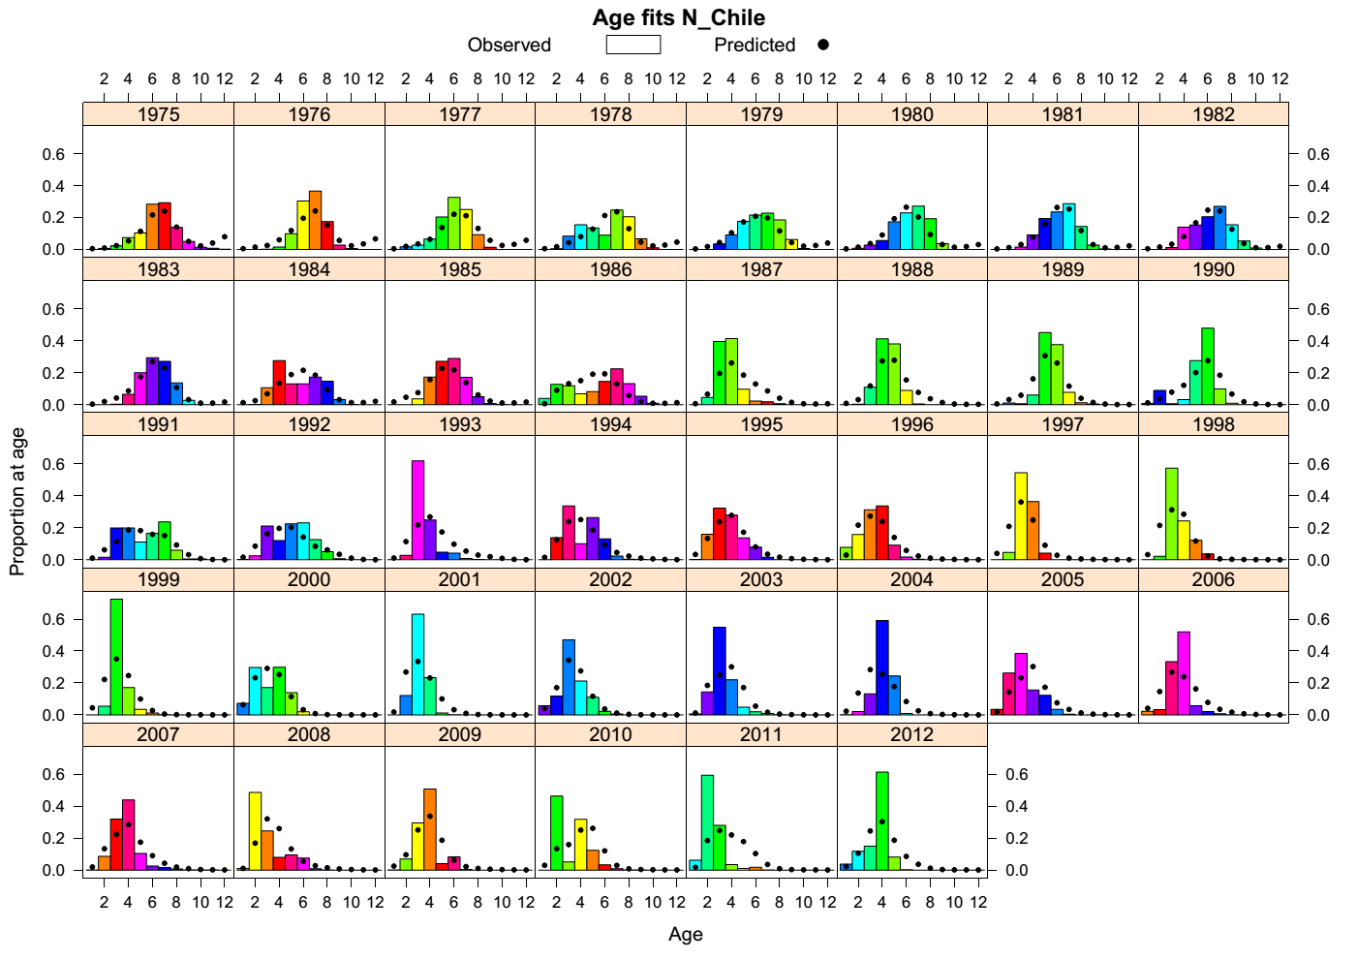

Figure A5.7. Model fit (Model 4.1) to the age compositions for the Chilean northern zone fishery (Fleet 1). Bars represent the observed data and dots represent the model fit and color codes correspond to cohorts.
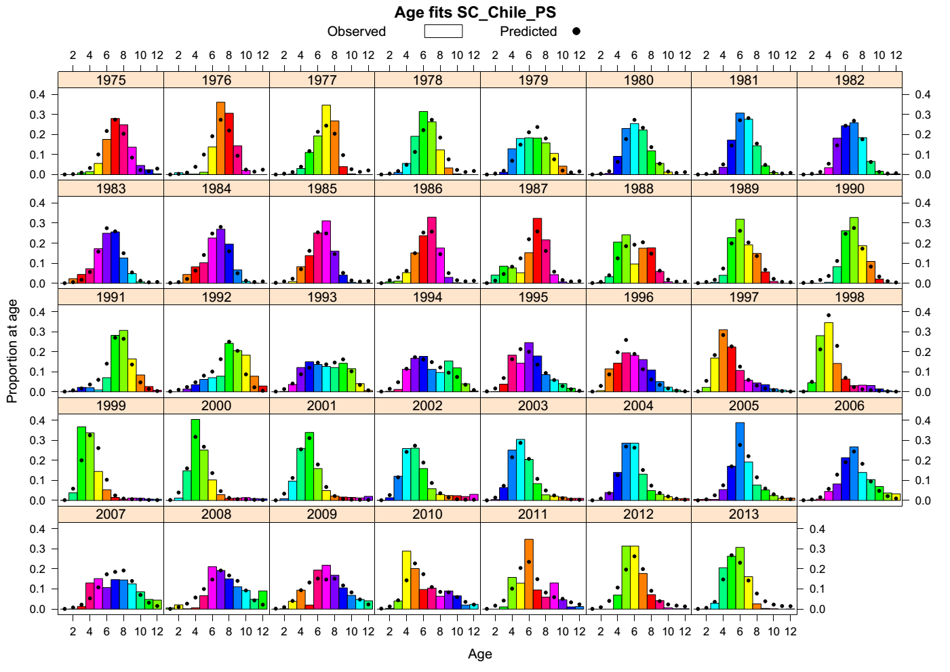

Figure A5.8. Model fit (Model 4.1) to the age compositions for the South-Central Chilean purse seine fishery (Fleet 2). Bars represent the observed data and dots represent the model fit and color codes correspond to cohorts.
To Come

Figure A5.9. Model fit (Model 4.1) to the length compositions for the far north fishery (Fleet 3). Bars represent the observed data and dots represent the model fit and color codes correspond to cohorts.
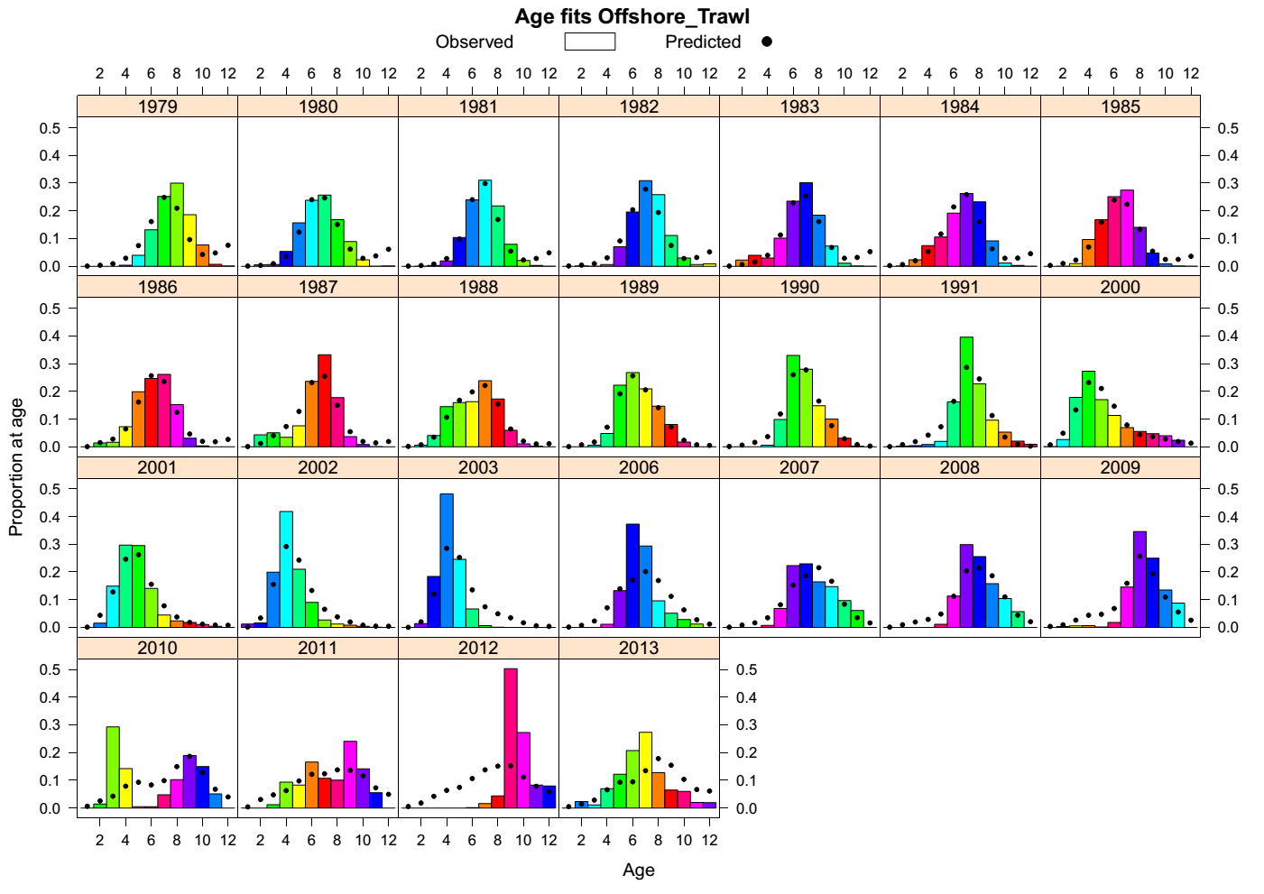

Figure A5.10. Model fit (Model 4.1) to the age compositions for the offshore trawl fishery (Fleet 4). Bars represent the observed data and dots represent the model fit and color codes correspond to cohorts.
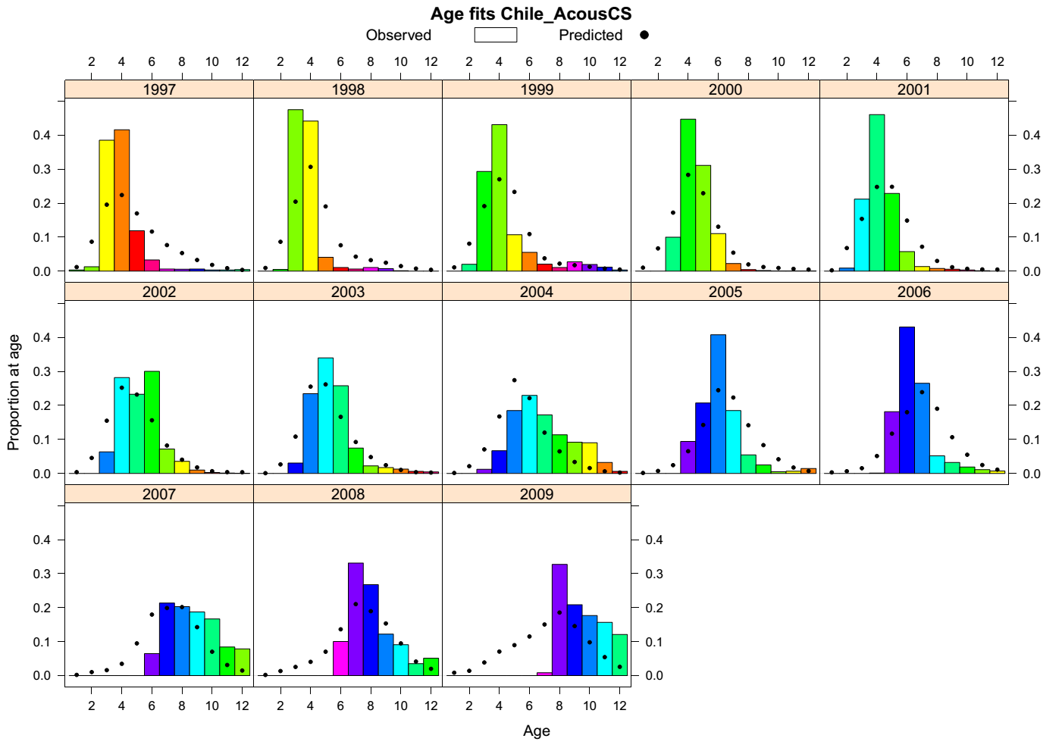

Figure A5.11. Model fit (Model 4.1) to the age compositions for the SC Chilean acoustic survey. Bars represent the observed data and dots represent the model fit and color codes correspond to cohorts.
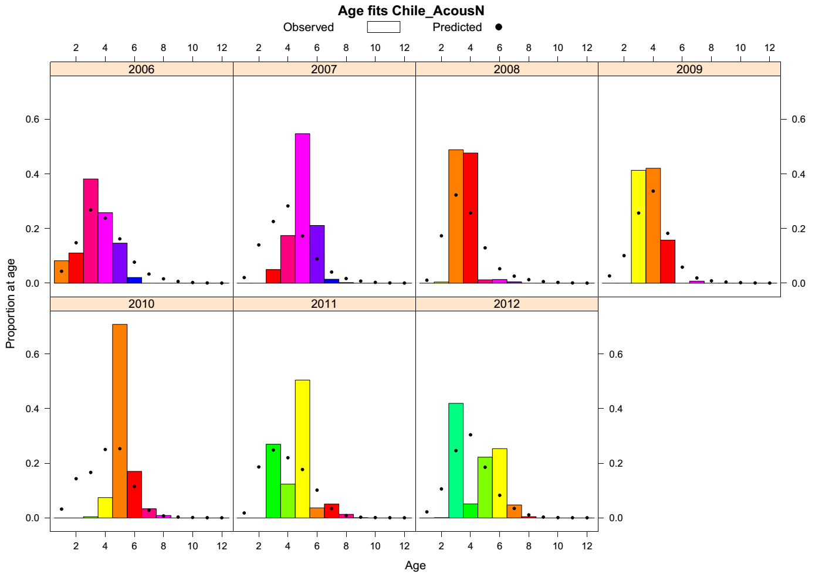

Figure A5.12. Model fit (Model 4.1) to the age compositions for the N Chilean acoustic survey. Bars represent the observed data and dots represent the model fit and color codes correspond to cohorts.

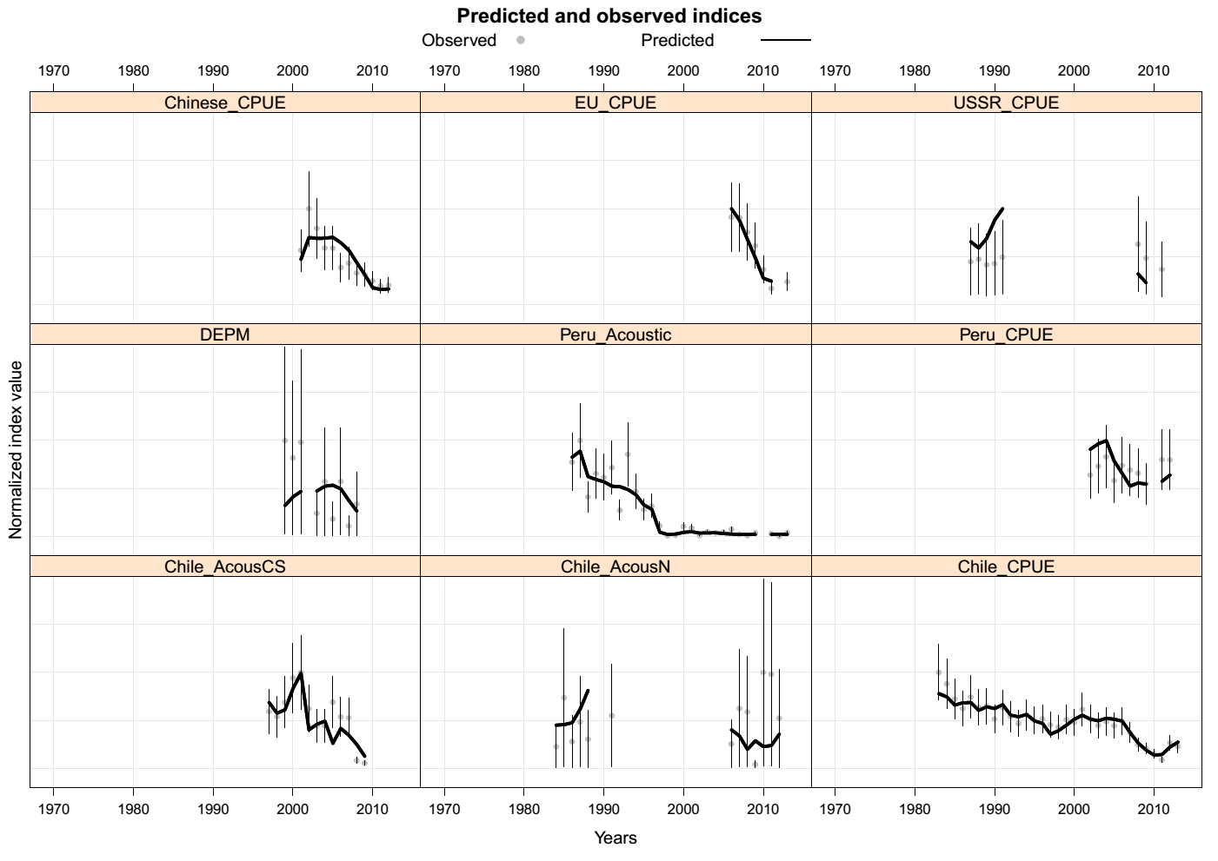

Figure A5.13. Model fit (Model 4.1) to different indices. Vertical bars represent 2 standard deviations around the observations.

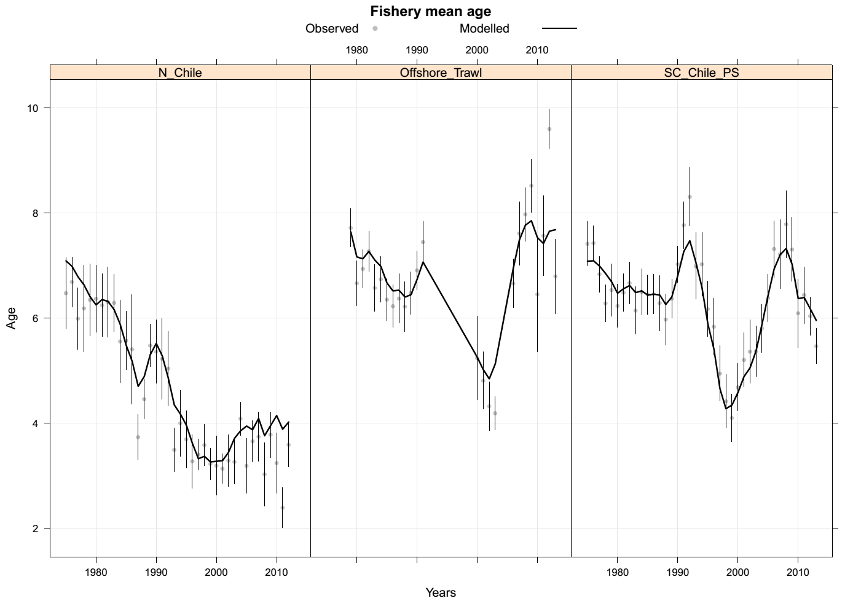

Figure A5.14. Mean age by year and fishery. Line represents the model and dots the observed values.
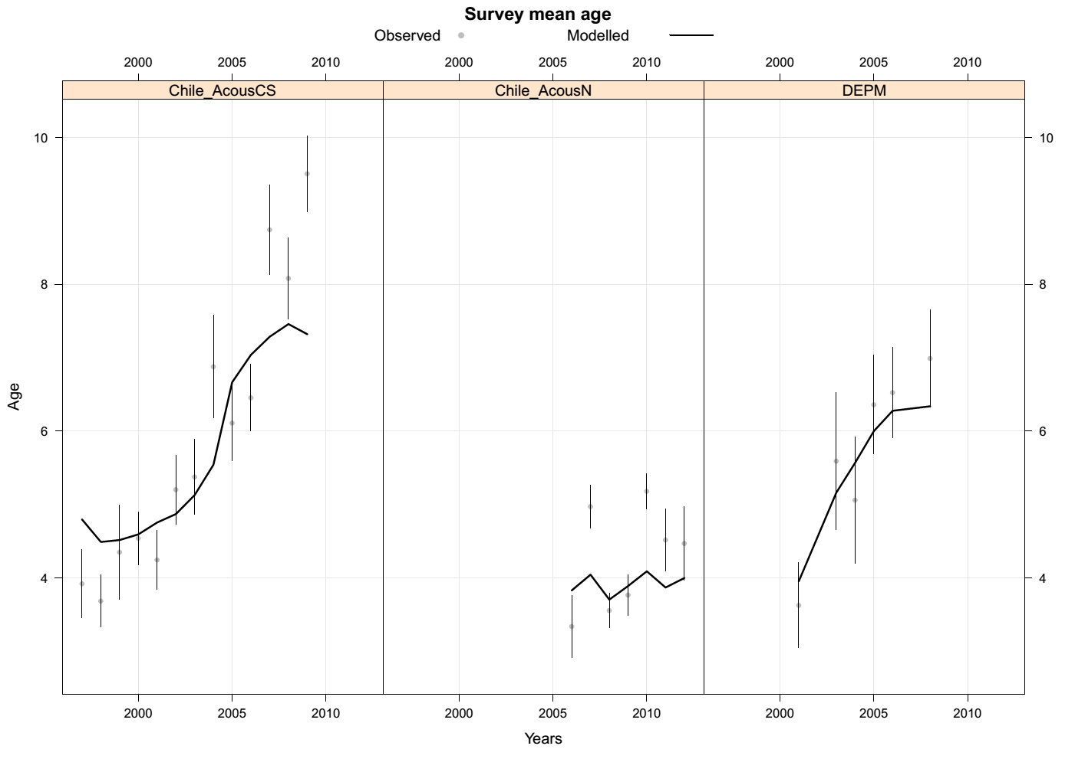

Figure A5.15. Mean age by year and survey. Line represents the model and dots the observed values.
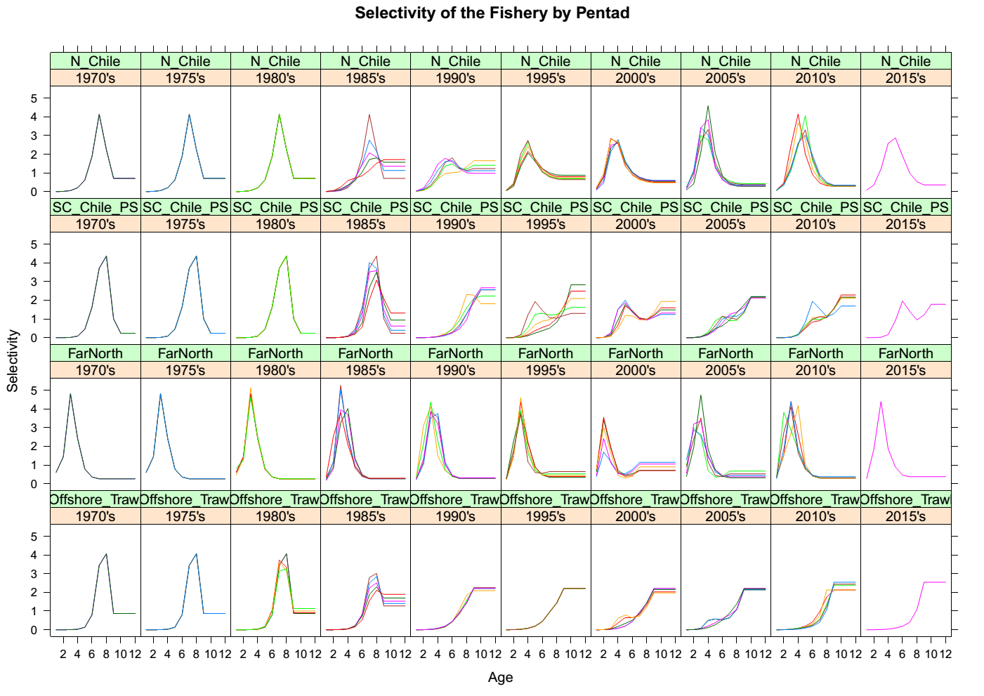

Figure A5.16. Estimates of selectivity by fishery over time for Model 4.1.
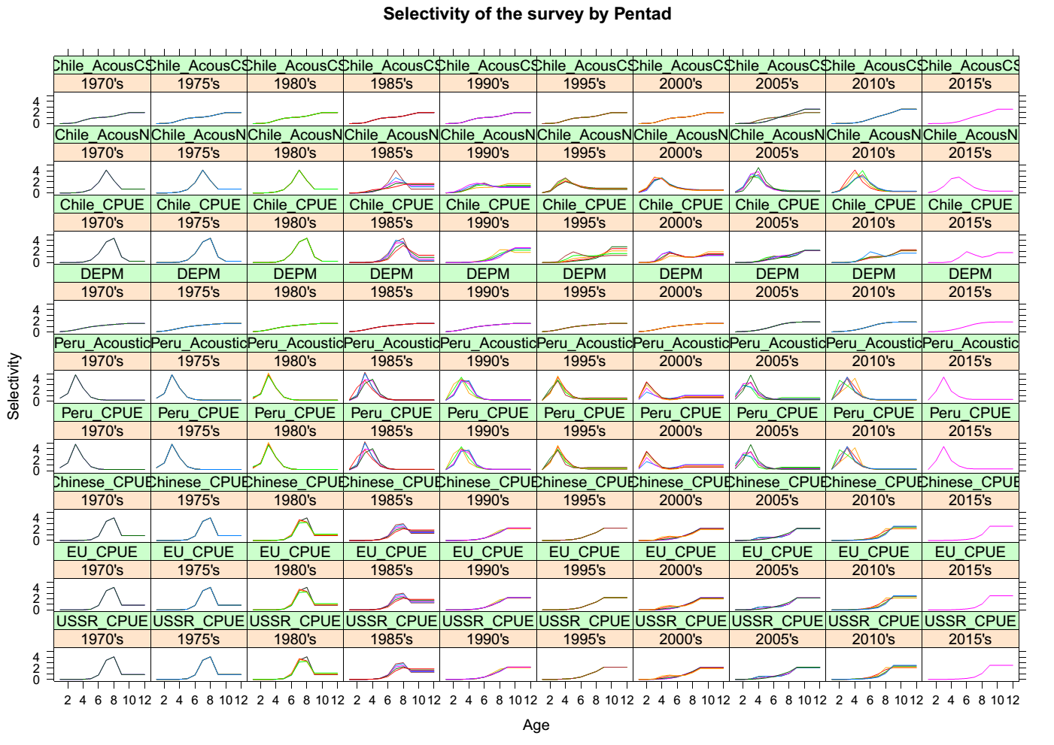

Figure A5.17. Model 4.1) estimates of selectivity for each index over time.
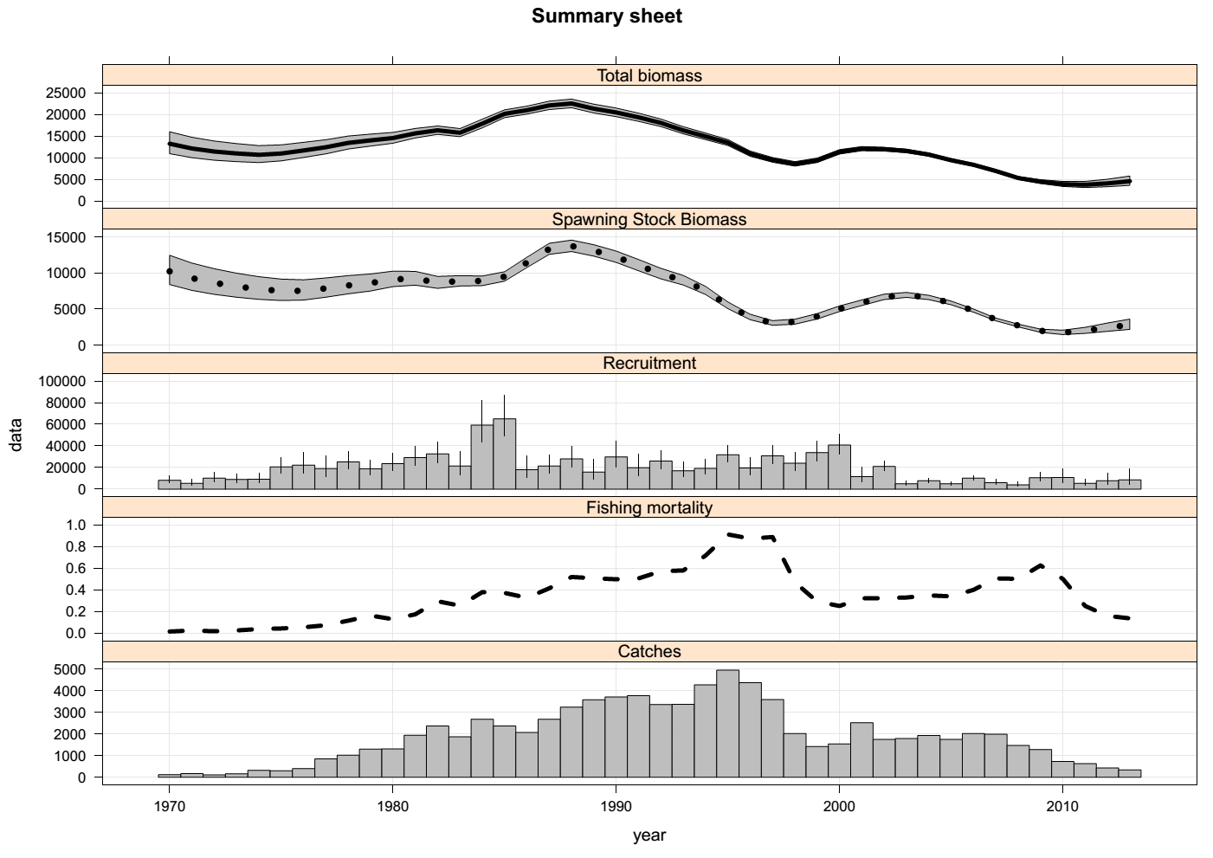

Figure A5.18. Summary estimates over time showing total and spawning biomass (kt; top two panels), recruitment at age 1 (millions; third from top) total fishing mortality (fourth panel) and total catch (kt; bottom). Shaded areas represent the approximate 90% confidence bands.

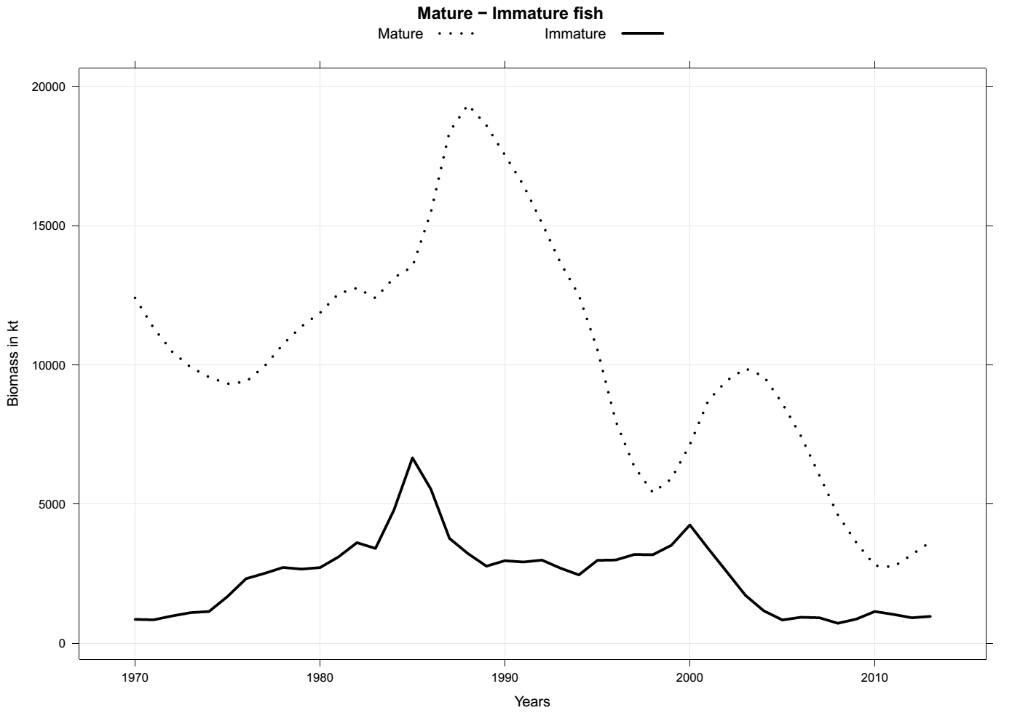

Figure A5.19. Model 4.1 results showing mature and immature estimated components of the jack mackerel stock, 1970-2013.
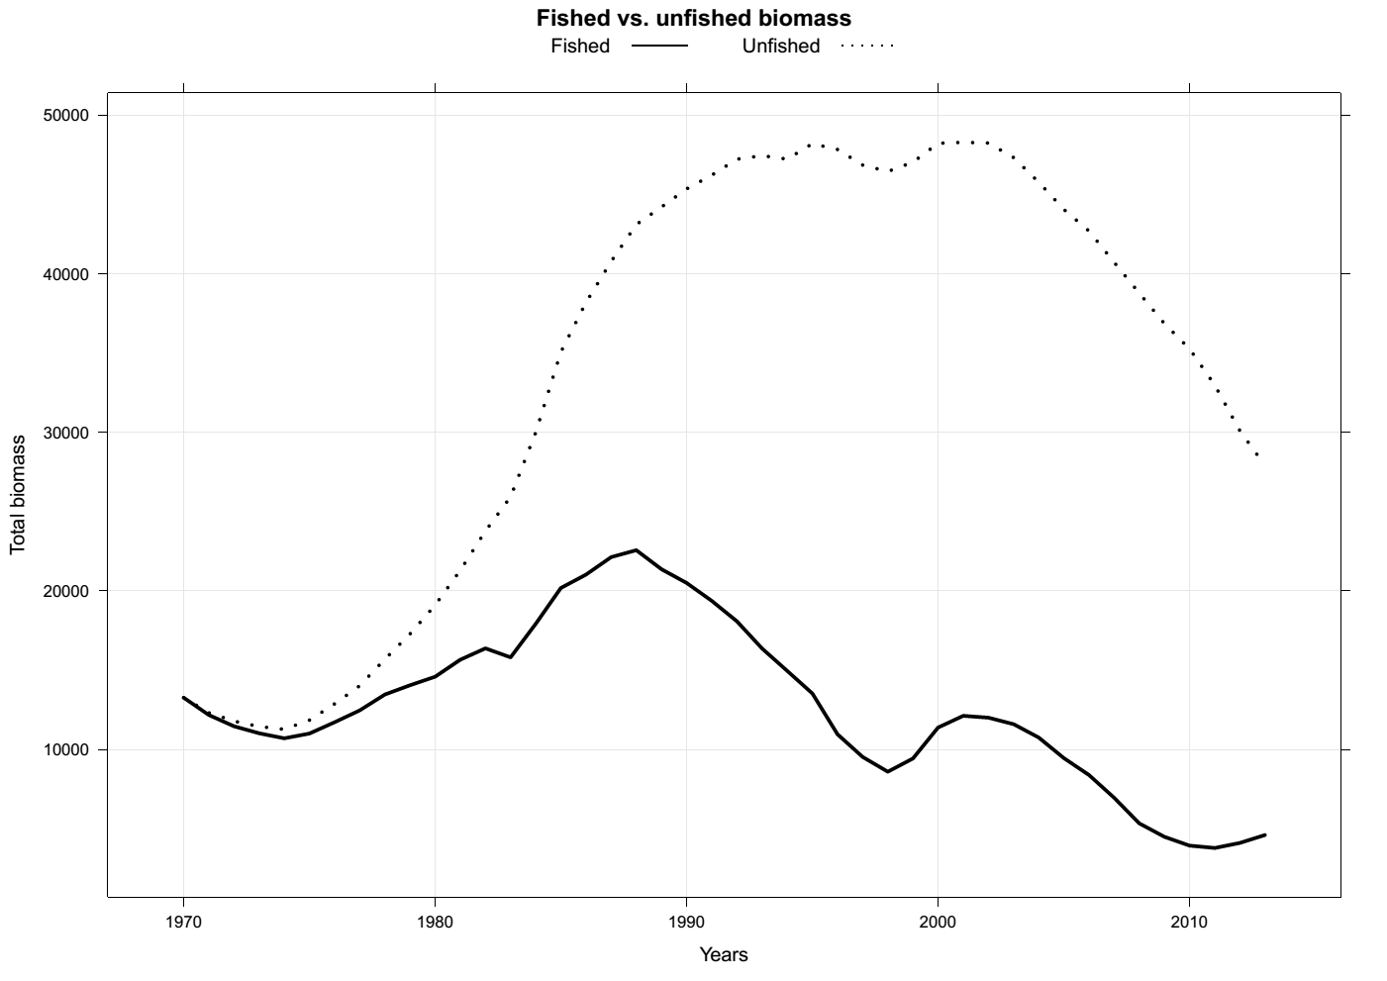

Figure A5.20. Model 4.1 results the estimated total biomass (solid line) and the estimated total biomass that would have occurred if no fishing had taken place, 1970-2013.

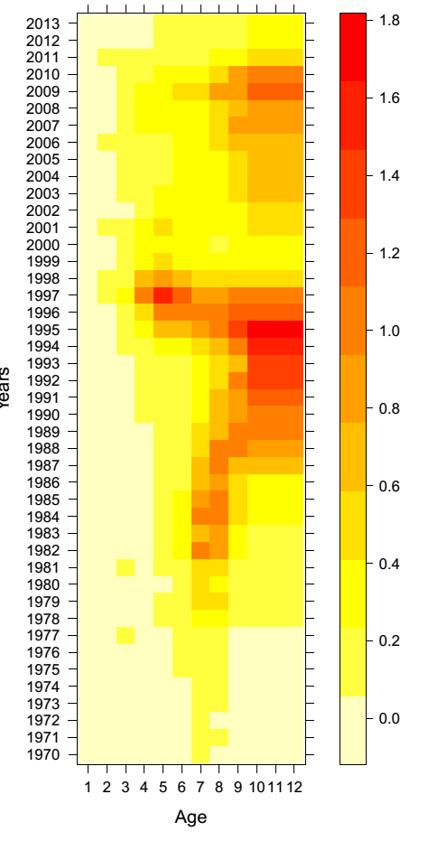

Figure A5.21. Historical fishing mortality at age.
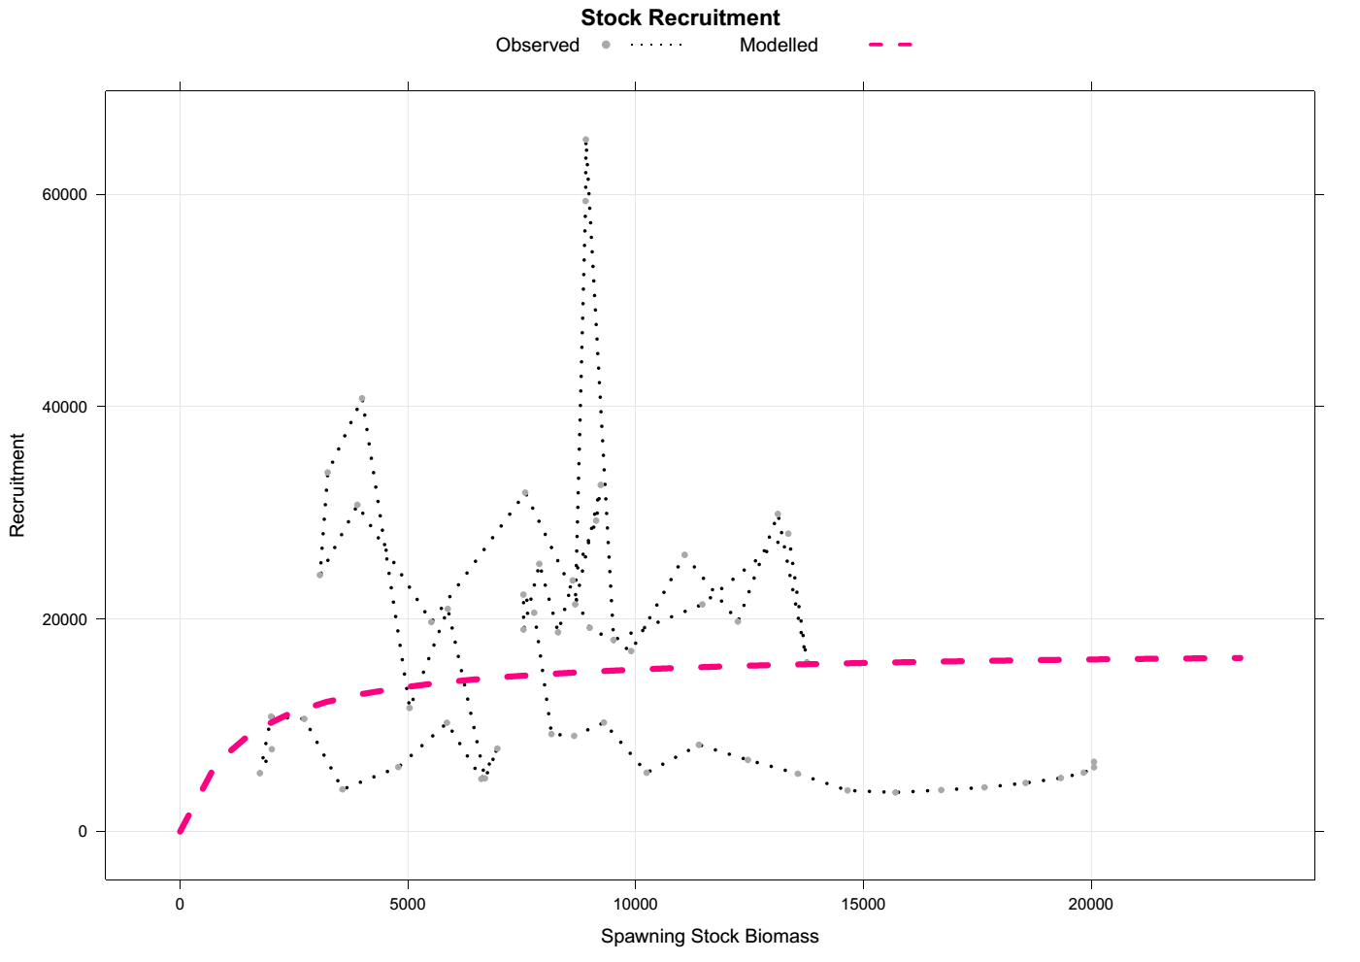

Figure A5.22. Model 4.1 stock recruitment curve relative to model estimates of biomass and recruitment.
Figure A5.23. Jack mackerel stock recruitment estimates with two alternative steepness values and for models 4.1-4.4. Models 4.1 and 4.4 are estimated based on the whole time series wherease the other two are based on recruits and spawning levels from 2000-2011.

